User Acceptance Testing – Acceptance Sign-Off Form
  - User : Admin
  - From Name : Dashboard Page
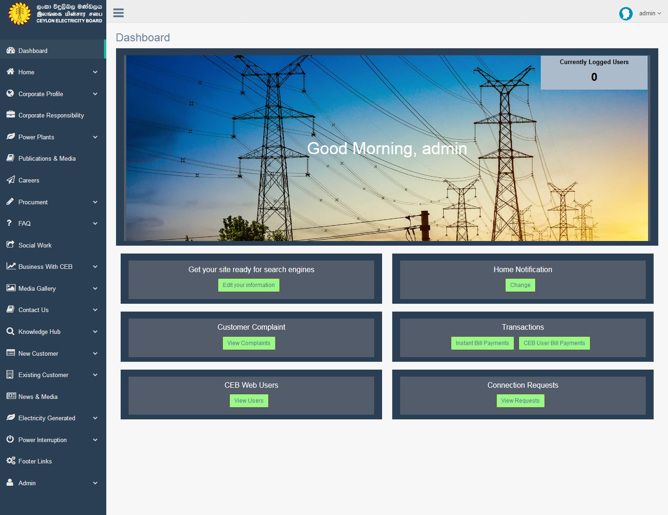

Criteria | Satisfied | Unsatisfied
Accuracy and Order of text fields

Readability and Understandability of
the content

Overall appearance of the form

Accepted by
Name : ……………………… Signature: ………………….. Date: ……………

User Acceptance Testing – Acceptance Sign-Off Form
  - User : Admin
  - From Name : Meta Tags – Landing Page

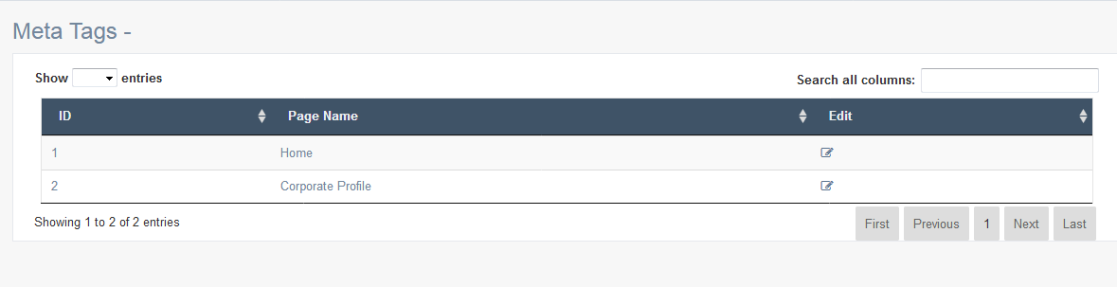

Criteria | Satisfied | Unsatisfied
Accuracy and Order of text fields

Readability and Understandability of
the content

Overall appearance of the form

Accepted by
Name : ……………………… Signature: ………………….. Date: ……………

User Acceptance Testing – Acceptance Sign-Off Form
  - User : Admin
  - From Name : Meta Tags – Edit Details

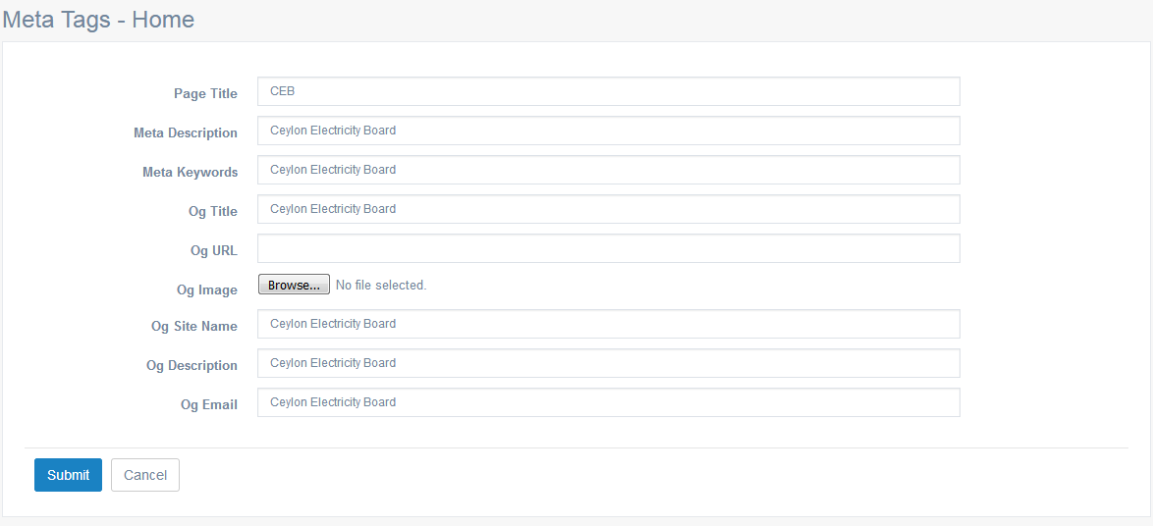

Criteria | Satisfied | Unsatisfied
Accuracy and Order of text fields

Readability and Understandability of
the content

Overall appearance of the form

Accepted by
Name : ……………………… Signature: ………………….. Date: ……………

User Acceptance Testing – Acceptance Sign-Off Form
  - User : Admin
  - From Name : Home Notification

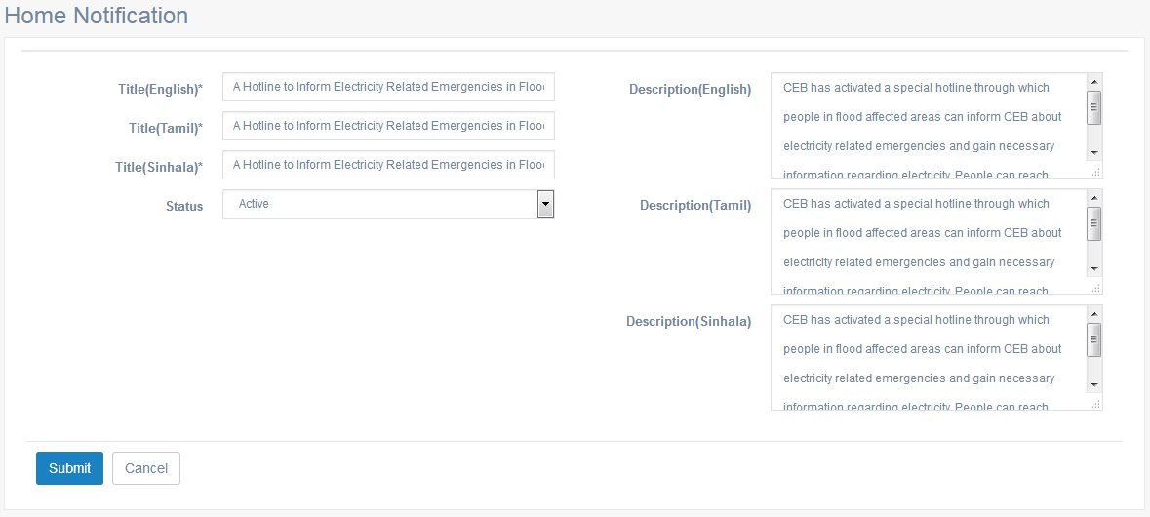

Criteria | Satisfied | Unsatisfied
Accuracy and Order of text fields

Readability and Understandability of
the content

Overall appearance of the form

Accepted by
Name : ……………………… Signature: ………………….. Date: ……………

User Acceptance Testing – Acceptance Sign-Off Form
  - User : Admin
  - From Name : User Complaints

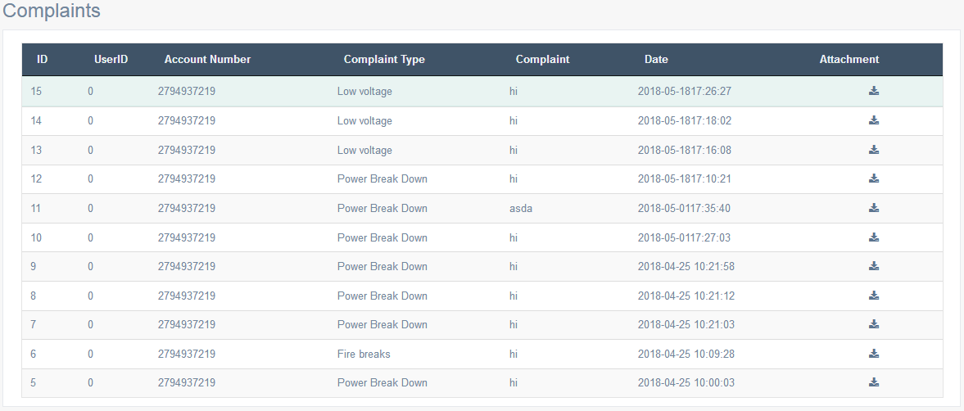

Criteria | Satisfied | Unsatisfied
Accuracy and Order of text fields

Readability and Understandability of
the content

Overall appearance of the form

Accepted by
Name : ……………………… Signature: ………………….. Date: ……………

User Acceptance Testing – Acceptance Sign-Off Form
  - User : Admin
  - From Name : Instant Payment Transaction

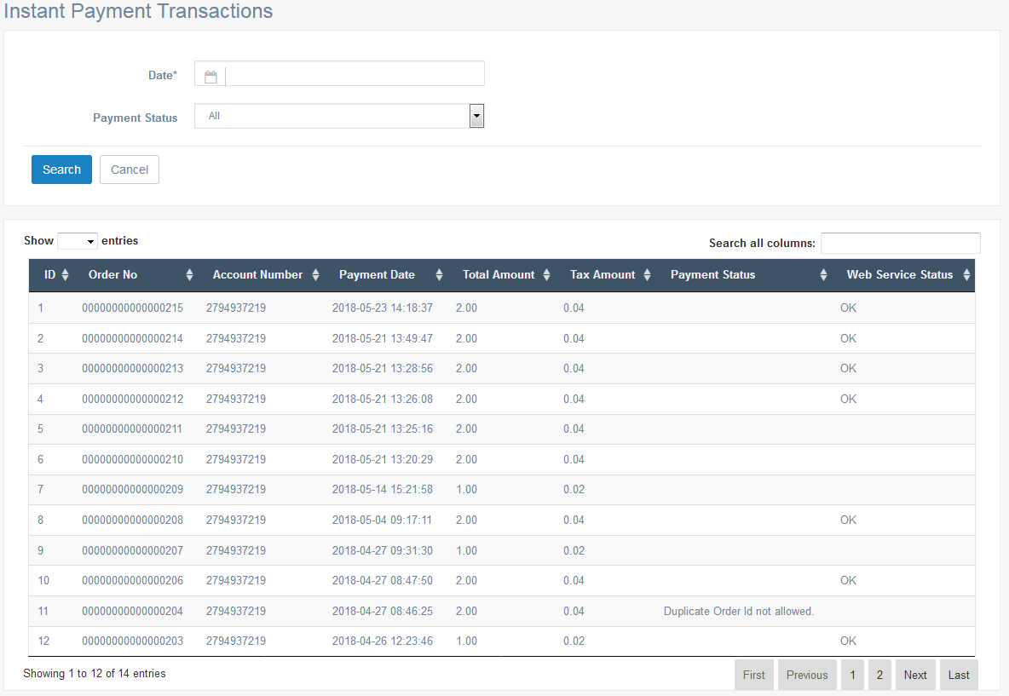

Criteria | Satisfied | Unsatisfied
Accuracy and Order of text fields

Readability and Understandability of
the content

Overall appearance of the form

Accepted by
Name : ……………………… Signature: ………………….. Date: ……………

User Acceptance Testing – Acceptance Sign-Off Form
  - User : Admin
  - From Name : CEB User Payment Transactions

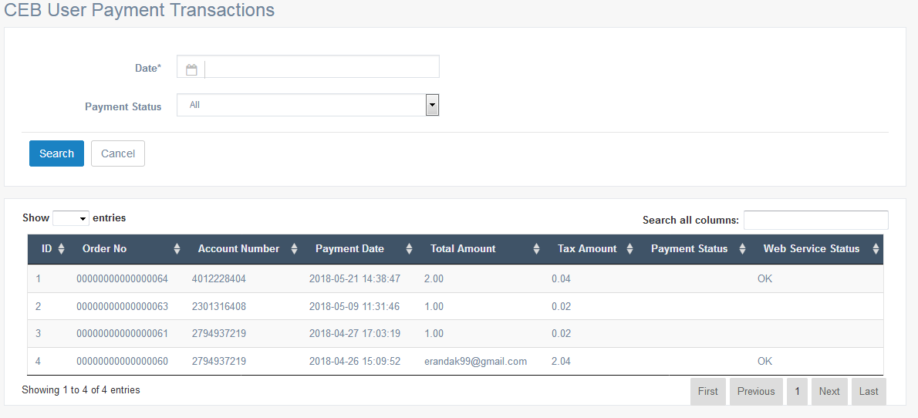

Criteria | Satisfied | Unsatisfied
Accuracy and Order of text fields

Readability and Understandability of
the content

Overall appearance of the form

Accepted by
Name : ……………………… Signature: ………………….. Date: ……………

User Acceptance Testing – Acceptance Sign-Off Form
  - User : Admin
  - From Name : CEB Users – Data Grid

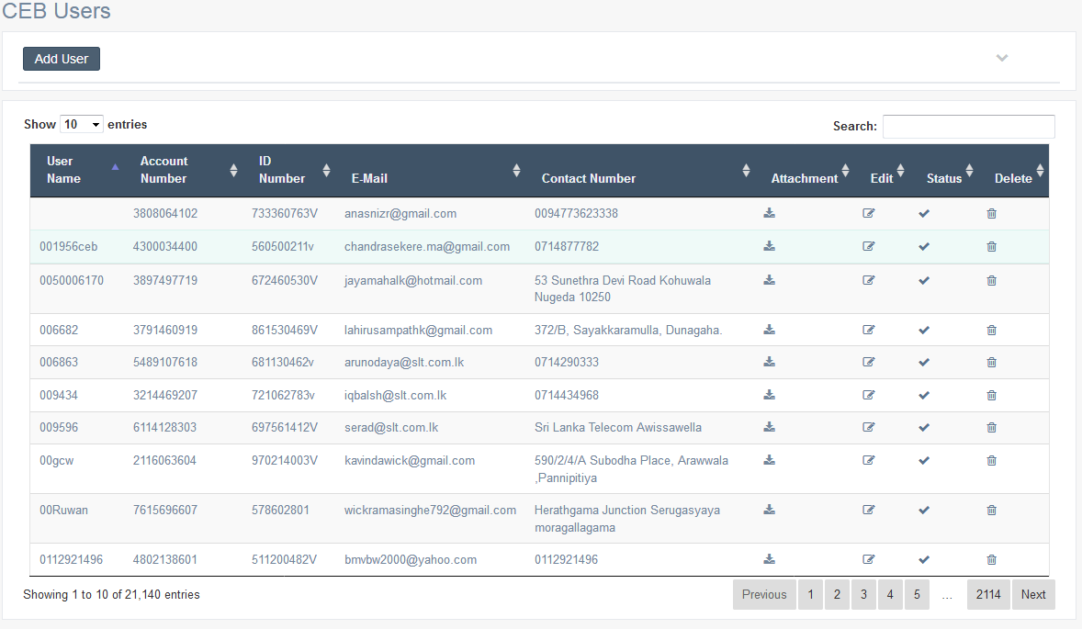

Criteria | Satisfied | Unsatisfied
Accuracy and Order of text fields

Readability and Understandability of
the content

Overall appearance of the form

Accepted by
Name : ……………………… Signature: ………………….. Date: ……………

User Acceptance Testing – Acceptance Sign-Off Form
  - User : Admin
  - From Name : CEB Users – Add users
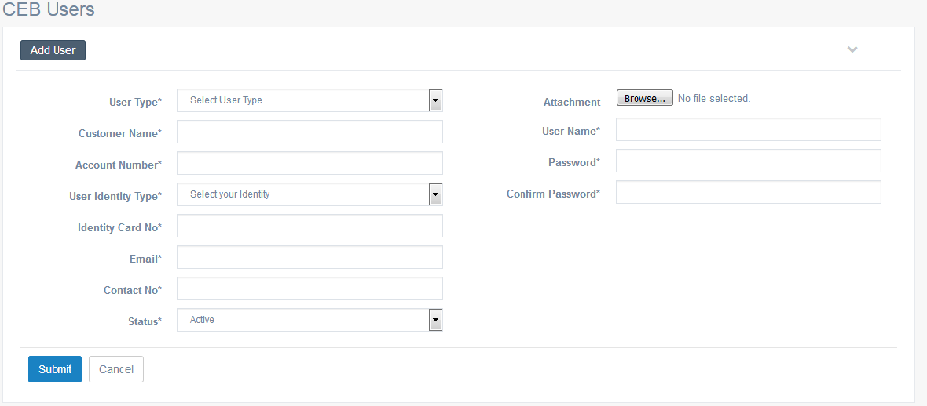

Criteria | Satisfied | Unsatisfied
Accuracy and Order of text fields

Readability and Understandability of
the content

Overall appearance of the form

Accepted by
Name : ……………………… Signature: ………………….. Date: ……………

User Acceptance Testing – Acceptance Sign-Off Form
  - User : Admin
  - From Name : CEB Users – Edit users
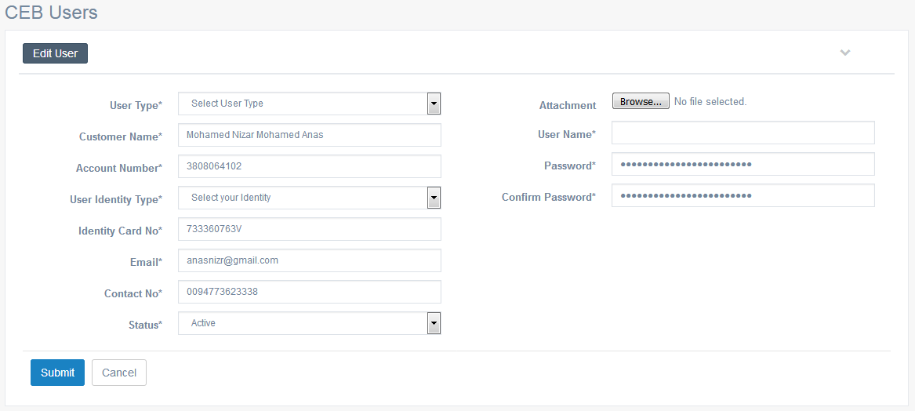

Criteria | Satisfied | Unsatisfied
Accuracy and Order of text fields

Readability and Understandability of
the content

Overall appearance of the form

Accepted by
Name : ……………………… Signature: ………………….. Date: ……………

User Acceptance Testing – Acceptance Sign-Off Form
  - User : Admin
  - From Name : Connection Requests

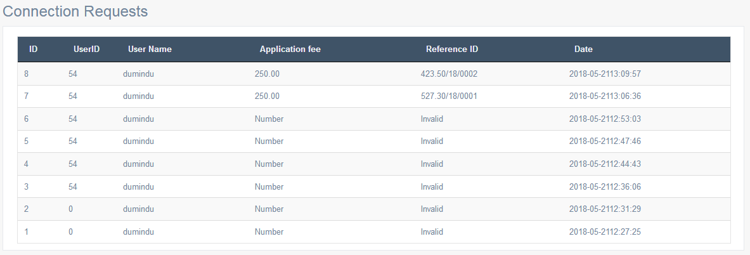

Criteria | Satisfied | Unsatisfied
Accuracy and Order of text fields

Readability and Understandability of
the content

Overall appearance of the form

Accepted by
Name : ……………………… Signature: ………………….. Date: ……………

User Acceptance Testing – Acceptance Sign-Off Form
  - User : Admin
  - From Name : Main Slider - List

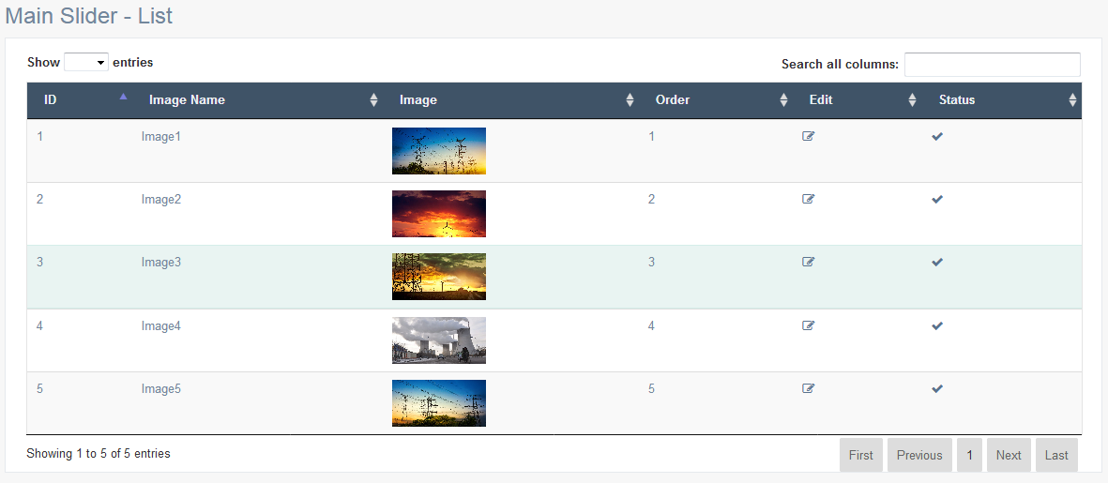

Criteria | Satisfied | Unsatisfied
Accuracy and Order of text fields

Readability and Understandability of
the content

Overall appearance of the form

Accepted by
Name : ……………………… Signature: ………………….. Date: ……………

User Acceptance Testing – Acceptance Sign-Off Form
  - User : Admin
  - From Name : Main Slider – Edit Details

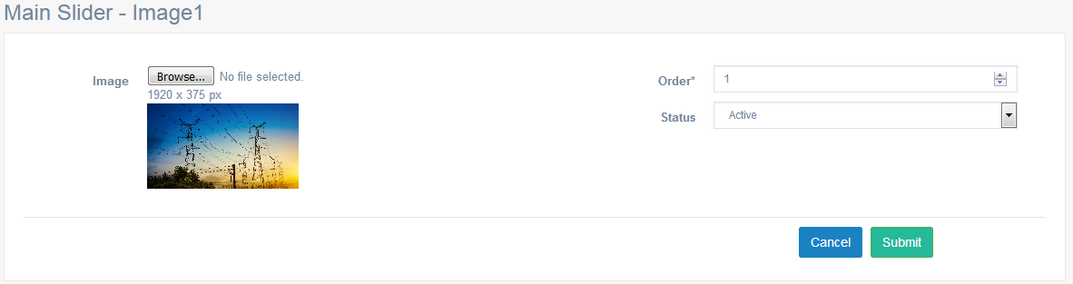

Criteria | Satisfied | Unsatisfied
Accuracy and Order of text fields

Readability and Understandability of
the content

Overall appearance of the form

Accepted by
Name : ……………………… Signature: ………………….. Date: ……………

User Acceptance Testing – Acceptance Sign-Off Form
  - User : Admin
  - From Name : Top Banners - View

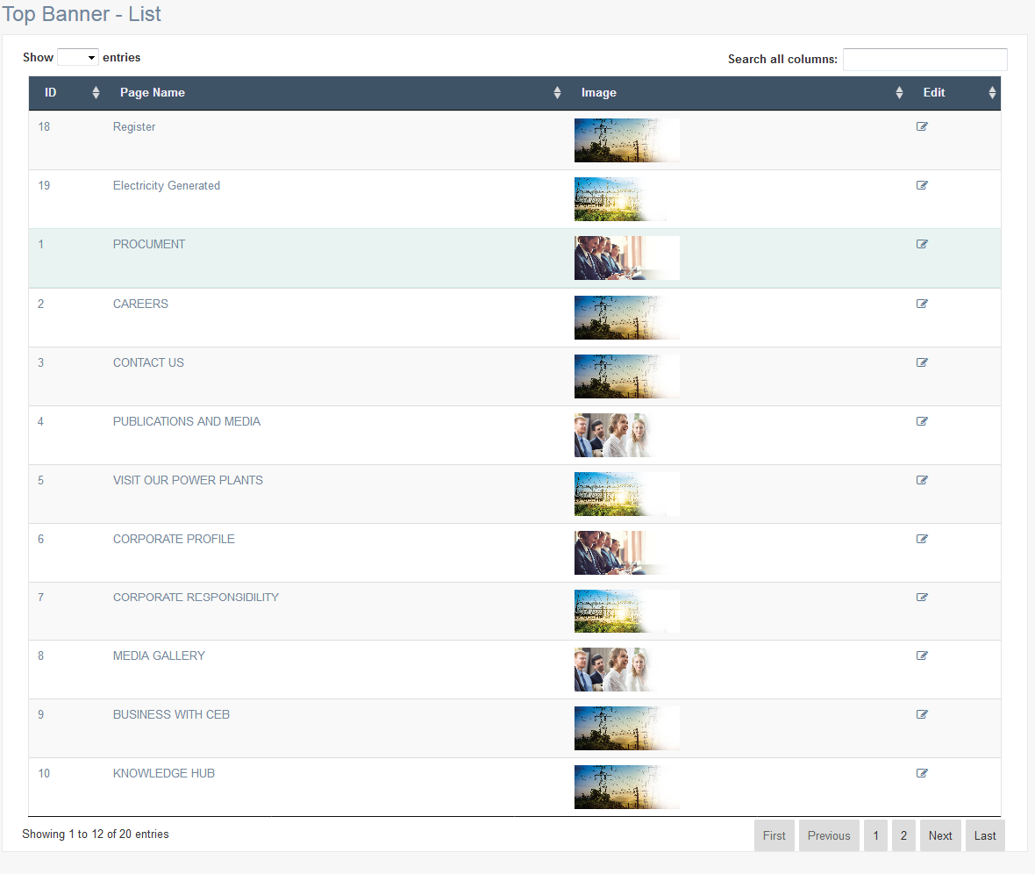

Criteria | Satisfied | Unsatisfied
Accuracy and Order of text fields

Readability and Understandability of
the content

Overall appearance of the form

Accepted by
Name : ……………………… Signature: ………………….. Date: ……………

User Acceptance Testing – Acceptance Sign-Off Form
  - User : Admin
  - From Name : Top Banners – Edit Details

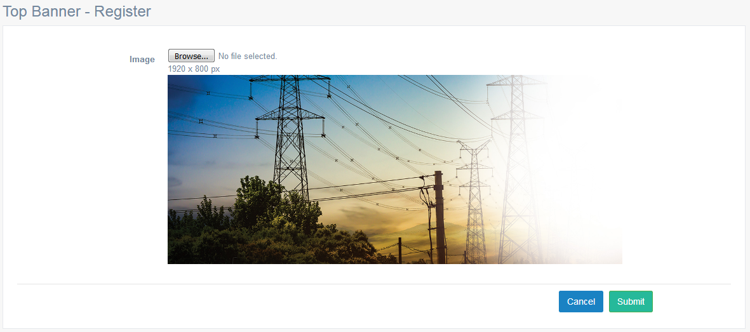

Criteria | Satisfied | Unsatisfied
Accuracy and Order of text fields

Readability and Understandability of
the content

Overall appearance of the form

Accepted by
Name : ……………………… Signature: ………………….. Date: ……………

User Acceptance Testing – Acceptance Sign-Off Form
  - User : Admin
  - From Name : Generated Electricity

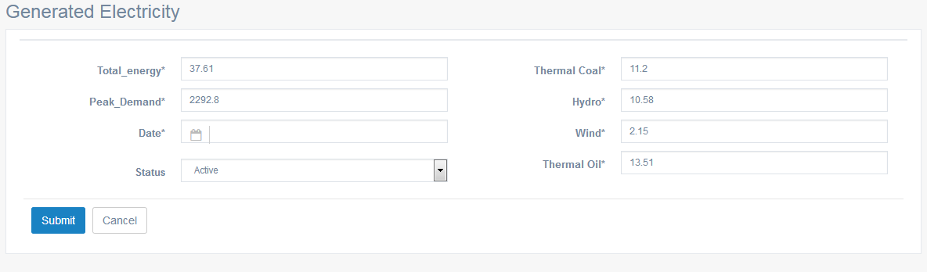

Criteria | Satisfied | Unsatisfied
Accuracy and Order of text fields

Readability and Understandability of
the content

Overall appearance of the form

Accepted by
Name : ……………………… Signature: ………………….. Date: ……………

User Acceptance Testing – Acceptance Sign-Off Form
  - User : Admin
  - From Name : Home Content

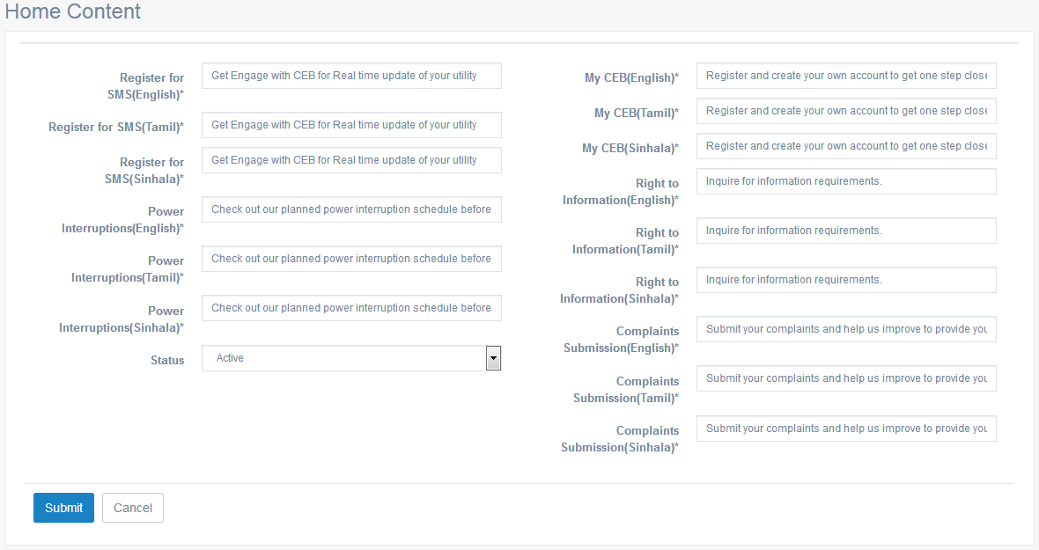

Criteria | Satisfied | Unsatisfied
Accuracy and Order of text fields

Readability and Understandability of
the content

Overall appearance of the form

Accepted by
Name : ……………………… Signature: ………………….. Date: ……………

User Acceptance Testing – Acceptance Sign-Off Form
  - User : Admin
  - From Name : Vision & Mission
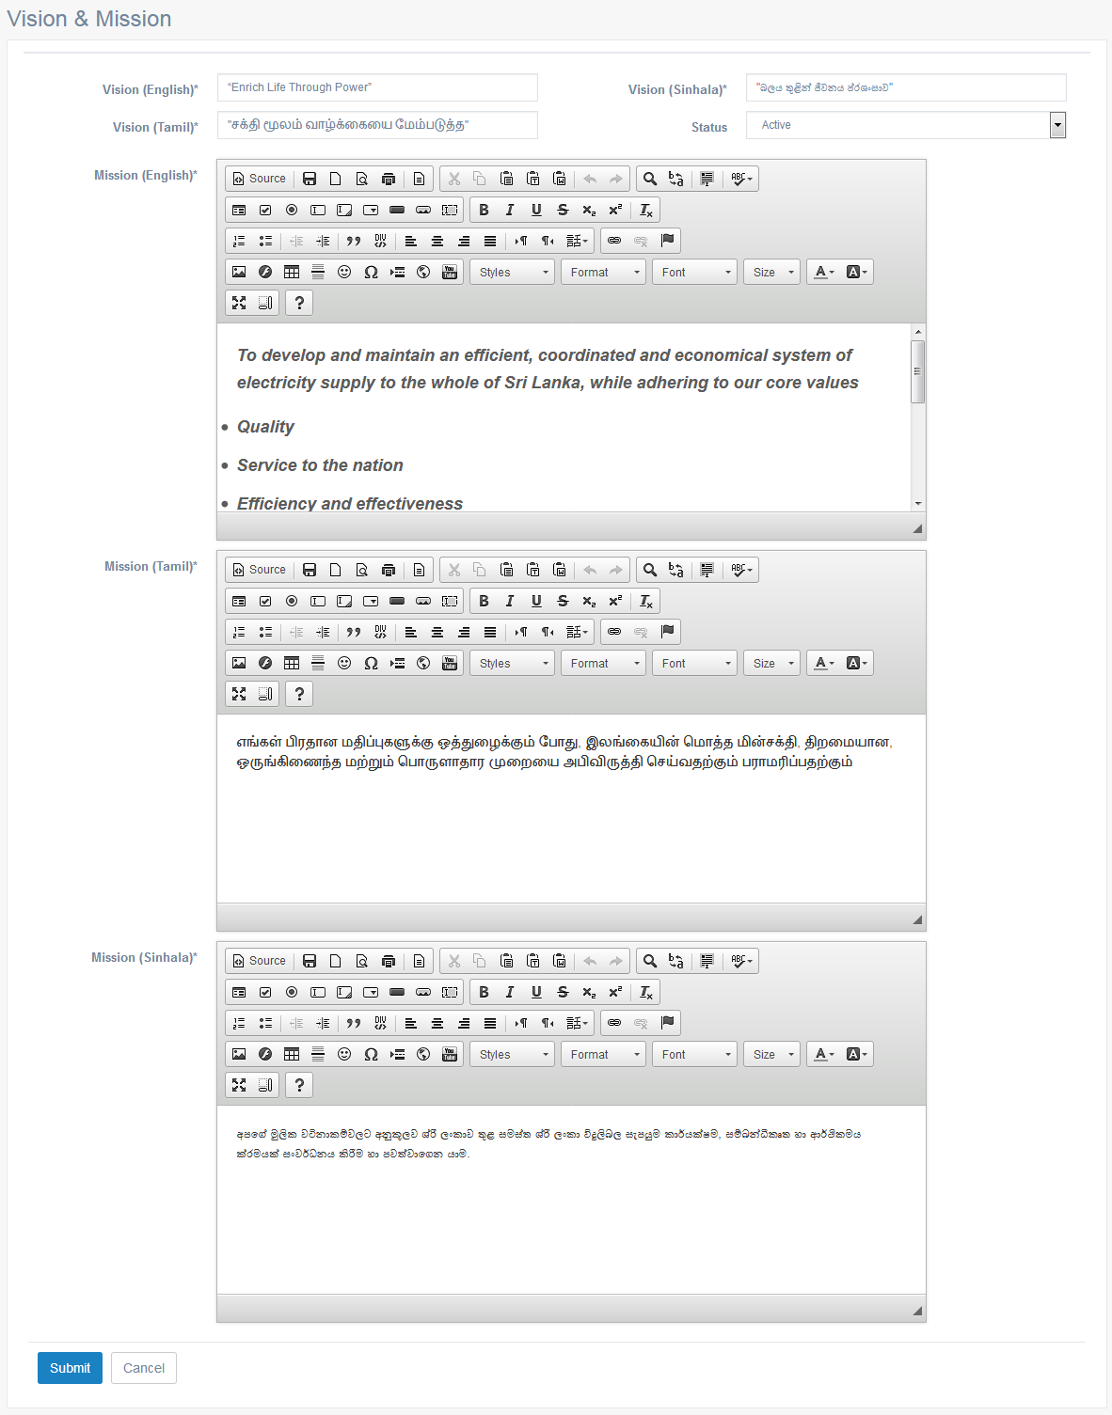

Criteria | Satisfied | Unsatisfied
Accuracy and Order of text fields

Readability and Understandability of
the content

Overall appearance of the form

Accepted by
Name : ……………………… Signature: ………………….. Date: ……………

User Acceptance Testing – Acceptance Sign-Off Form
  - User : Admin
  - From Name : Board Members - List

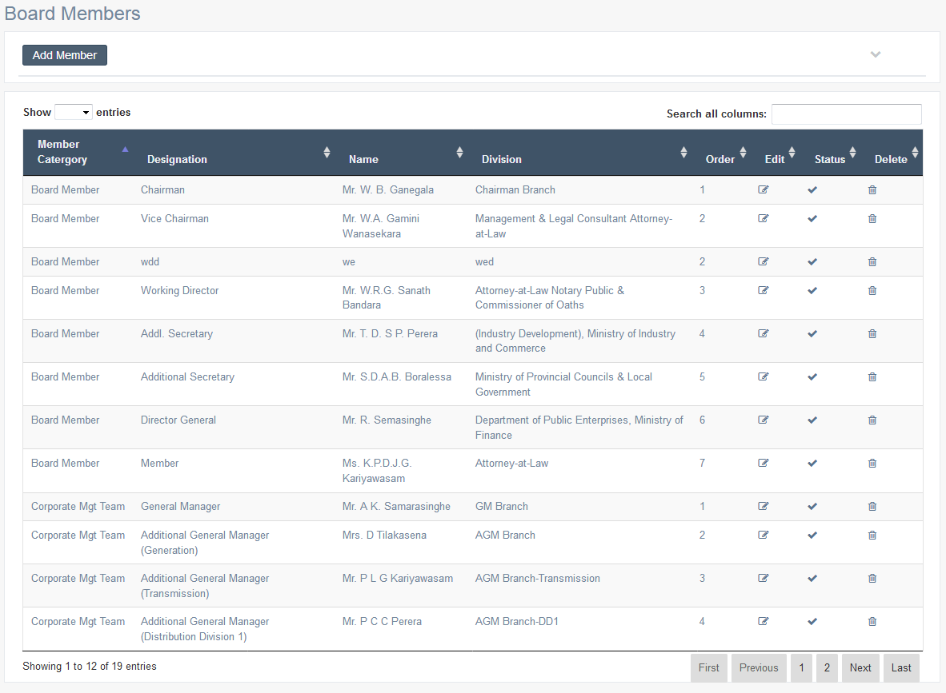

Criteria | Satisfied | Unsatisfied
Accuracy and Order of text fields

Readability and Understandability of
the content

Overall appearance of the form

Accepted by
Name : ……………………… Signature: ………………….. Date: ……………

User Acceptance Testing – Acceptance Sign-Off Form
  - User : Admin
  - From Name : Board Members – Add Details

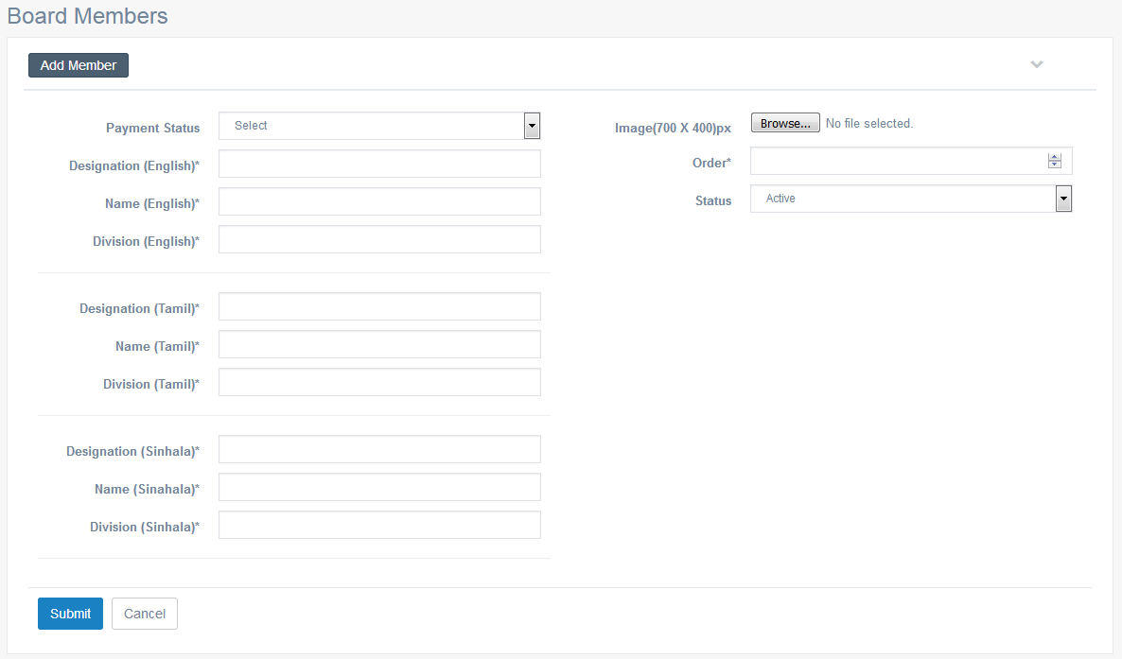

Criteria | Satisfied | Unsatisfied
Accuracy and Order of text fields

Readability and Understandability of
the content

Overall appearance of the form

Accepted by
Name : ……………………… Signature: ………………….. Date: ……………

User Acceptance Testing – Acceptance Sign-Off Form
  - User : Admin
  - From Name : Board Members – Edit details

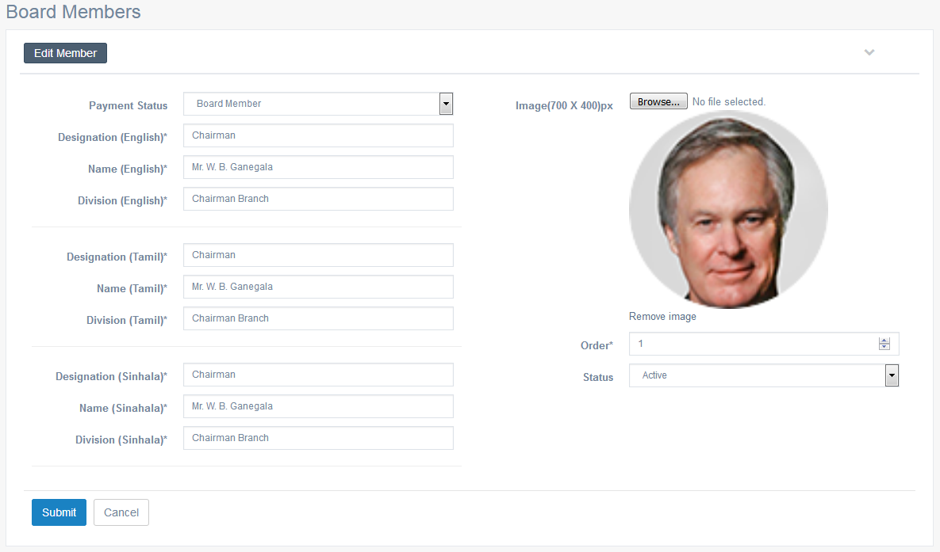

Criteria | Satisfied | Unsatisfied
Accuracy and Order of text fields

Readability and Understandability of
the content

Overall appearance of the form

Accepted by
Name : ……………………… Signature: ………………….. Date: ……………

User Acceptance Testing – Acceptance Sign-Off Form
  - User : Admin
  - From Name : Responsibility
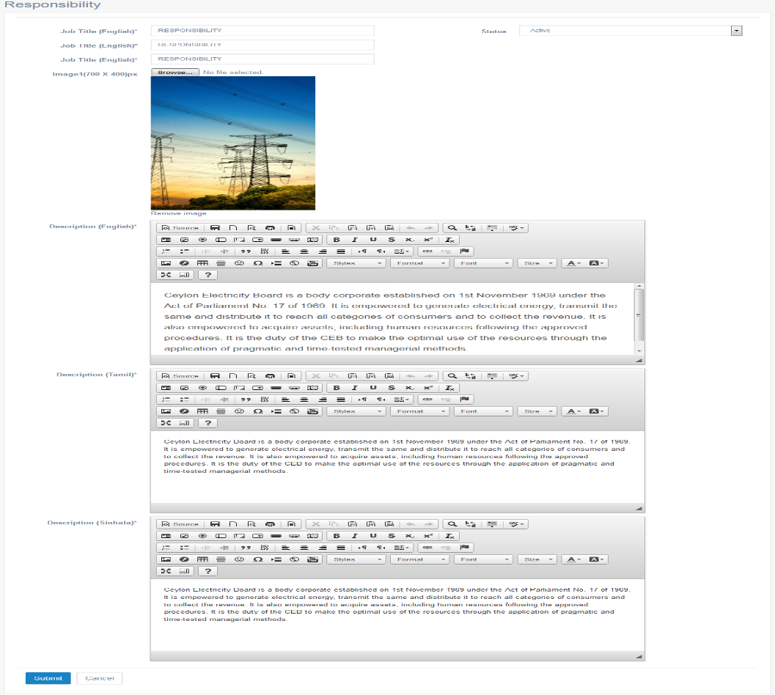

Criteria | Satisfied | Unsatisfied
Accuracy and Order of text fields

Readability and Understandability of
the content

Overall appearance of the form

Accepted by
Name : ……………………… Signature: ………………….. Date: ……………
User Acceptance Testing – Acceptance Sign-Off Form
  - User : Admin
  - From Name : Power Stations - List
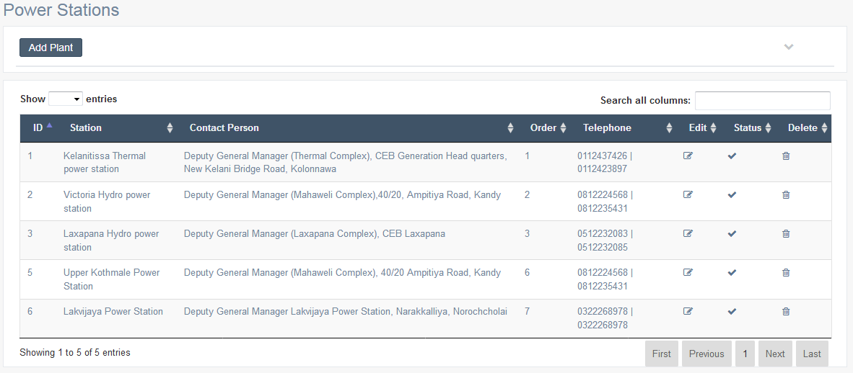

Criteria | Satisfied | Unsatisfied
Accuracy and Order of text fields

Readability and Understandability of
the content

Overall appearance of the form

Accepted by
Name : ……………………… Signature: ………………….. Date: ……………

User Acceptance Testing – Acceptance Sign-Off Form
  - User : Admin
  - From Name : Power Stations – Add details

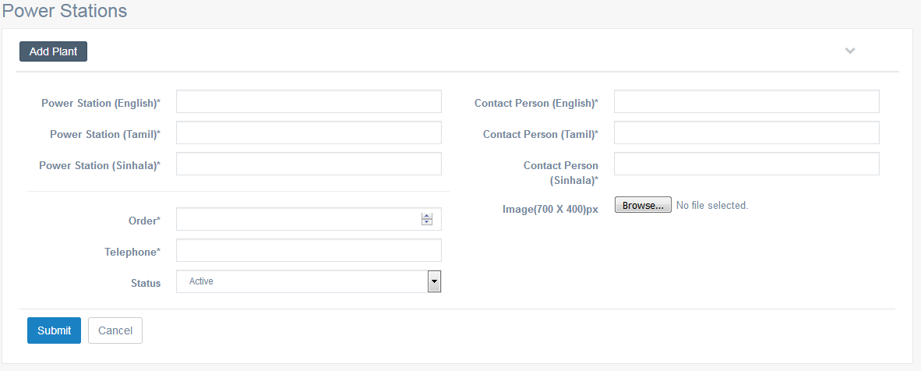

Criteria | Satisfied | Unsatisfied
Accuracy and Order of text fields

Readability and Understandability of
the content

Overall appearance of the form

Accepted by
Name : ……………………… Signature: ………………….. Date: ……………

User Acceptance Testing – Acceptance Sign-Off Form
  - User : Admin
  - From Name : Power Stations – Edit details

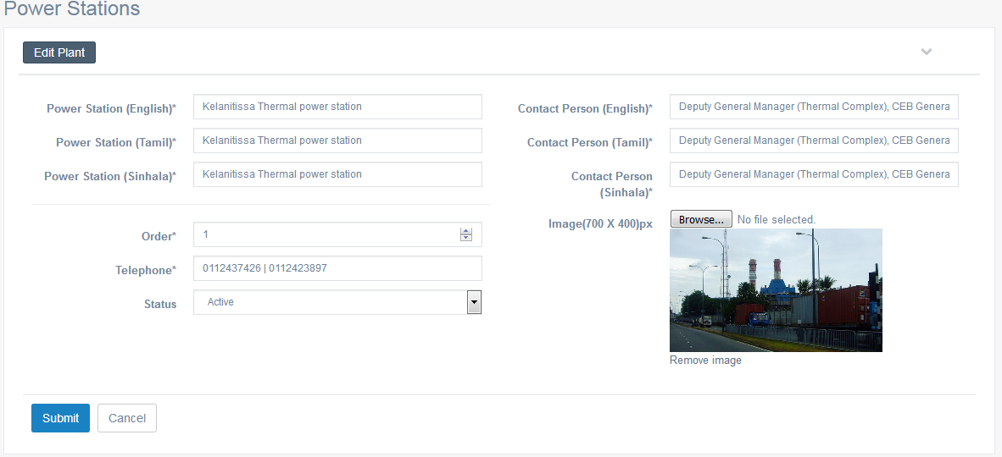

Criteria | Satisfied | Unsatisfied
Accuracy and Order of text fields

Readability and Understandability of
the content

Overall appearance of the form

Accepted by
Name : ……………………… Signature: ………………….. Date: ……………

User Acceptance Testing – Acceptance Sign-Off Form
  - User : Admin
  - From Name : How to Visit to Power Plant
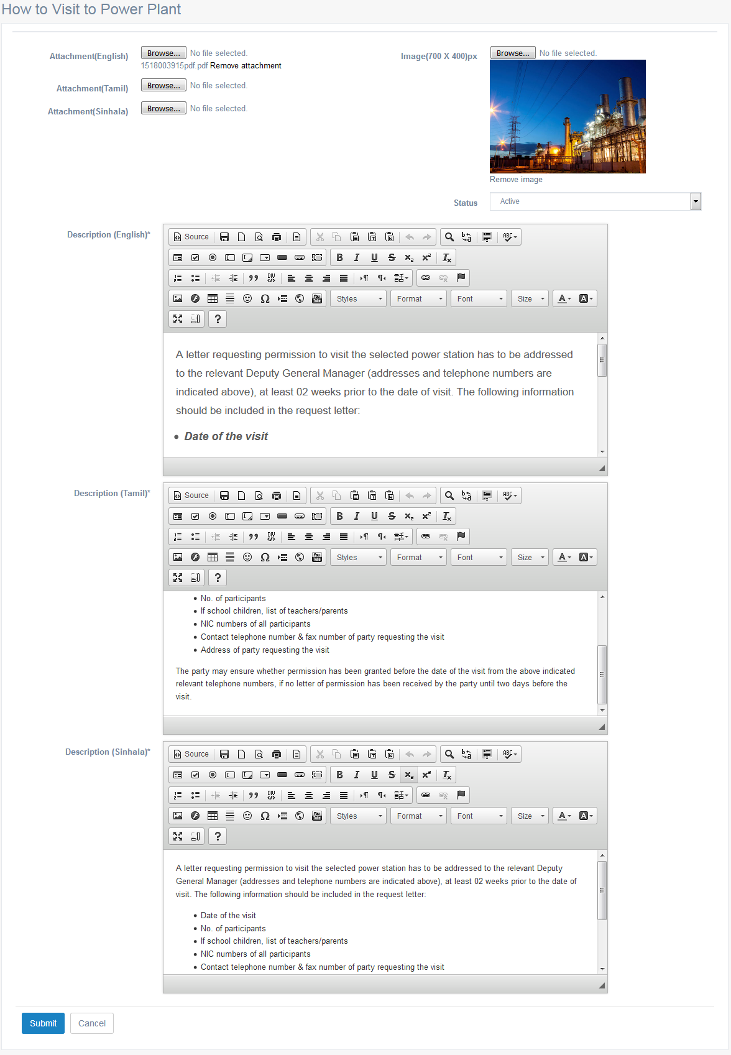

Criteria | Satisfied | Unsatisfied
Accuracy and Order of text fields

Readability and Understandability of
the content

Overall appearance of the form

Accepted by
Name : ……………………… Signature: ………………….. Date: ……………

User Acceptance Testing – Acceptance Sign-Off Form
  - User : Admin
  - From Name : Publications & Media - List

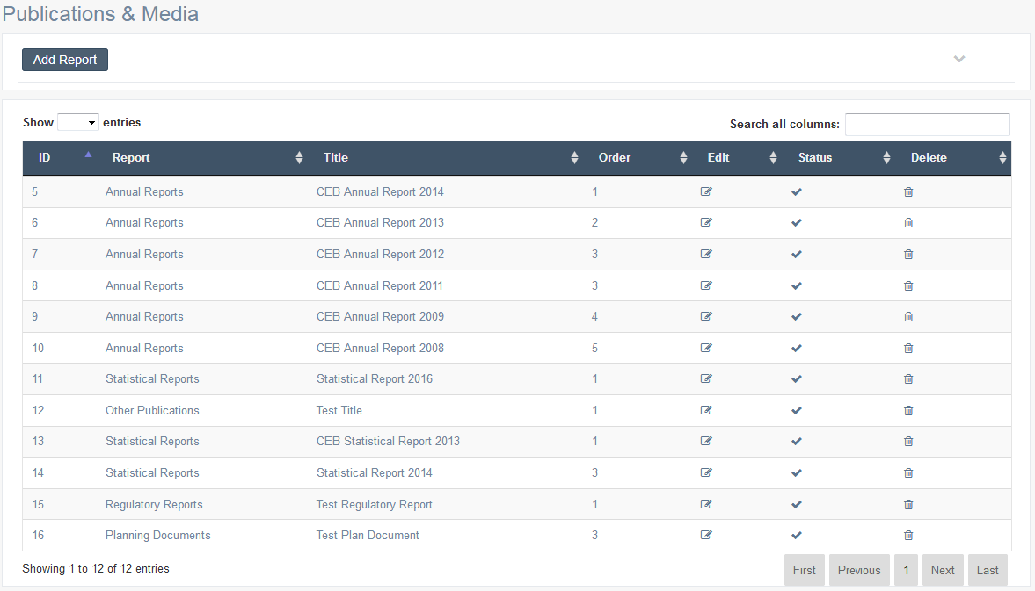

Criteria | Satisfied | Unsatisfied
Accuracy and Order of text fields

Readability and Understandability of
the content

Overall appearance of the form

Accepted by
Name : ……………………… Signature: ………………….. Date: ……………

User Acceptance Testing – Acceptance Sign-Off Form
  - User : Admin
  - From Name : Publications & Media – Add Details

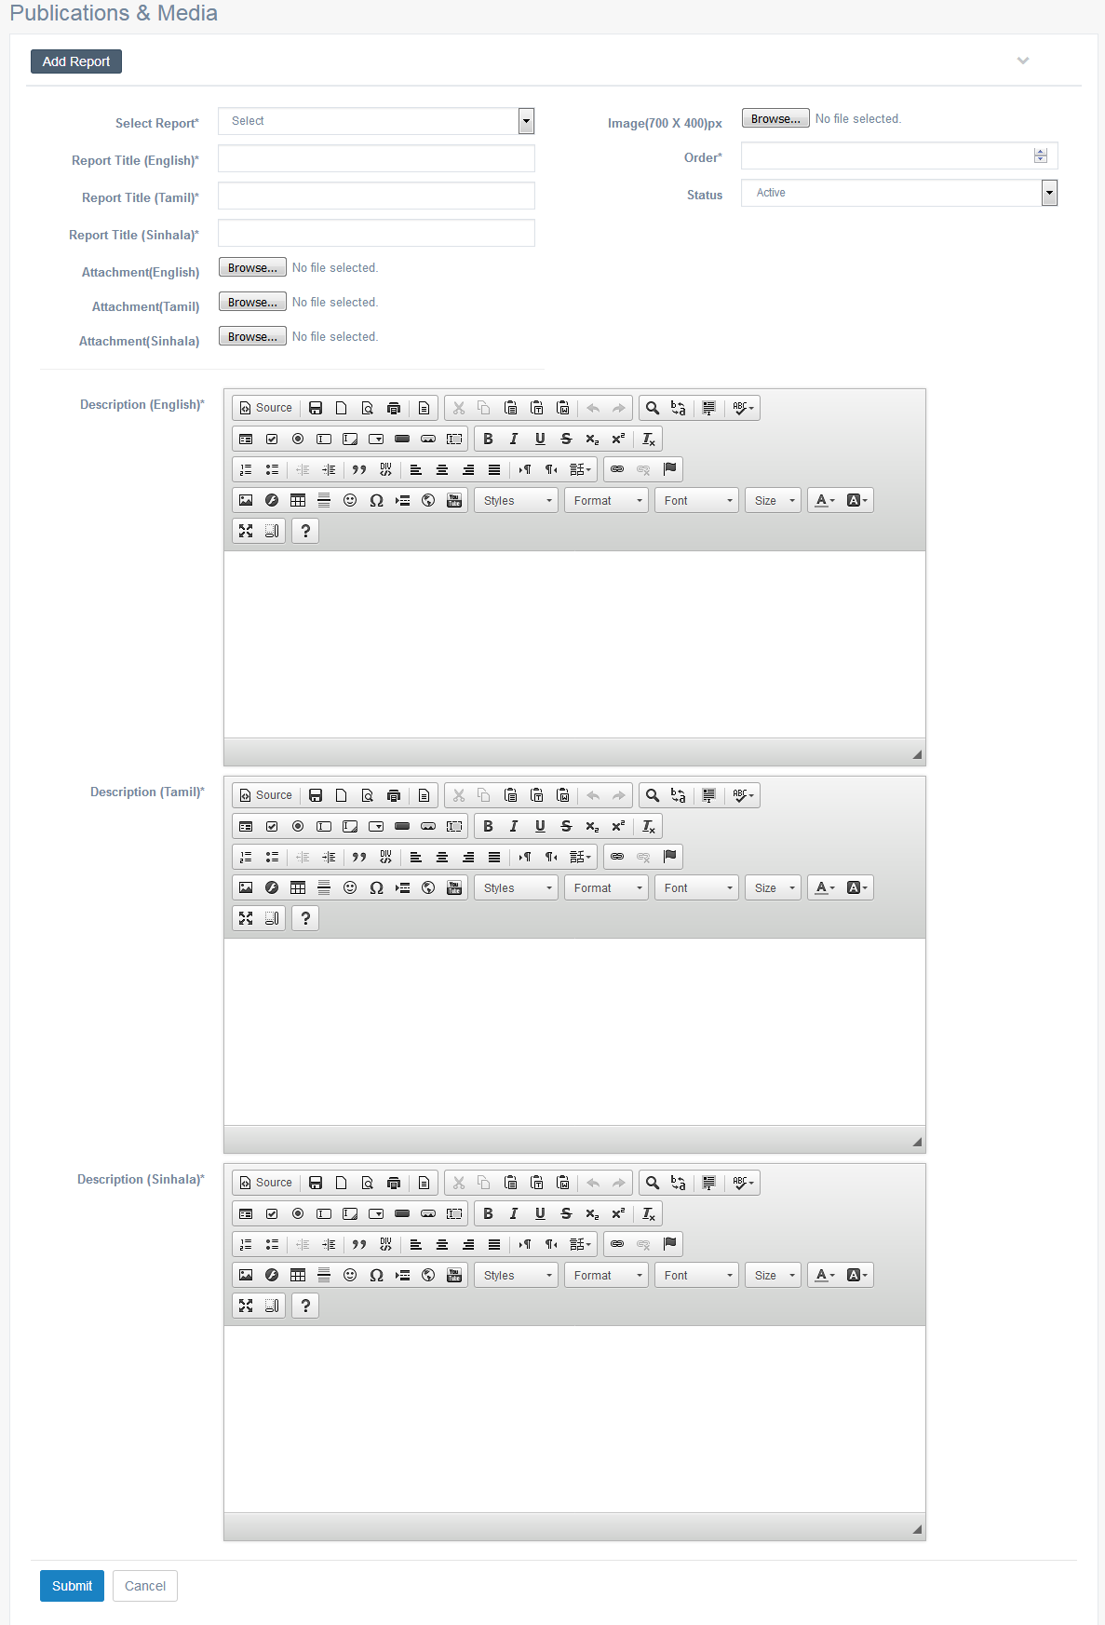

Criteria | Satisfied | Unsatisfied
Accuracy and Order of text fields

Readability and Understandability of
the content

Overall appearance of the form

Accepted by
Name : ……………………… Signature: ………………….. Date: ……………

User Acceptance Testing – Acceptance Sign-Off Form
  - User : Admin
  - From Name : Publications & Media – Edit Details

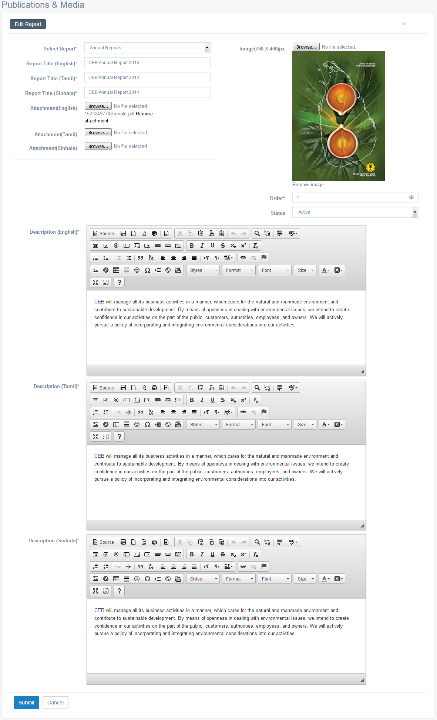

Criteria | Satisfied | Unsatisfied
Accuracy and Order of text fields

Readability and Understandability of
the content

Overall appearance of the form

Accepted by
Name : ……………………… Signature: ………………….. Date: ……………

User Acceptance Testing – Acceptance Sign-Off Form
  - User : Admin
  - From Name : Careers - LIst

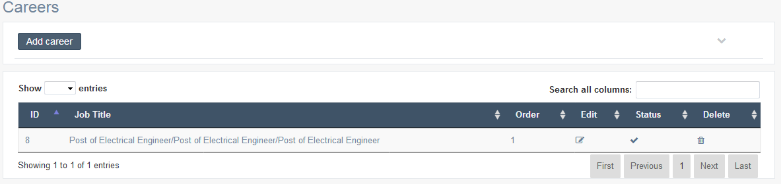

Criteria | Satisfied | Unsatisfied
Accuracy and Order of text fields

Readability and Understandability of
the content

Overall appearance of the form

Accepted by
Name : ……………………… Signature: ………………….. Date: ……………

User Acceptance Testing – Acceptance Sign-Off Form
  - User : Admin
  - From Name : Careers – Add Details

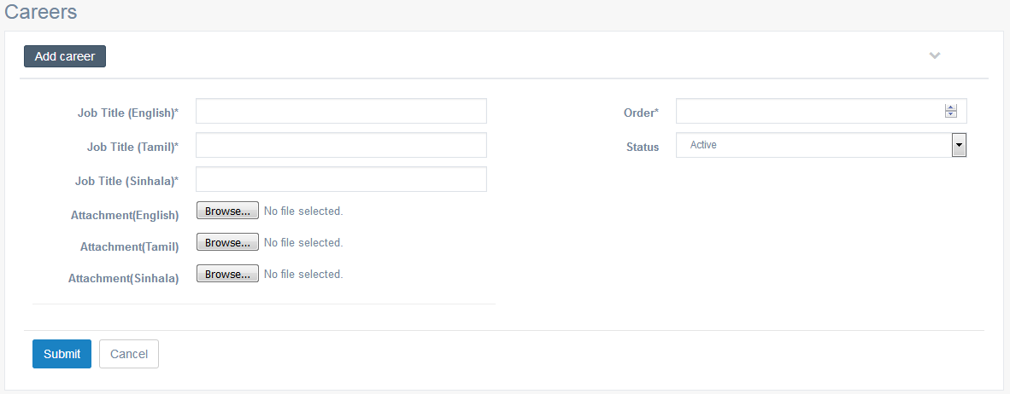

Criteria | Satisfied | Unsatisfied
Accuracy and Order of text fields

Readability and Understandability of
the content

Overall appearance of the form

Accepted by
Name : ……………………… Signature: ………………….. Date: ……………

User Acceptance Testing – Acceptance Sign-Off Form
  - User : Admin
  - From Name : Careers – Edit Details

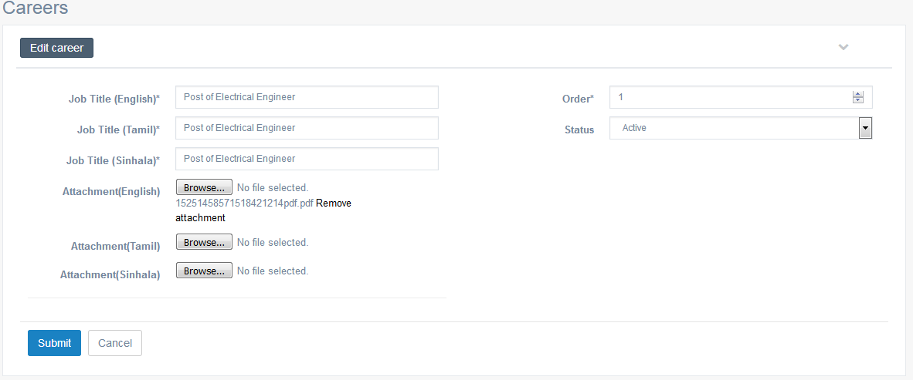

Criteria | Satisfied | Unsatisfied
Accuracy and Order of text fields

Readability and Understandability of
the content

Overall appearance of the form

Accepted by
Name : ……………………… Signature: ………………….. Date: ……………

User Acceptance Testing – Acceptance Sign-Off Form
  - User : Admin
  - From Name : Specification Category – List

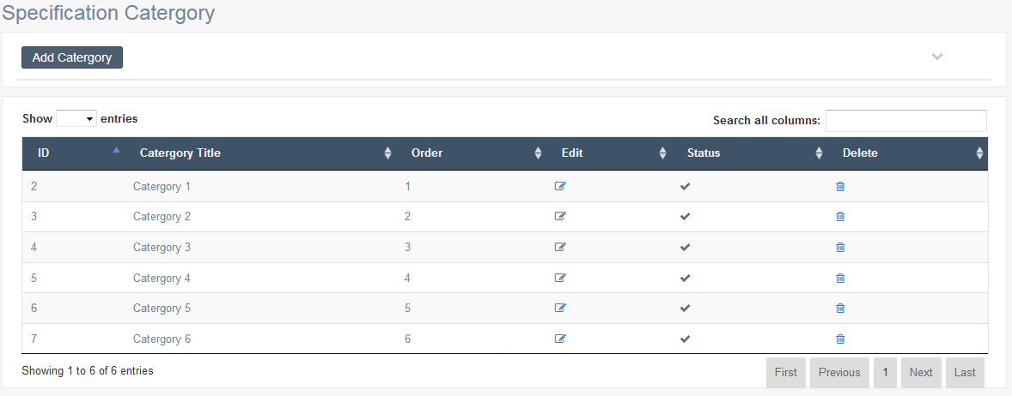

Criteria | Satisfied | Unsatisfied
Accuracy and Order of text fields

Readability and Understandability of
the content

Overall appearance of the form

Accepted by
Name : ……………………… Signature: ………………….. Date: ……………

User Acceptance Testing – Acceptance Sign-Off Form
  - User : Admin
  - From Name : Specification Category – Add Details

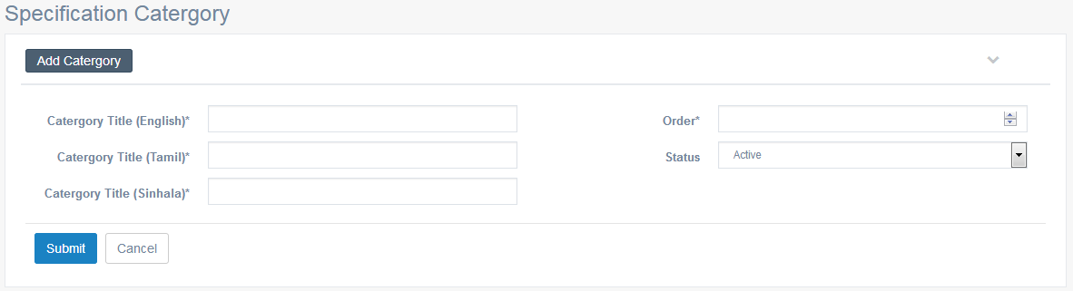

Criteria | Satisfied | Unsatisfied
Accuracy and Order of text fields

Readability and Understandability of
the content

Overall appearance of the form

Accepted by
Name : ……………………… Signature: ………………….. Date: ……………

User Acceptance Testing – Acceptance Sign-Off Form
  - User : Admin
  - From Name : Specification Category – Edit Details

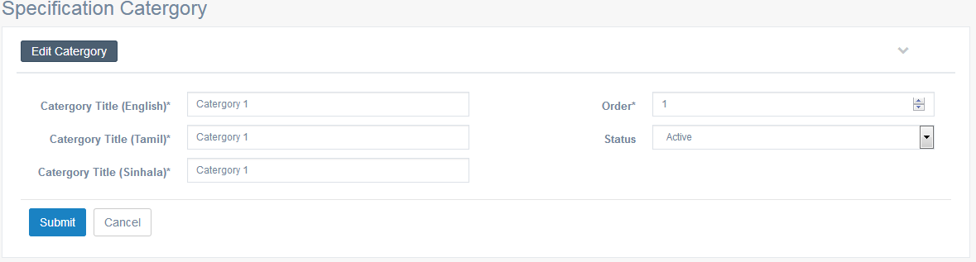

Criteria | Satisfied | Unsatisfied
Accuracy and Order of text fields

Readability and Understandability of
the content

Overall appearance of the form

Accepted by
Name : ……………………… Signature: ………………….. Date: ……………

User Acceptance Testing – Acceptance Sign-Off Form
  - User : Admin
  - From Name : Standard Specifications – List

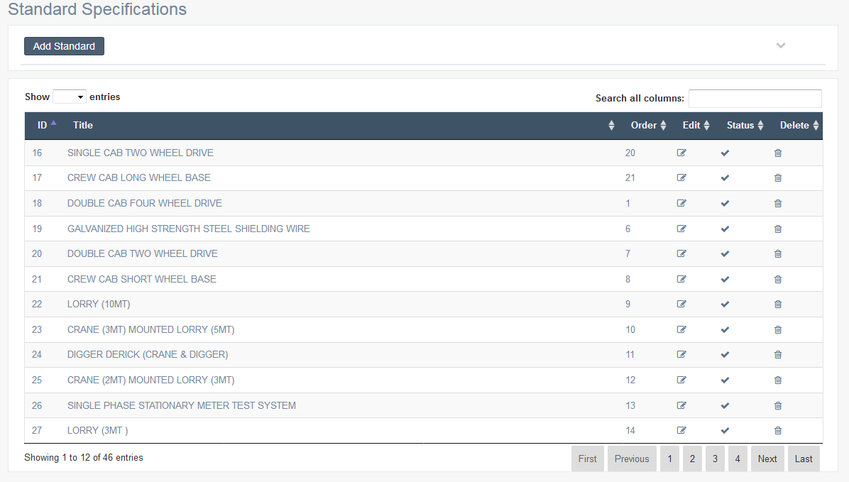

Criteria | Satisfied | Unsatisfied
Accuracy and Order of text fields

Readability and Understandability of
the content

Overall appearance of the form

Accepted by
Name : ……………………… Signature: ………………….. Date: ……………

User Acceptance Testing – Acceptance Sign-Off Form
  - User : Admin
  - From Name : Standard Specifications – Add Details
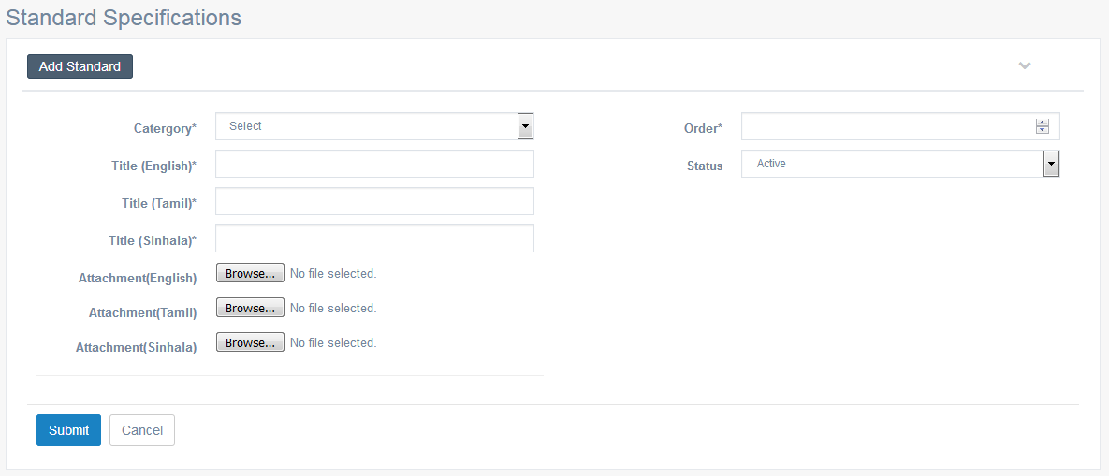

Criteria | Satisfied | Unsatisfied
Accuracy and Order of text fields

Readability and Understandability of
the content

Overall appearance of the form

Accepted by
Name : ……………………… Signature: ………………….. Date: ……………

User Acceptance Testing – Acceptance Sign-Off Form
  - User : Admin
  - From Name : Standard Specifications – Edit Details
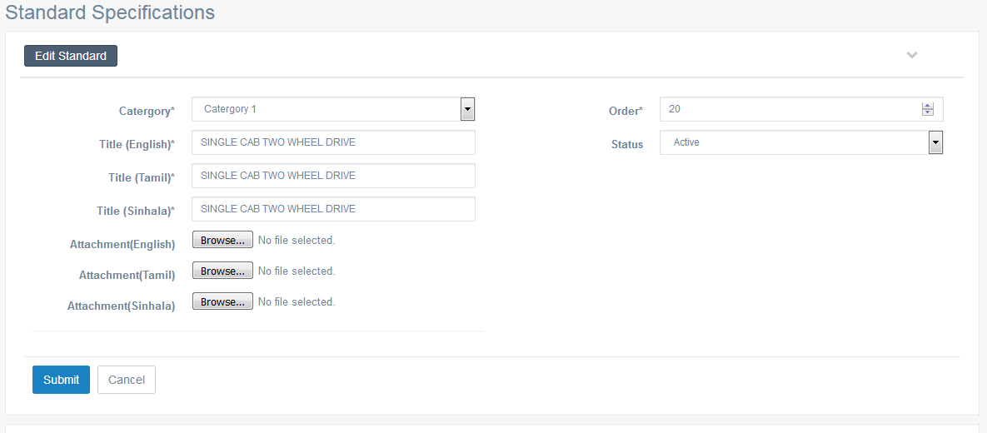

Criteria | Satisfied | Unsatisfied
Accuracy and Order of text fields

Readability and Understandability of
the content

Overall appearance of the form

Accepted by
Name : ……………………… Signature: ………………….. Date: ……………

User Acceptance Testing – Acceptance Sign-Off Form
  - User : Admin
  - From Name : Tender Awards - List
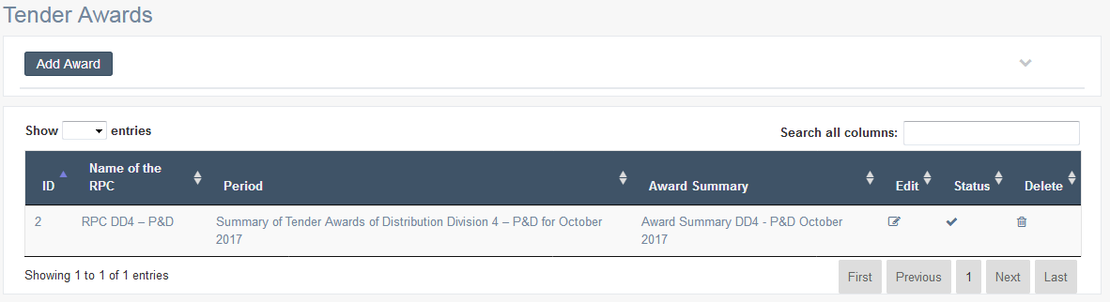

Criteria | Satisfied | Unsatisfied
Accuracy and Order of text fields

Readability and Understandability of
the content

Overall appearance of the form

Accepted by
Name : ……………………… Signature: ………………….. Date: ……………

User Acceptance Testing – Acceptance Sign-Off Form
  - User : Admin
  - From Name : Tender Awards – Add Details

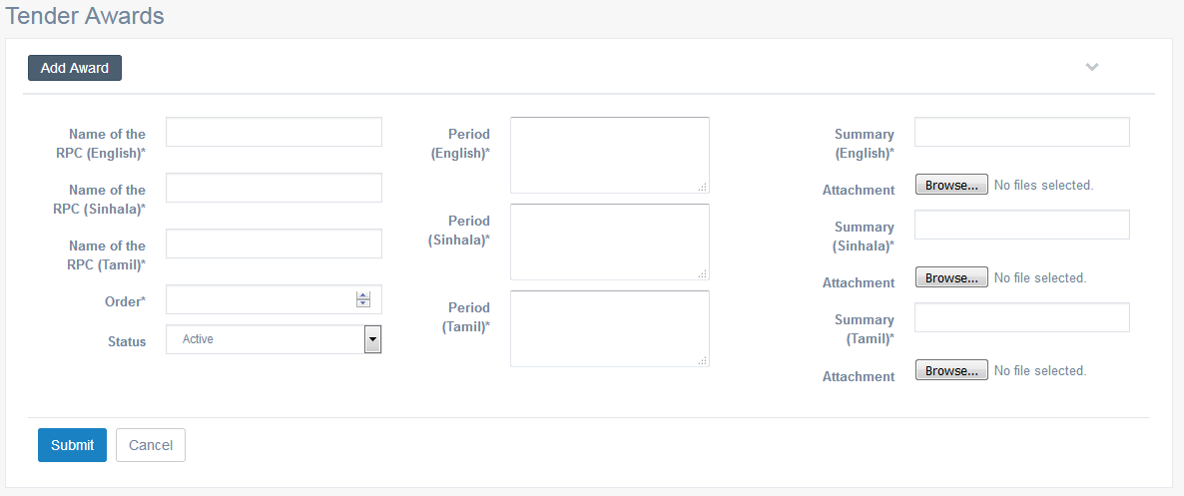

Criteria | Satisfied | Unsatisfied
Accuracy and Order of text fields

Readability and Understandability of
the content

Overall appearance of the form

Accepted by
Name : ……………………… Signature: ………………….. Date: ……………

User Acceptance Testing – Acceptance Sign-Off Form
  - User : Admin
  - From Name : Tender Awards – Edit Details

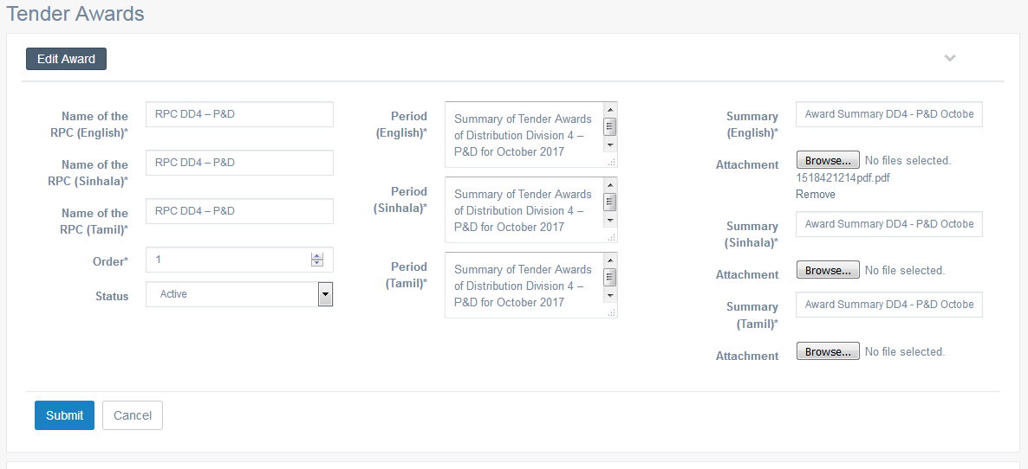

Criteria | Satisfied | Unsatisfied
Accuracy and Order of text fields

Readability and Understandability of
the content

Overall appearance of the form

Accepted by
Name : ……………………… Signature: ………………….. Date: ……………

User Acceptance Testing – Acceptance Sign-Off Form
  - User : Admin
  - From Name : Tender Notices – List

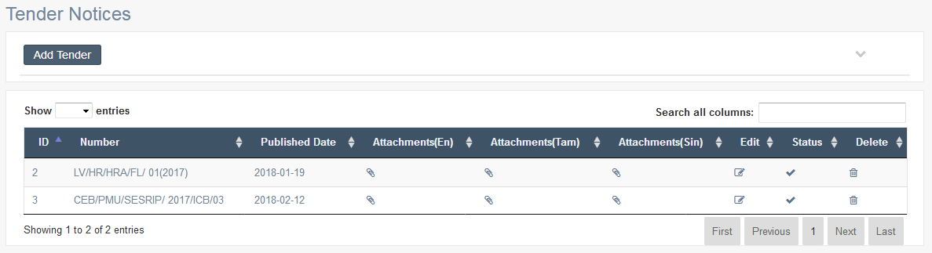

Criteria | Satisfied | Unsatisfied
Accuracy and Order of text fields

Readability and Understandability of
the content

Overall appearance of the form

Accepted by
Name : ……………………… Signature: ………………….. Date: ……………

User Acceptance Testing – Acceptance Sign-Off Form
  - User : Admin
  - From Name : Tender Notices – Add Details

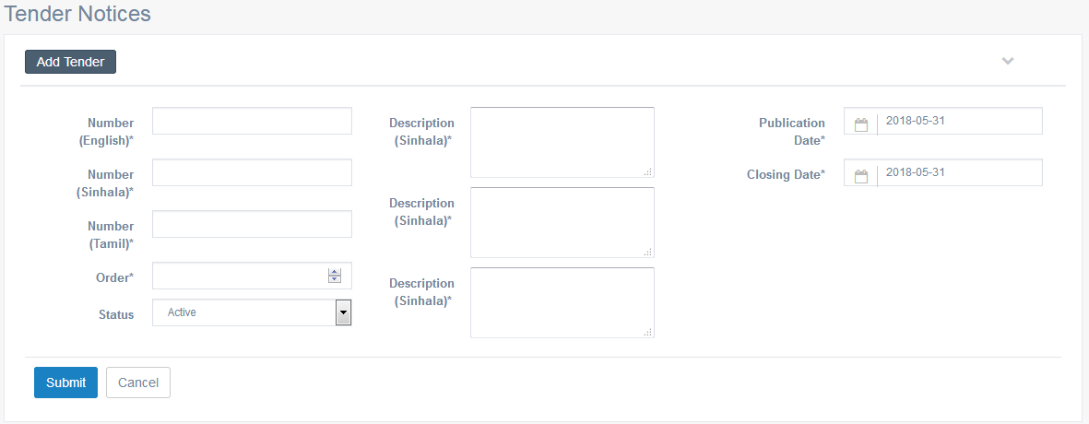

Criteria | Satisfied | Unsatisfied
Accuracy and Order of text fields

Readability and Understandability of
the content

Overall appearance of the form

Accepted by
Name : ……………………… Signature: ………………….. Date: ……………

User Acceptance Testing – Acceptance Sign-Off Form
  - User : Admin
  - From Name : Tender Notices – Edit Details

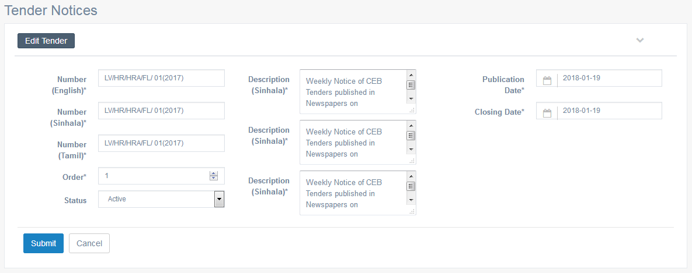

Criteria | Satisfied | Unsatisfied
Accuracy and Order of text fields

Readability and Understandability of
the content

Overall appearance of the form

Accepted by
Name : ……………………… Signature: ………………….. Date: ……………

User Acceptance Testing – Acceptance Sign-Off Form
  - User : Admin
  - From Name : Tender Notices – Attachments (En) List

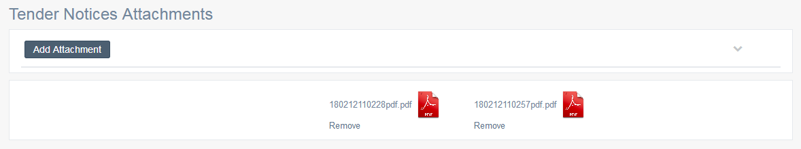

Criteria | Satisfied | Unsatisfied
Accuracy and Order of text fields

Readability and Understandability of
the content

Overall appearance of the form

Accepted by
Name : ……………………… Signature: ………………….. Date: ……………

User Acceptance Testing – Acceptance Sign-Off Form
  - User : Admin
  - From Name : Tender Notices – Add Attachments (En)

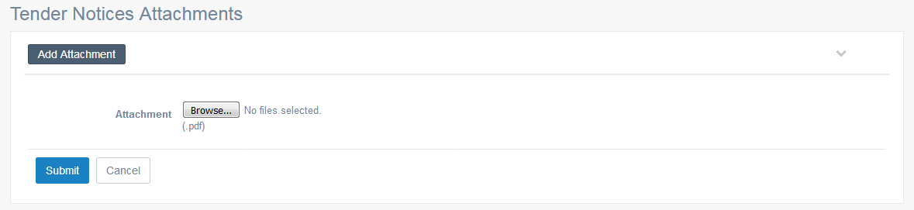

Criteria | Satisfied | Unsatisfied
Accuracy and Order of text fields

Readability and Understandability of
the content

Overall appearance of the form

Accepted by
Name : ……………………… Signature: ………………….. Date: ……………

User Acceptance Testing – Acceptance Sign-Off Form
  - User : Admin
  - From Name : Tender Notices – Attachments (Si) List

Criteria | Satisfied | Unsatisfied
Accuracy and Order of text fields

Readability and Understandability of
the content

Overall appearance of the form

Accepted by
Name : ……………………… Signature: ………………….. Date: ……………

User Acceptance Testing – Acceptance Sign-Off Form
  - User : Admin
  - From Name : Tender Notices – Add Attachments (Si)

Criteria | Satisfied | Unsatisfied
Accuracy and Order of text fields

Readability and Understandability of
the content

Overall appearance of the form

Accepted by
Name : ……………………… Signature: ………………….. Date: ……………

User Acceptance Testing – Acceptance Sign-Off Form
  - User : Admin
  - From Name : Tender Notices – Attachments (Ta) List

Criteria | Satisfied | Unsatisfied
Accuracy and Order of text fields

Readability and Understandability of
the content

Overall appearance of the form

Accepted by
Name : ……………………… Signature: ………………….. Date: ……………

User Acceptance Testing – Acceptance Sign-Off Form
  - User : Admin
  - From Name : Tender Notices – Add Attachments (Ta)

Criteria | Satisfied | Unsatisfied
Accuracy and Order of text fields

Readability and Understandability of
the content

Overall appearance of the form

Accepted by
Name : ……………………… Signature: ………………….. Date: ……………

User Acceptance Testing – Acceptance Sign-Off Form
  - User : Admin
  - From Name : FAQ Category – List

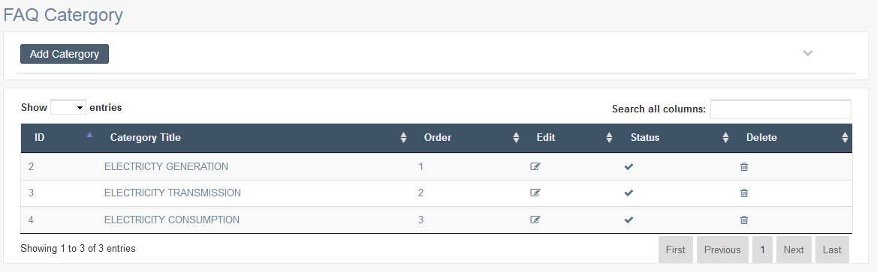

Criteria | Satisfied | Unsatisfied
Accuracy and Order of text fields

Readability and Understandability of
the content

Overall appearance of the form

Accepted by
Name : ……………………… Signature: ………………….. Date: ……………

User Acceptance Testing – Acceptance Sign-Off Form
  - User : Admin
  - From Name : FAQ Category – Add Details

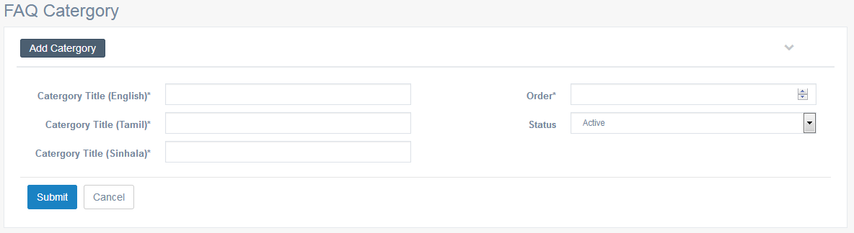

Criteria | Satisfied | Unsatisfied
Accuracy and Order of text fields

Readability and Understandability of
the content

Overall appearance of the form

Accepted by
Name : ……………………… Signature: ………………….. Date: ……………

User Acceptance Testing – Acceptance Sign-Off Form
  - User : Admin
  - From Name : FAQ Category – Edit Details

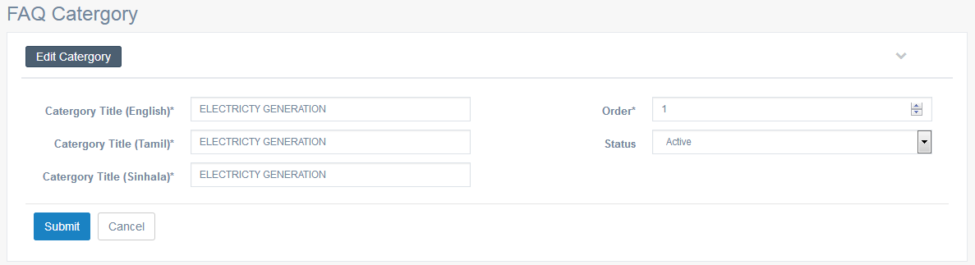

Criteria | Satisfied | Unsatisfied
Accuracy and Order of text fields

Readability and Understandability of
the content

Overall appearance of the form

Accepted by
Name : ……………………… Signature: ………………….. Date: ……………

User Acceptance Testing – Acceptance Sign-Off Form
  - User : Admin
  - From Name : Frequently Ask Questions – List

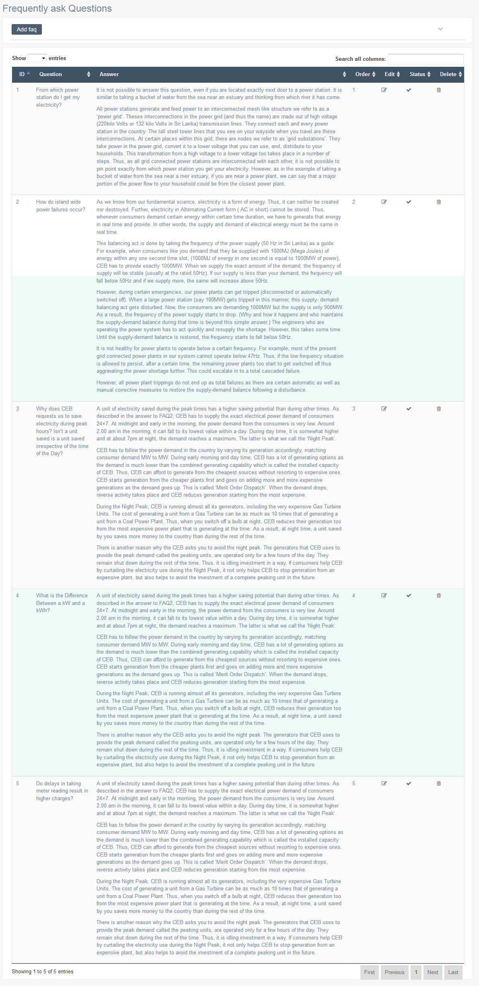

Criteria | Satisfied | Unsatisfied
Accuracy and Order of text fields

Readability and Understandability of
the content

Overall appearance of the form

Accepted by
Name : ……………………… Signature: ………………….. Date: ……………

User Acceptance Testing – Acceptance Sign-Off Form
  - User : Admin
  - From Name : Frequently Ask Questions – Add Details
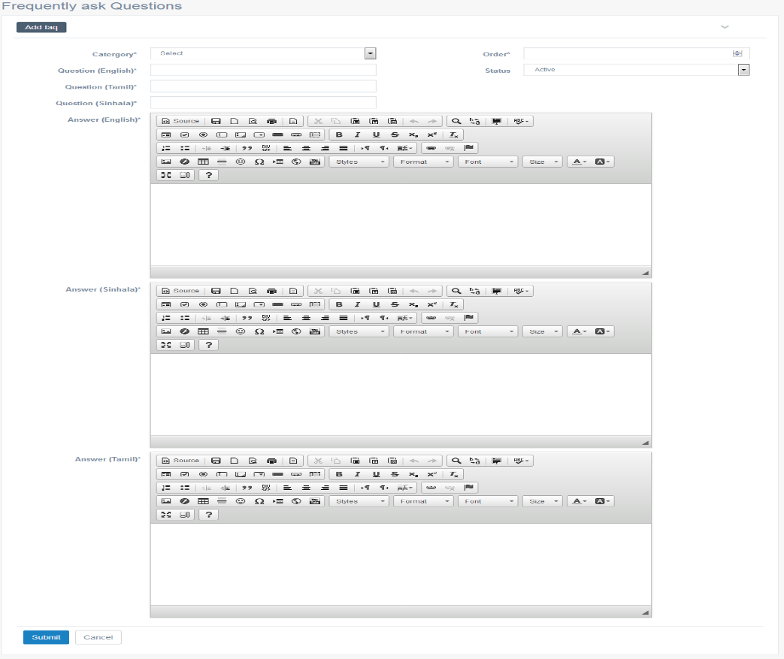

Criteria | Satisfied | Unsatisfied
Accuracy and Order of text fields

Readability and Understandability of
the content

Overall appearance of the form

Accepted by
Name : ……………………… Signature: ………………….. Date: ……………

User Acceptance Testing – Acceptance Sign-Off Form
  - User : Admin
  - From Name : Frequently Ask Questions – Edit Details

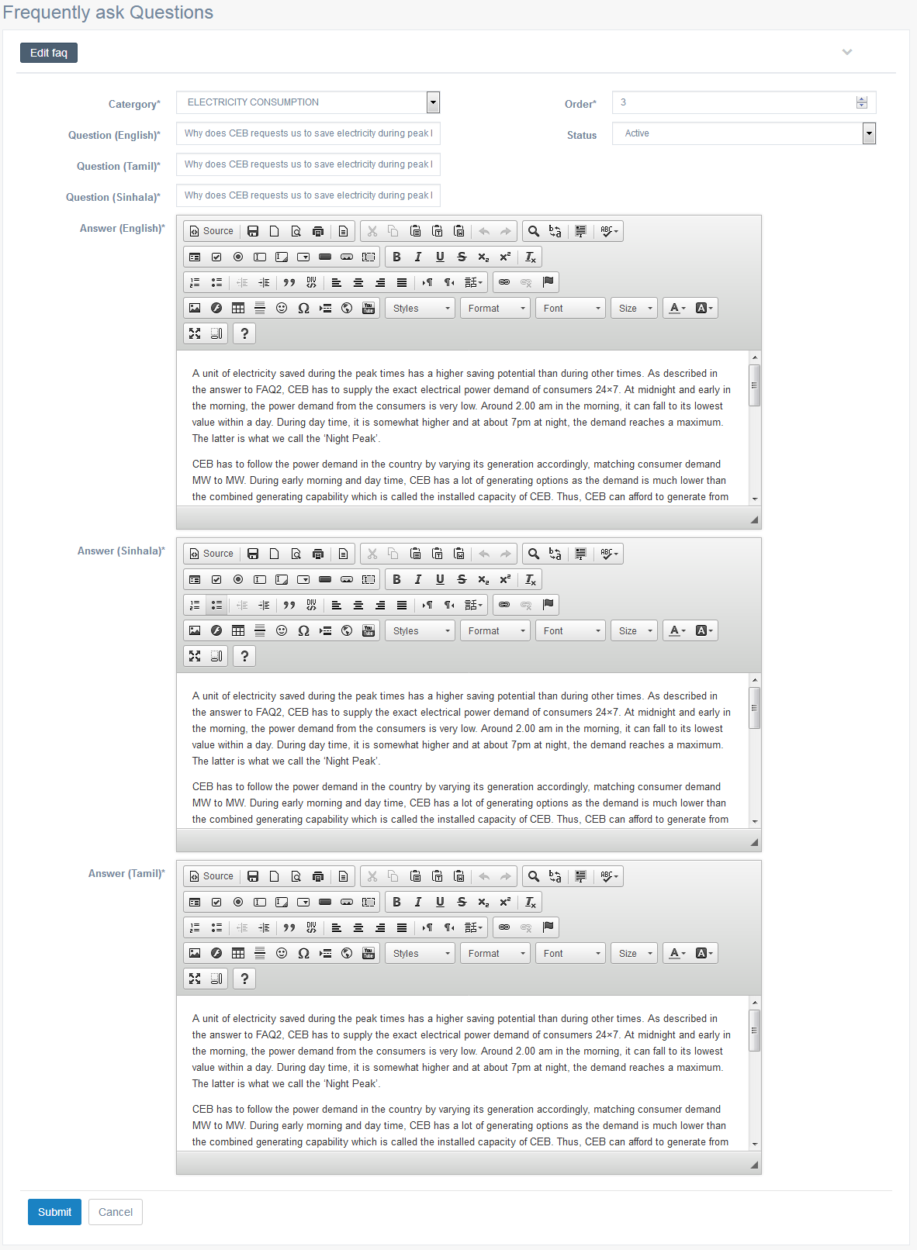

Criteria | Satisfied | Unsatisfied
Accuracy and Order of text fields

Readability and Understandability of
the content

Overall appearance of the form

Accepted by
Name : ……………………… Signature: ………………….. Date: ……………

User Acceptance Testing – Acceptance Sign-Off Form
  - User : Admin
  - From Name : Social Work – List

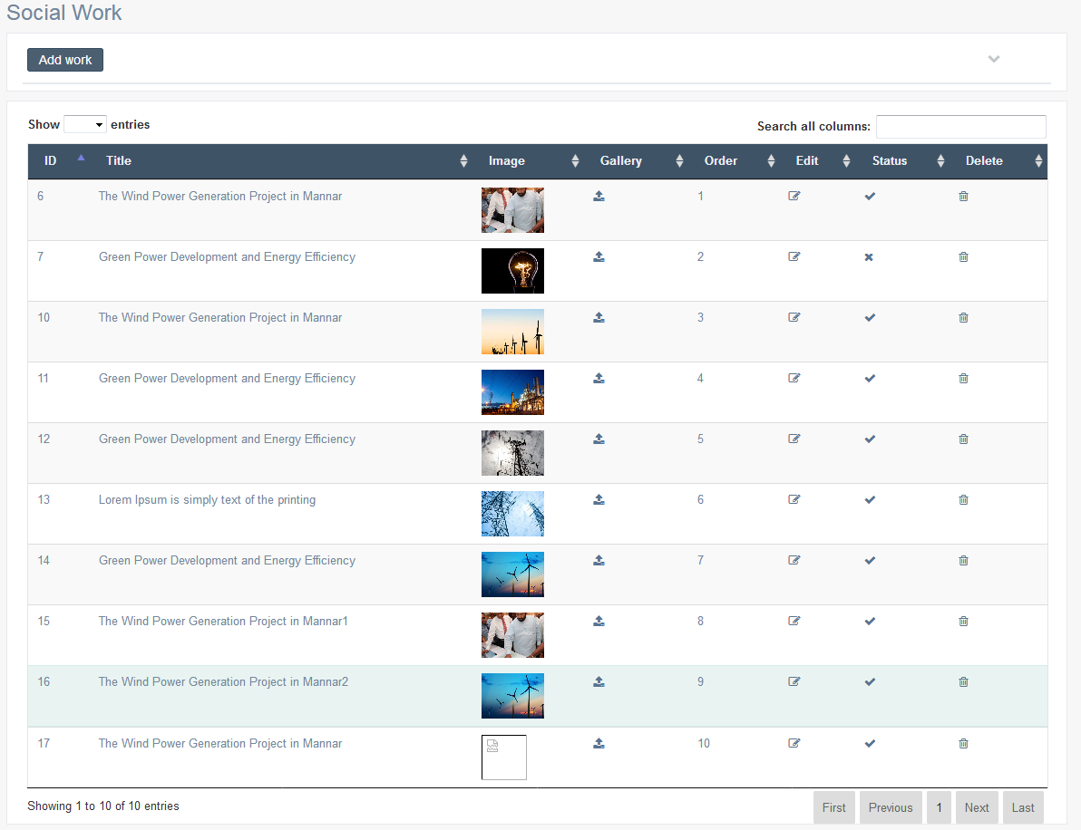

Criteria | Satisfied | Unsatisfied
Accuracy and Order of text fields

Readability and Understandability of
the content

Overall appearance of the form

Accepted by
Name : ……………………… Signature: ………………….. Date: ……………

User Acceptance Testing – Acceptance Sign-Off Form
  - User : Admin
  - From Name : Social Work – Add Details

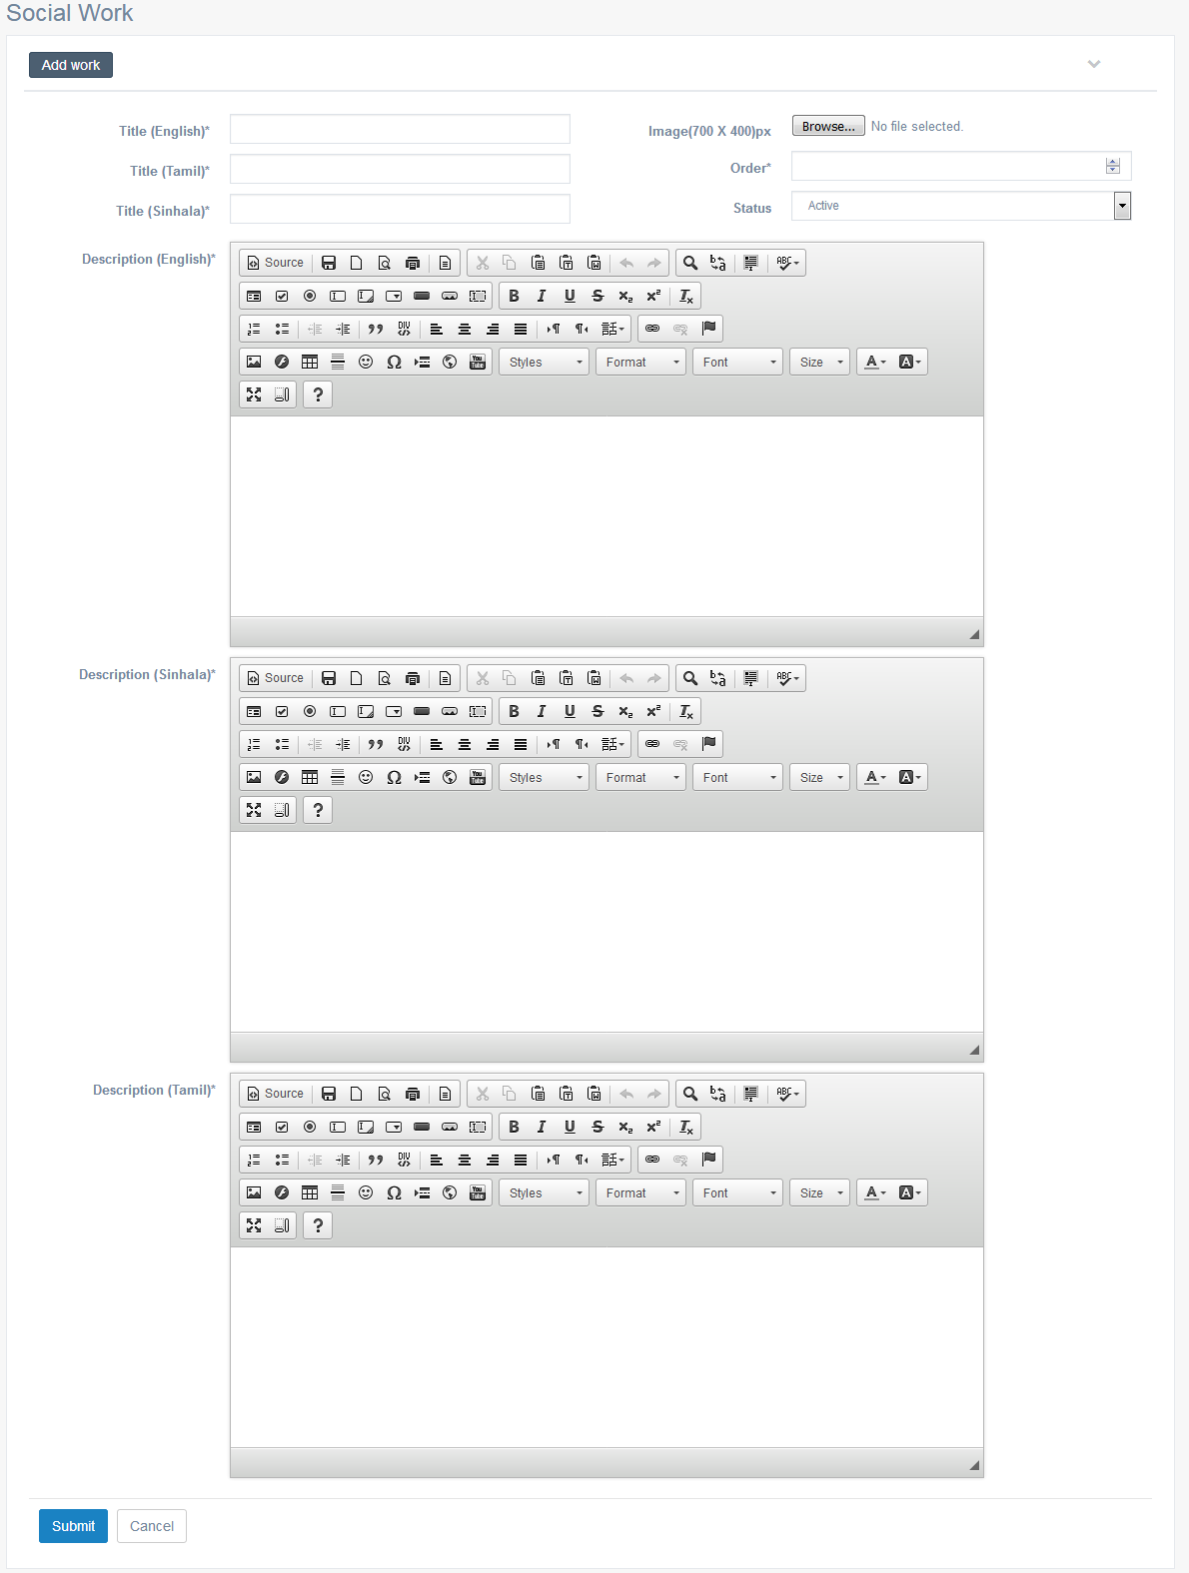

Criteria | Satisfied | Unsatisfied
Accuracy and Order of text fields

Readability and Understandability of
the content

Overall appearance of the form

Accepted by
Name : ……………………… Signature: ………………….. Date: ……………

User Acceptance Testing – Acceptance Sign-Off Form
  - User : Admin
  - From Name : Social Work – Edit Details

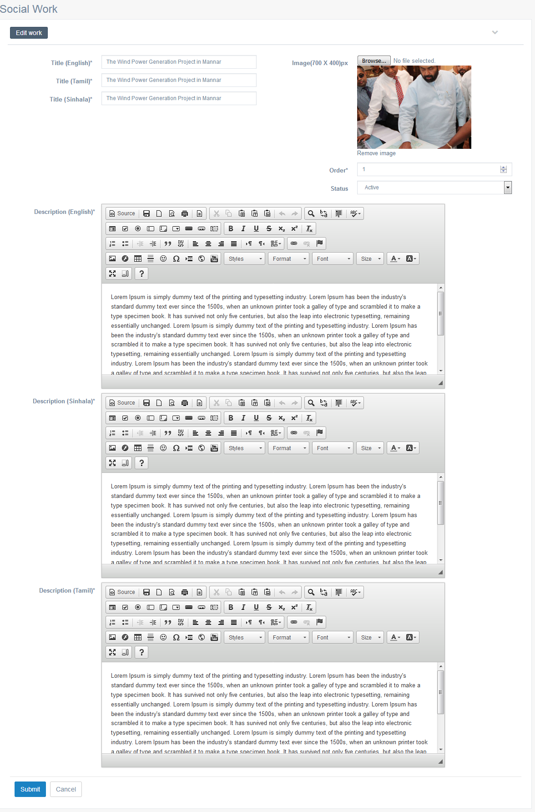

Criteria | Satisfied | Unsatisfied
Accuracy and Order of text fields

Readability and Understandability of
the content

Overall appearance of the form

Accepted by
Name : ……………………… Signature: ………………….. Date: ……………

User Acceptance Testing – Acceptance Sign-Off Form
  - User : Admin
  - From Name : Social Work – Gallery

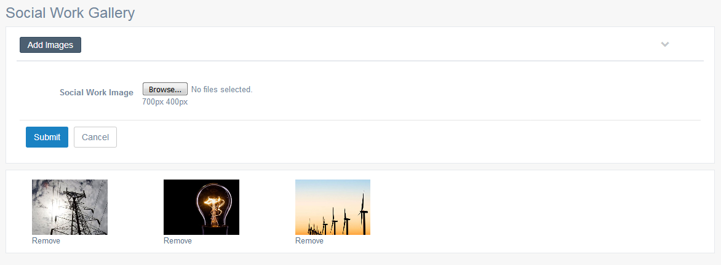

Criteria | Satisfied | Unsatisfied
Accuracy and Order of text fields

Readability and Understandability of
the content

Overall appearance of the form

Accepted by
Name : ……………………… Signature: ………………….. Date: ……………

User Acceptance Testing – Acceptance Sign-Off Form
  - User : Admin
  - From Name : What is NCRC
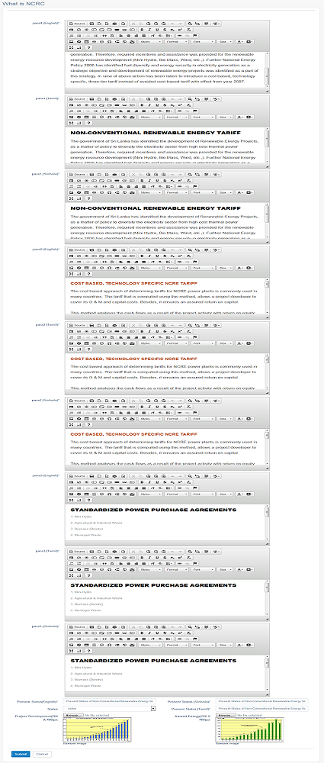

Criteria | Satisfied | Unsatisfied
Accuracy and Order of text fields

Readability and Understandability of
the content

Overall appearance of the form

Accepted by
Name : ……………………… Signature: ………………….. Date: ……………

User Acceptance Testing – Acceptance Sign-Off Form
  - User : Admin
  - From Name : Conventional Renewable Energy Sector - List

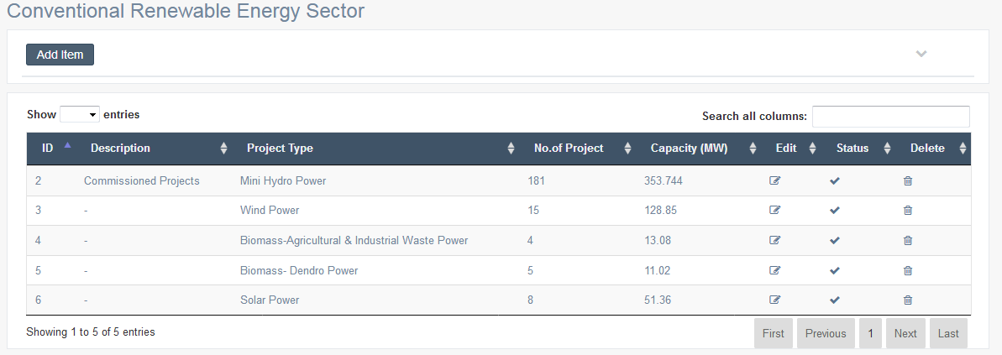

Criteria | Satisfied | Unsatisfied
Accuracy and Order of text fields

Readability and Understandability of
the content

Overall appearance of the form

Accepted by
Name : ……………………… Signature: ………………….. Date: ……………

User Acceptance Testing – Acceptance Sign-Off Form
  - User : Admin
  - From Name : Conventional Renewable Energy Sector – Add Details
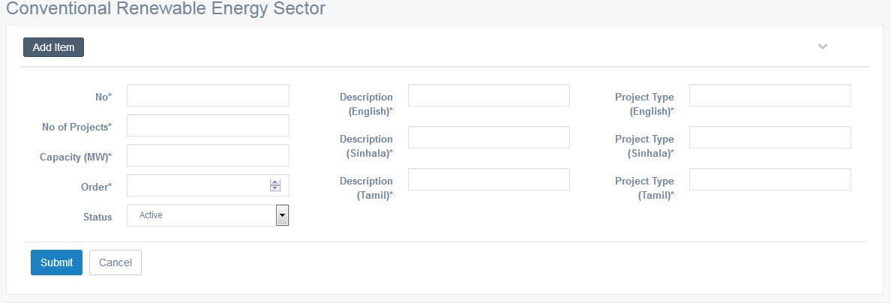

Criteria | Satisfied | Unsatisfied
Accuracy and Order of text fields

Readability and Understandability of
the content

Overall appearance of the form

Accepted by
Name : ……………………… Signature: ………………….. Date: ……………

User Acceptance Testing – Acceptance Sign-Off Form
  - User : Admin
  - From Name : Conventional Renewable Energy Sector – Edit Details
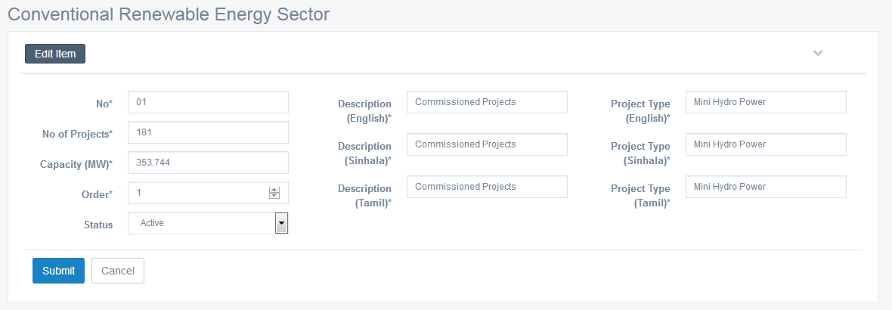

Criteria | Satisfied | Unsatisfied
Accuracy and Order of text fields

Readability and Understandability of
the content

Overall appearance of the form

Accepted by
Name : ……………………… Signature: ………………….. Date: ……………

User Acceptance Testing – Acceptance Sign-Off Form
  - User : Admin
  - From Name : NCRE Project Development – List
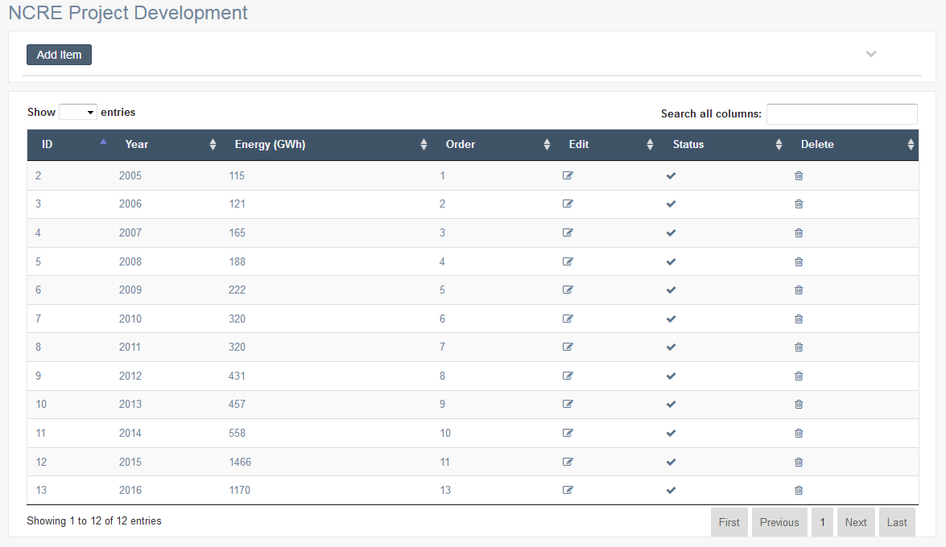

Criteria | Satisfied | Unsatisfied
Accuracy and Order of text fields

Readability and Understandability of
the content

Overall appearance of the form

Accepted by
Name : ……………………… Signature: ………………….. Date: ……………

User Acceptance Testing – Acceptance Sign-Off Form
  - User : Admin
  - From Name : NCRE Project Development – Add Details

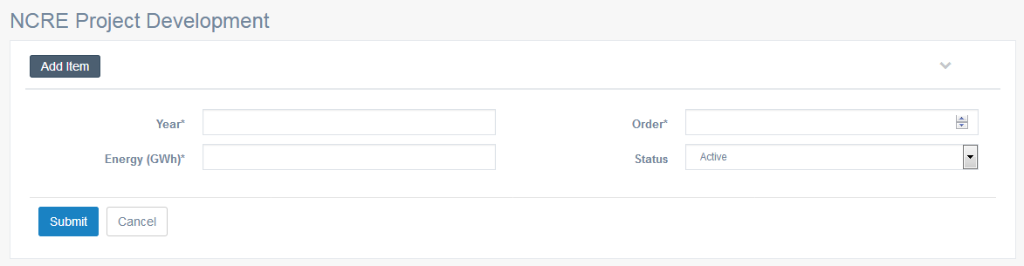

Criteria | Satisfied | Unsatisfied
Accuracy and Order of text fields

Readability and Understandability of
the content

Overall appearance of the form

Accepted by
Name : ……………………… Signature: ………………….. Date: ……………

User Acceptance Testing – Acceptance Sign-Off Form
  - User : Admin
  - From Name : NCRE Project Development – Edit Details

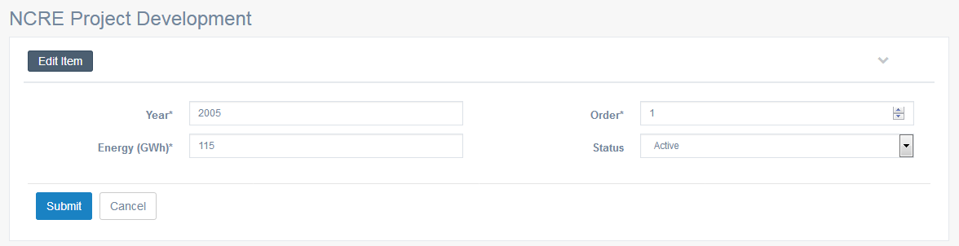

Criteria | Satisfied | Unsatisfied
Accuracy and Order of text fields

Readability and Understandability of
the content

Overall appearance of the form

Accepted by
Name : ……………………… Signature: ………………….. Date: ……………

User Acceptance Testing – Acceptance Sign-Off Form
  - User : Admin
  - From Name : Annual Energy Contribution – List

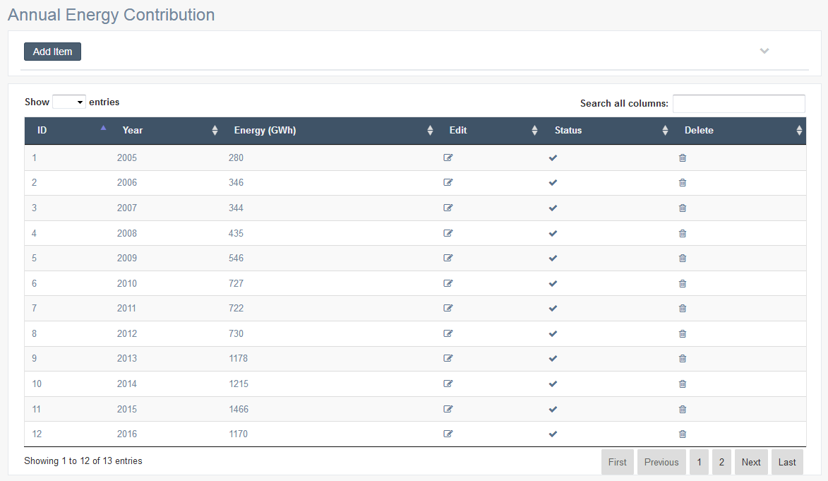

Criteria | Satisfied | Unsatisfied
Accuracy and Order of text fields

Readability and Understandability of
the content

Overall appearance of the form

Accepted by
Name : ……………………… Signature: ………………….. Date: ……………

User Acceptance Testing – Acceptance Sign-Off Form
  - User : Admin
  - From Name : Annual Energy Contribution – Add Details

  - 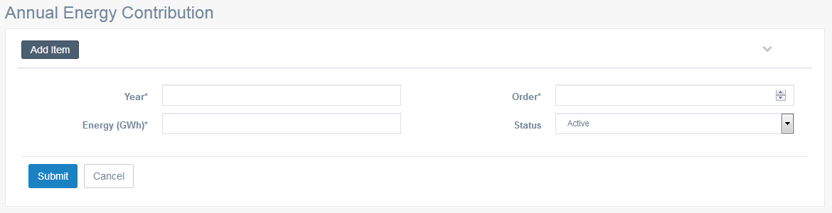

Criteria | Satisfied | Unsatisfied
Accuracy and Order of text fields

Readability and Understandability of
the content

Overall appearance of the form

Accepted by
Name : ……………………… Signature: ………………….. Date: ……………

User Acceptance Testing – Acceptance Sign-Off Form
  - User : Admin
  - From Name : Annual Energy Contribution– Edit Details

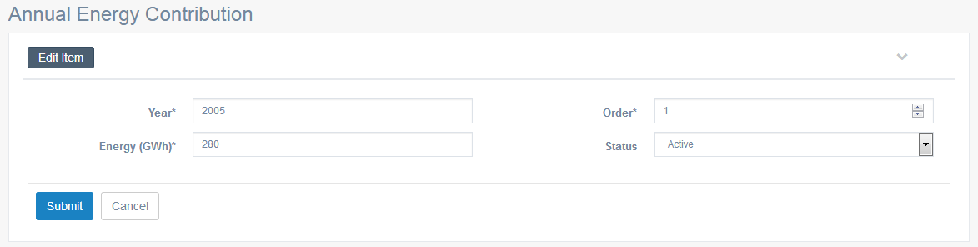

Criteria | Satisfied | Unsatisfied
Accuracy and Order of text fields

Readability and Understandability of
the content

Overall appearance of the form

Accepted by
Name : ……………………… Signature: ………………….. Date: ……………

User Acceptance Testing – Acceptance Sign-Off Form
  - User : Admin
  - From Name : Service Agreements
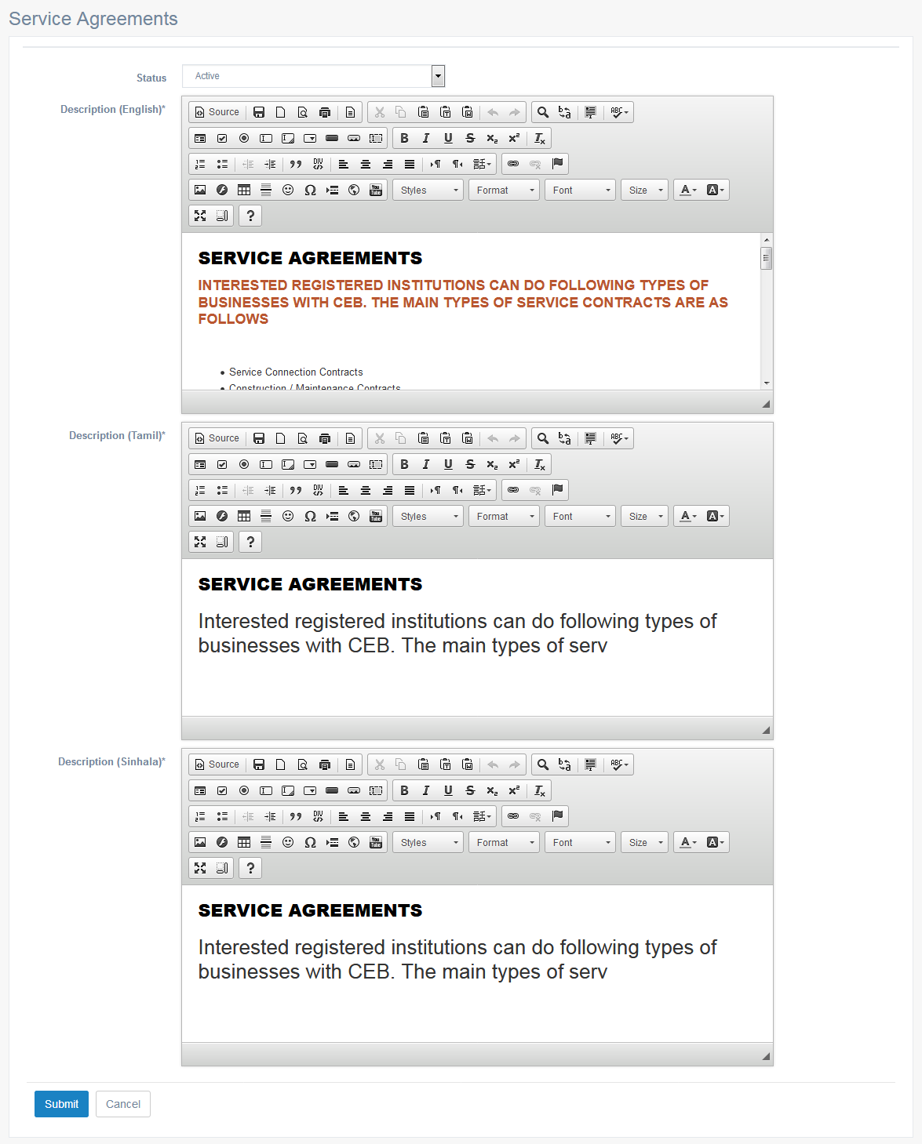

Criteria | Satisfied | Unsatisfied
Accuracy and Order of text fields

Readability and Understandability of
the content

Overall appearance of the form

Accepted by
Name : ……………………… Signature: ………………….. Date: ……………

User Acceptance Testing – Acceptance Sign-Off Form
  - User : Admin
  - From Name : More Details

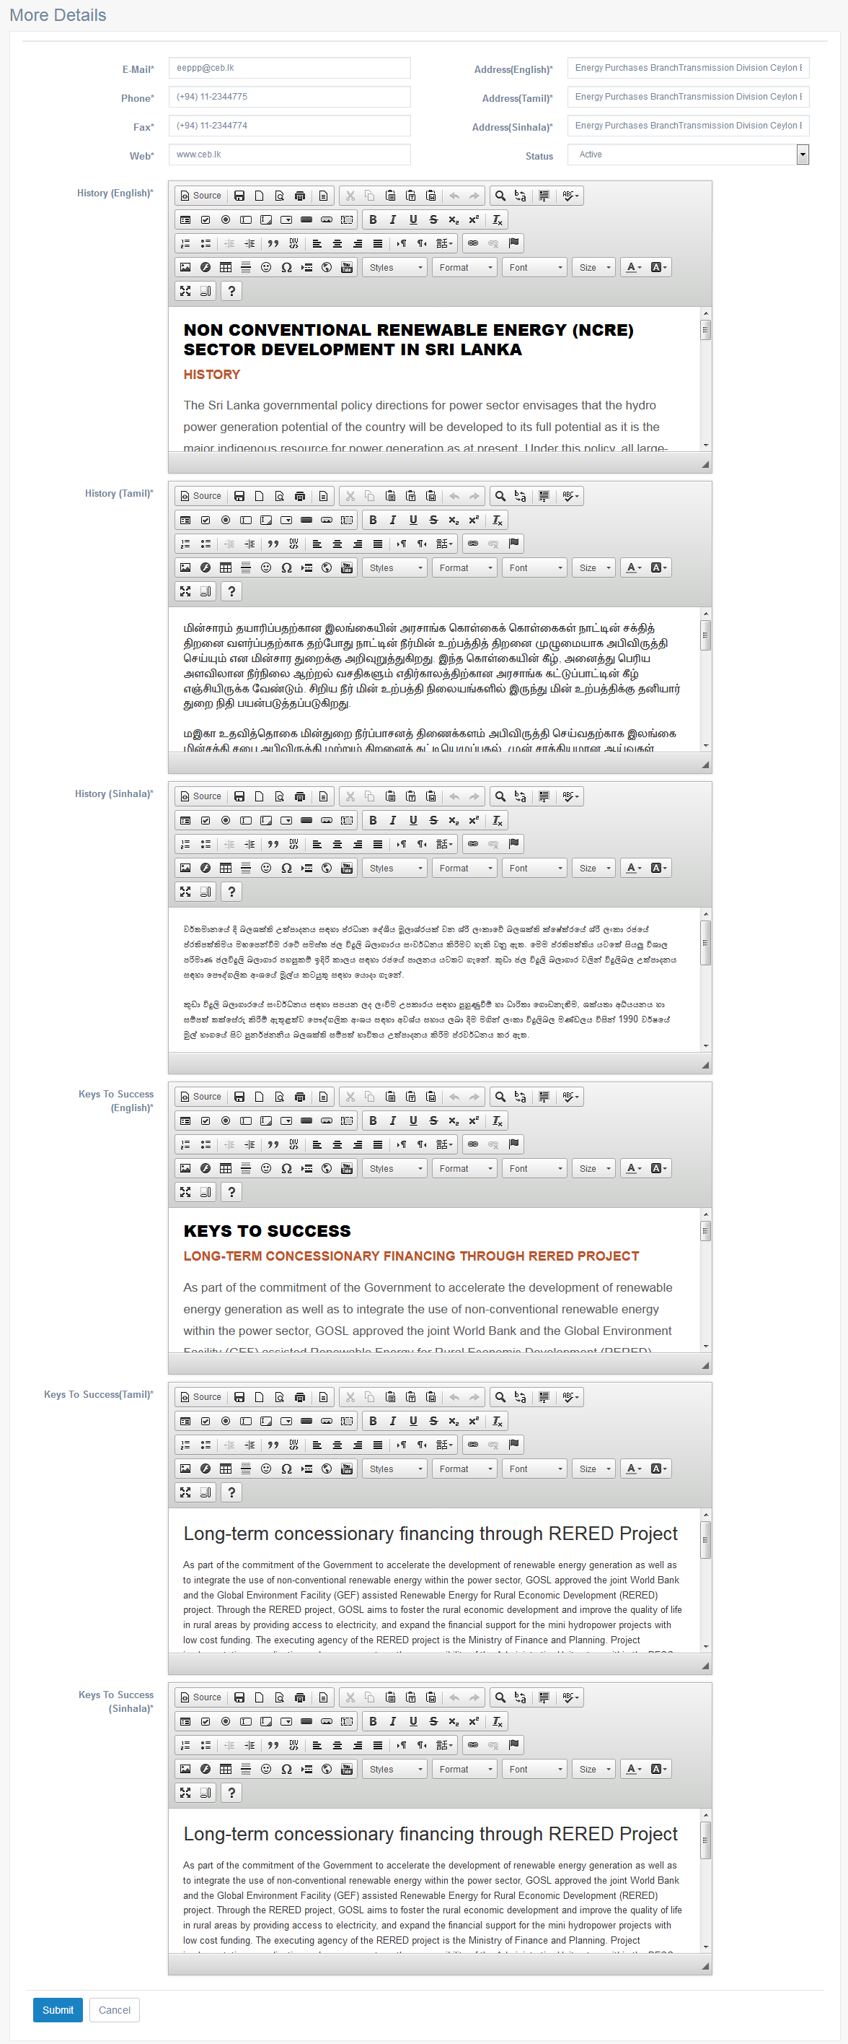

Criteria | Satisfied | Unsatisfied
Accuracy and Order of text fields

Readability and Understandability of
the content

Overall appearance of the form

Accepted by
Name : ……………………… Signature: ………………….. Date: ……………

User Acceptance Testing – Acceptance Sign-Off Form
  - User : Admin
  - From Name : Media Gallery Category – List

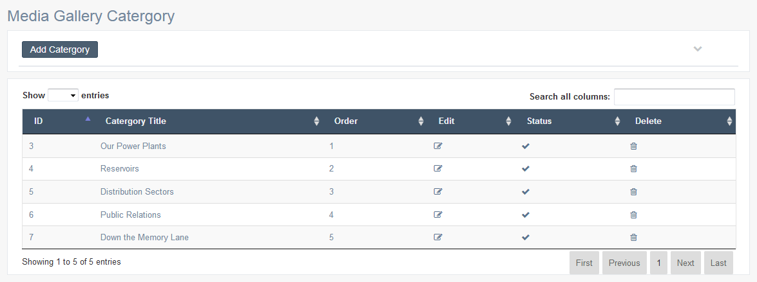

Criteria | Satisfied | Unsatisfied
Accuracy and Order of text fields

Readability and Understandability of
the content

Overall appearance of the form

Accepted by
Name : ……………………… Signature: ………………….. Date: ……………

User Acceptance Testing – Acceptance Sign-Off Form
  - User : Admin
  - From Name : Media Gallery Category – Add Details

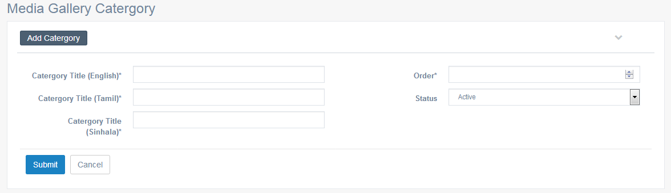

Criteria | Satisfied | Unsatisfied
Accuracy and Order of text fields

Readability and Understandability of
the content

Overall appearance of the form

Accepted by
Name : ……………………… Signature: ………………….. Date: ……………

User Acceptance Testing – Acceptance Sign-Off Form
  - User : Admin
  - From Name : Media Gallery Category – Edit Details

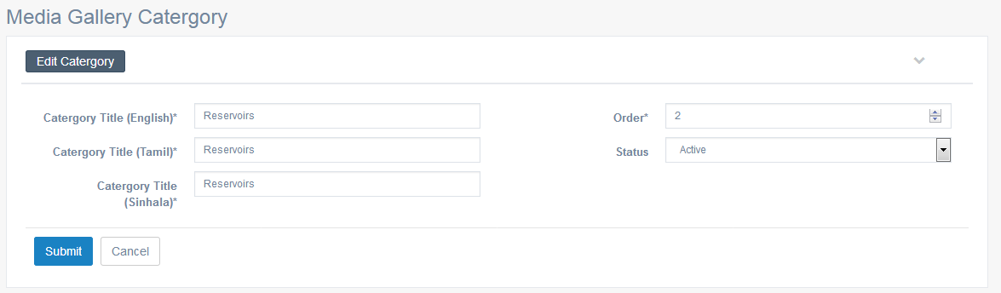

Criteria | Satisfied | Unsatisfied
Accuracy and Order of text fields

Readability and Understandability of
the content

Overall appearance of the form

Accepted by
Name : ……………………… Signature: ………………….. Date: ……………

User Acceptance Testing – Acceptance Sign-Off Form
  - User : Admin
  - From Name : Media Sub Category – List

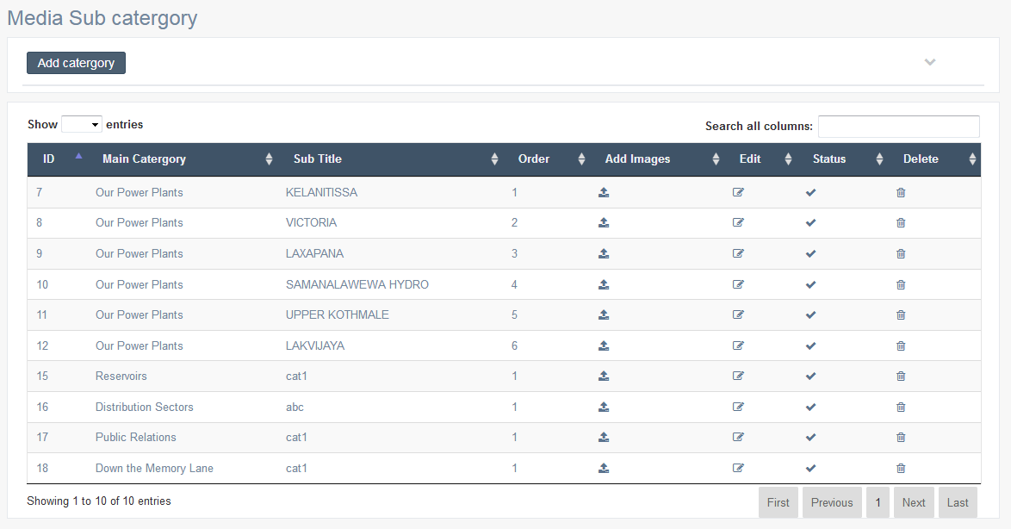

Criteria | Satisfied | Unsatisfied
Accuracy and Order of text fields

Readability and Understandability of
the content

Overall appearance of the form

Accepted by
Name : ……………………… Signature: ………………….. Date: ……………

User Acceptance Testing – Acceptance Sign-Off Form
  - User : Admin
  - From Name : Media Sub Category – Add Details

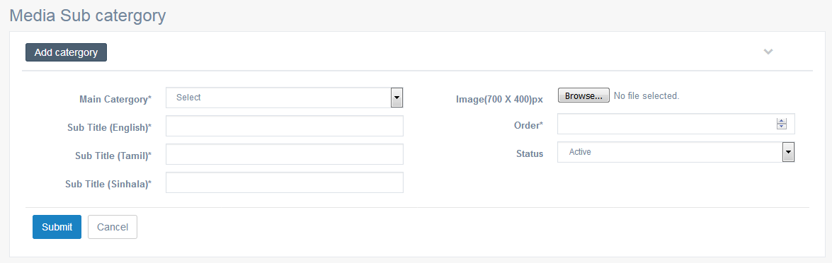

Criteria | Satisfied | Unsatisfied
Accuracy and Order of text fields

Readability and Understandability of
the content

Overall appearance of the form

Accepted by
Name : ……………………… Signature: ………………….. Date: ……………

User Acceptance Testing – Acceptance Sign-Off Form
  - User : Admin
  - From Name : Media Sub Category – Edit Details

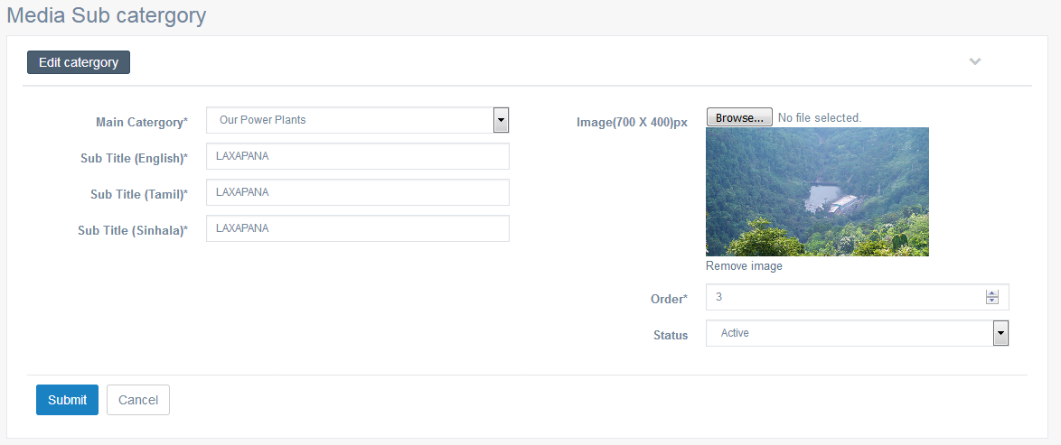

Criteria | Satisfied | Unsatisfied
Accuracy and Order of text fields

Readability and Understandability of
the content

Overall appearance of the form

Accepted by
Name : ……………………… Signature: ………………….. Date: ……………

User Acceptance Testing – Acceptance Sign-Off Form
  - User : Admin
  - From Name : Media Gallery Images - List

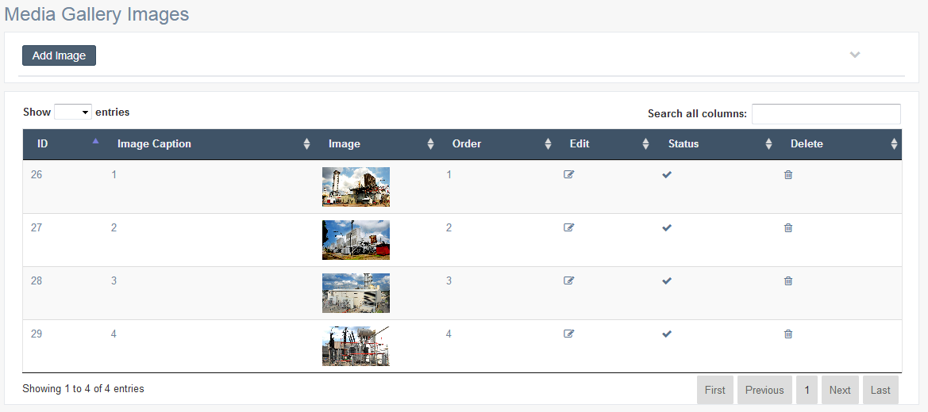

Criteria | Satisfied | Unsatisfied
Accuracy and Order of text fields

Readability and Understandability of
the content

Overall appearance of the form

Accepted by
Name : ……………………… Signature: ………………….. Date: ……………

User Acceptance Testing – Acceptance Sign-Off Form
  - User : Admin
  - From Name : Media Gallery Images – Add Details

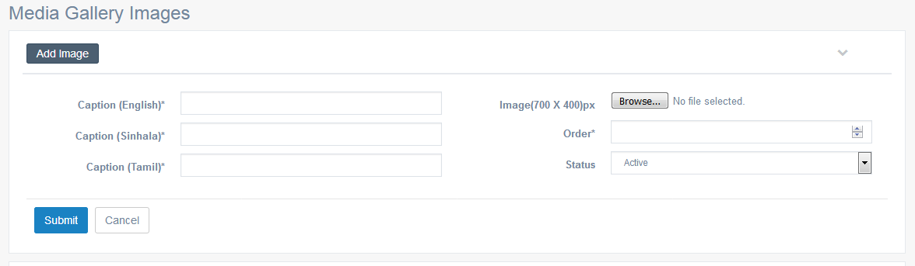

Criteria | Satisfied | Unsatisfied
Accuracy and Order of text fields

Readability and Understandability of
the content

Overall appearance of the form

Accepted by
Name : ……………………… Signature: ………………….. Date: ……………

User Acceptance Testing – Acceptance Sign-Off Form
  - User : Admin
  - From Name : Media Gallery Images – Edit Details

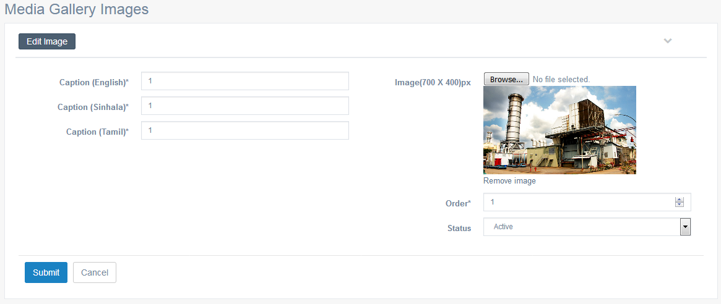

Criteria | Satisfied | Unsatisfied
Accuracy and Order of text fields

Readability and Understandability of
the content

Overall appearance of the form

Accepted by
Name : ……………………… Signature: ………………….. Date: ……………

User Acceptance Testing – Acceptance Sign-Off Form
  - User : Admin
  - From Name : Call Us – Office List
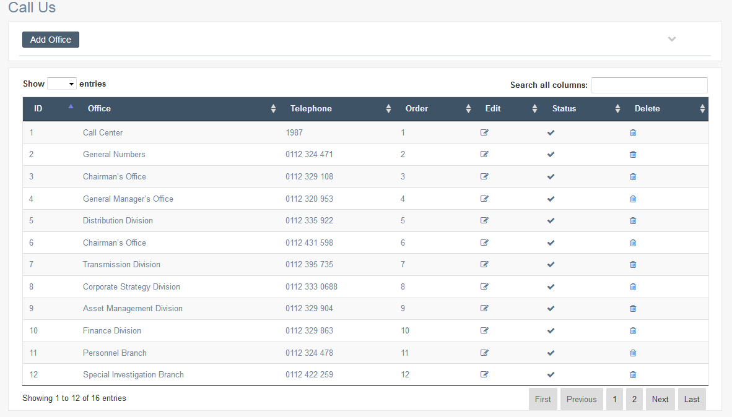

Criteria | Satisfied | Unsatisfied
Accuracy and Order of text fields

Readability and Understandability of
the content

Overall appearance of the form

Accepted by
Name : ……………………… Signature: ………………….. Date: ……………

User Acceptance Testing – Acceptance Sign-Off Form
  - User : Admin
  - From Name : Call Us – Add Details

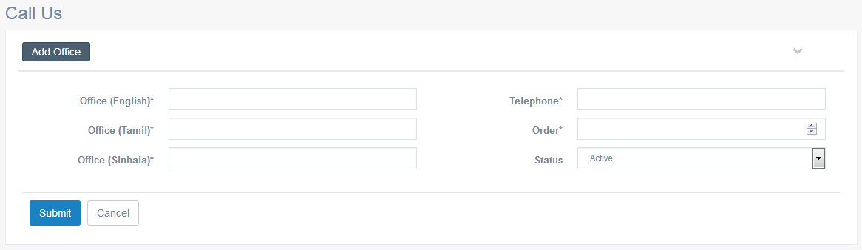

Criteria | Satisfied | Unsatisfied
Accuracy and Order of text fields

Readability and Understandability of
the content

Overall appearance of the form

Accepted by
Name : ……………………… Signature: ………………….. Date: ……………

User Acceptance Testing – Acceptance Sign-Off Form
  - User : Admin
  - From Name : Call Us – Edit Details

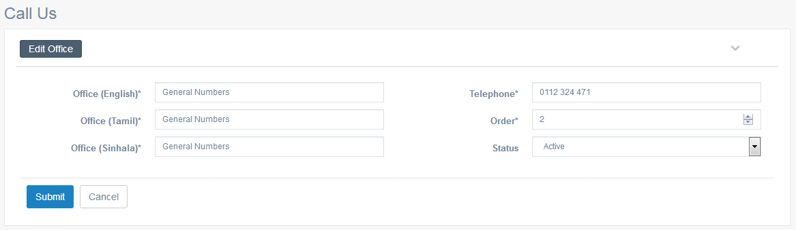

Criteria | Satisfied | Unsatisfied
Accuracy and Order of text fields

Readability and Understandability of
the content

Overall appearance of the form

Accepted by
Name : ……………………… Signature: ………………….. Date: ……………

User Acceptance Testing – Acceptance Sign-Off Form
  - User : Admin
  - From Name : Province Categorization - List

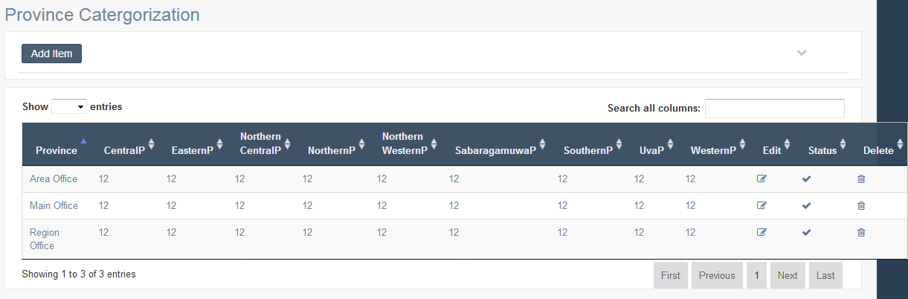

Criteria | Satisfied | Unsatisfied
Accuracy and Order of text fields

Readability and Understandability of
the content

Overall appearance of the form

Accepted by
Name : ……………………… Signature: ………………….. Date: ……………

User Acceptance Testing – Acceptance Sign-Off Form
  - User : Admin
  - From Name : Province Categorization – Add Details

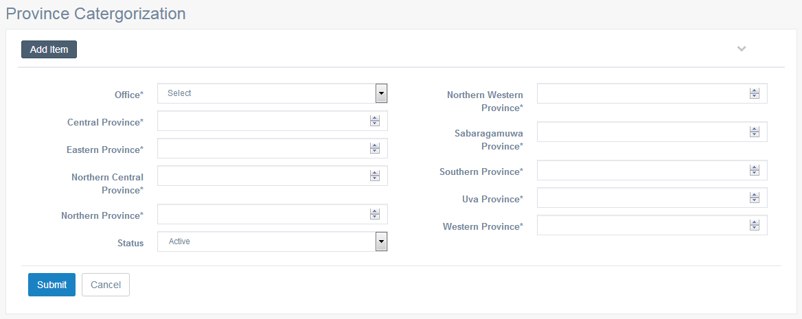

Criteria | Satisfied | Unsatisfied
Accuracy and Order of text fields

Readability and Understandability of
the content

Overall appearance of the form

Accepted by
Name : ……………………… Signature: ………………….. Date: ……………

User Acceptance Testing – Acceptance Sign-Off Form
  - User : Admin
  - From Name : Province Categorization– Edit Details

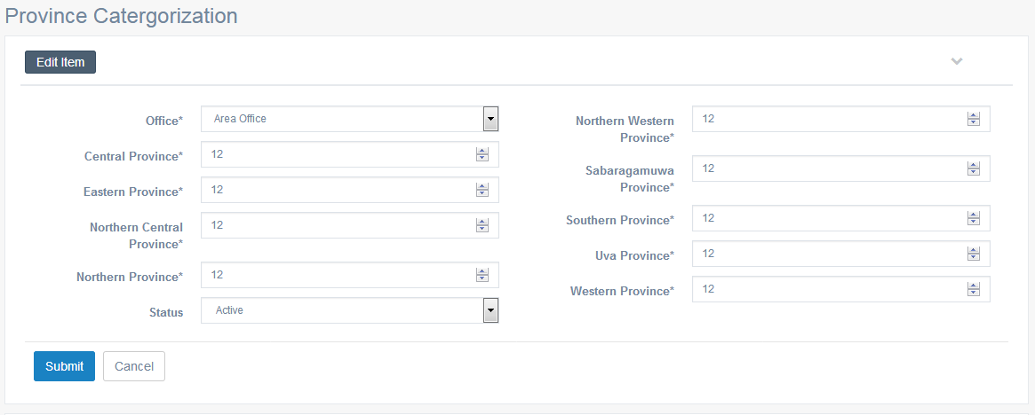

Criteria | Satisfied | Unsatisfied
Accuracy and Order of text fields

Readability and Understandability of
the content

Overall appearance of the form

Accepted by
Name : ……………………… Signature: ………………….. Date: ……………

User Acceptance Testing – Acceptance Sign-Off Form
  - User : Admin
  - From Name : Main Office– List

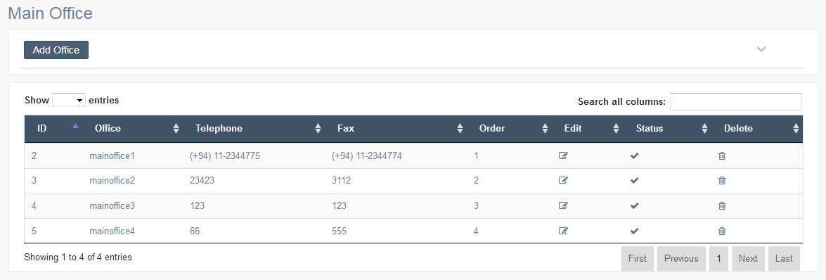

Criteria | Satisfied | Unsatisfied
Accuracy and Order of text fields

Readability and Understandability of
the content

Overall appearance of the form

Accepted by
Name : ……………………… Signature: ………………….. Date: ……………

User Acceptance Testing – Acceptance Sign-Off Form
  - User : Admin
  - From Name : Main Office– Add Details

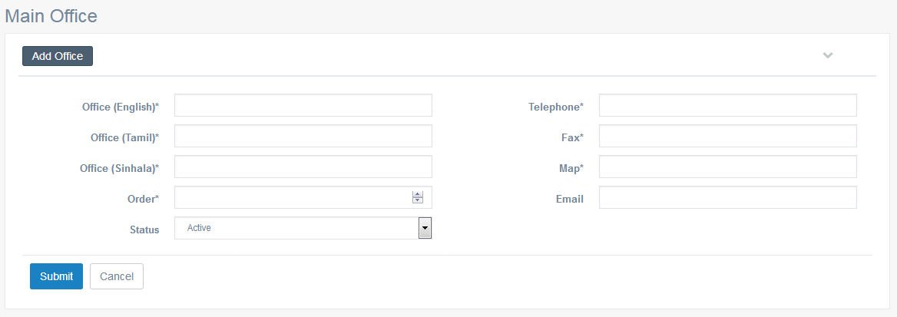

Criteria | Satisfied | Unsatisfied
Accuracy and Order of text fields

Readability and Understandability of
the content

Overall appearance of the form

Accepted by
Name : ……………………… Signature: ………………….. Date: ……………

User Acceptance Testing – Acceptance Sign-Off Form
  - User : Admin
  - From Name : Main Office – Edit Details

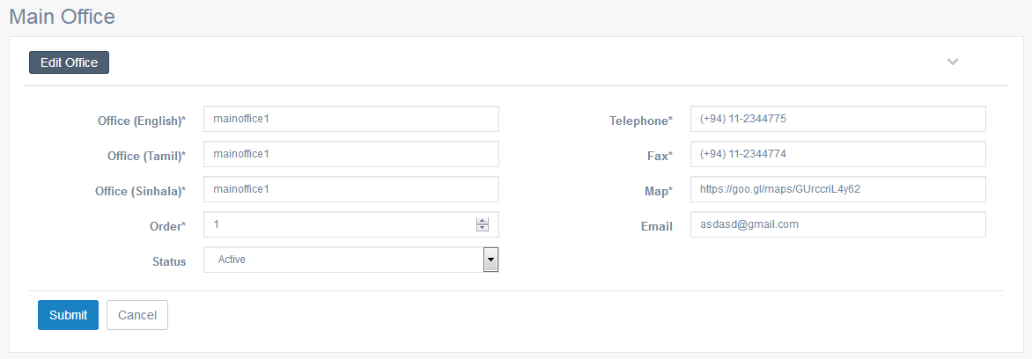

Criteria | Satisfied | Unsatisfied
Accuracy and Order of text fields

Readability and Understandability of
the content

Overall appearance of the form

Accepted by
Name : ……………………… Signature: ………………….. Date: ……………

User Acceptance Testing – Acceptance Sign-Off Form
  - User : Admin
  - From Name : Regional Office – List

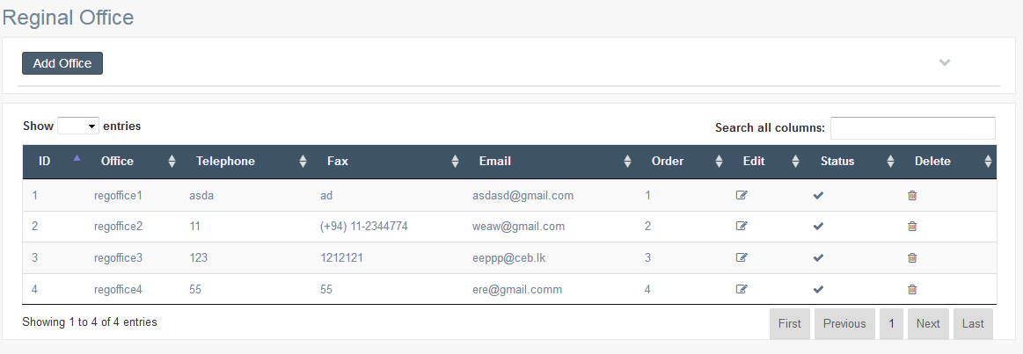

Criteria | Satisfied | Unsatisfied
Accuracy and Order of text fields

Readability and Understandability of
the content

Overall appearance of the form

Accepted by
Name : ……………………… Signature: ………………….. Date: ……………

User Acceptance Testing – Acceptance Sign-Off Form
  - User : Admin
  - From Name : Regional Office – Add Details

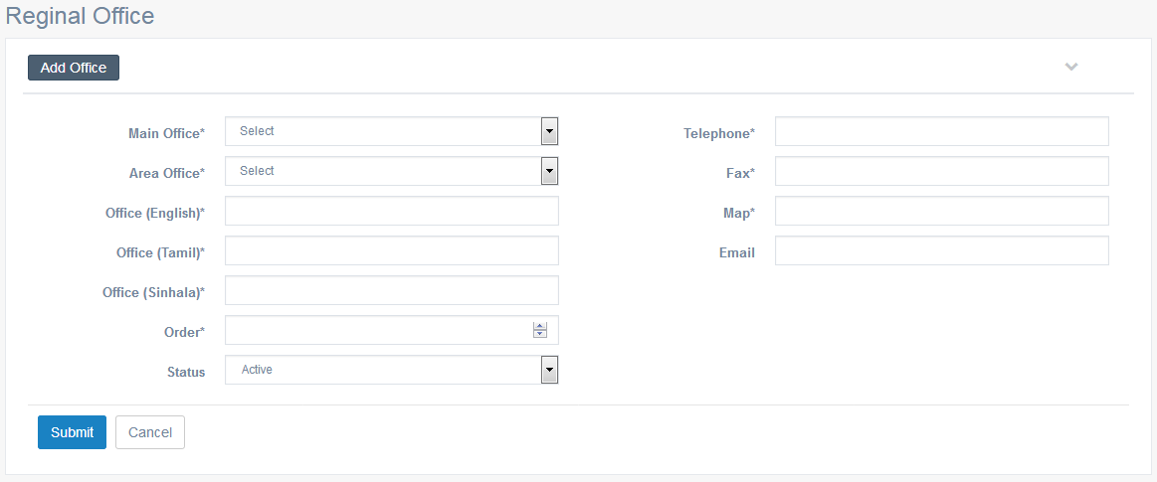

Criteria | Satisfied | Unsatisfied
Accuracy and Order of text fields

Readability and Understandability of
the content

Overall appearance of the form

Accepted by
Name : ……………………… Signature: ………………….. Date: ……………

User Acceptance Testing – Acceptance Sign-Off Form
  - User : Admin
  - From Name : Regional Office – Edit Details

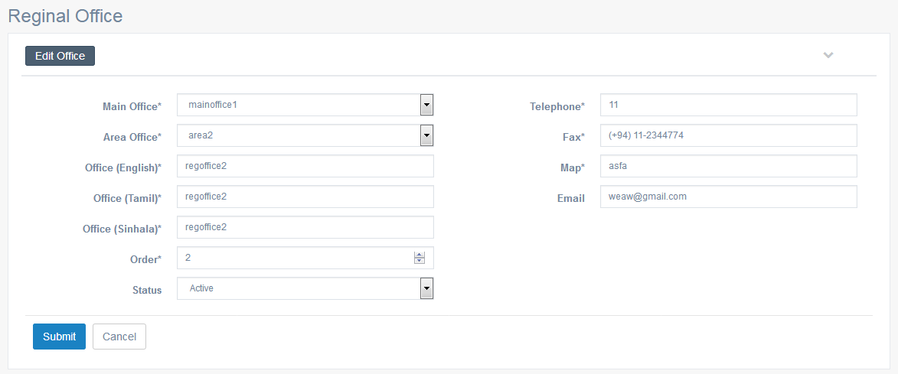

Criteria | Satisfied | Unsatisfied
Accuracy and Order of text fields

Readability and Understandability of
the content

Overall appearance of the form

Accepted by
Name : ……………………… Signature: ………………….. Date: ……………

User Acceptance Testing – Acceptance Sign-Off Form
  - User : Admin
  - From Name : Area Office – List

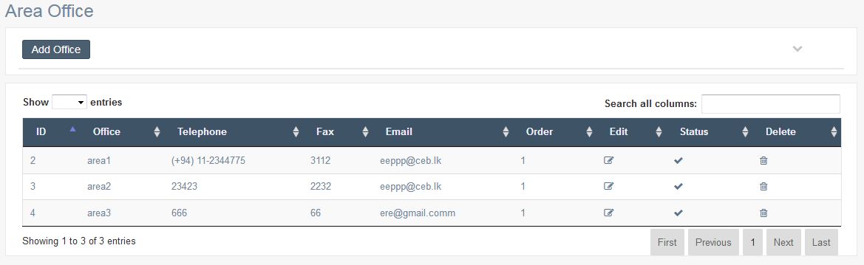

Criteria | Satisfied | Unsatisfied
Accuracy and Order of text fields

Readability and Understandability of
the content

Overall appearance of the form

Accepted by
Name : ……………………… Signature: ………………….. Date: ……………

User Acceptance Testing – Acceptance Sign-Off Form
  - User : Admin
  - From Name : Area Office – Add Details

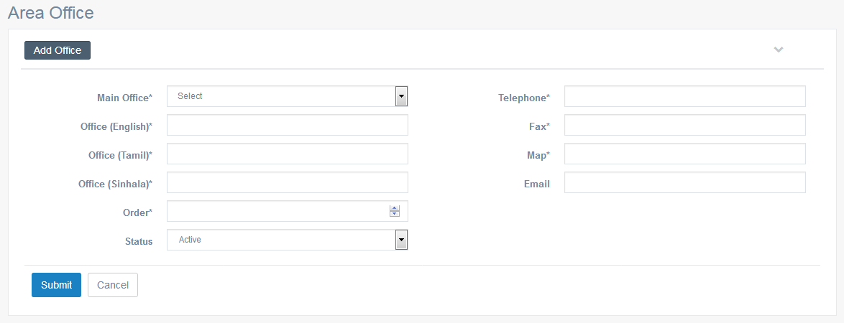

Criteria | Satisfied | Unsatisfied
Accuracy and Order of text fields

Readability and Understandability of
the content

Overall appearance of the form

Accepted by
Name : ……………………… Signature: ………………….. Date: ……………

User Acceptance Testing – Acceptance Sign-Off Form
  - User : Admin
  - From Name : Area Office – Edit Details

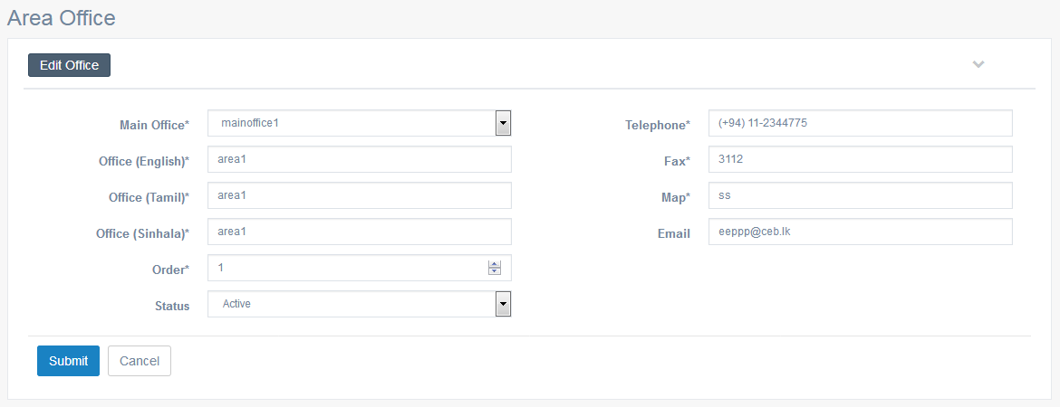

Criteria | Satisfied | Unsatisfied
Accuracy and Order of text fields

Readability and Understandability of
the content

Overall appearance of the form

Accepted by
Name : ……………………… Signature: ………………….. Date: ……………

User Acceptance Testing – Acceptance Sign-Off Form
  - User : Admin
  - From Name : Knowledge Hub – History
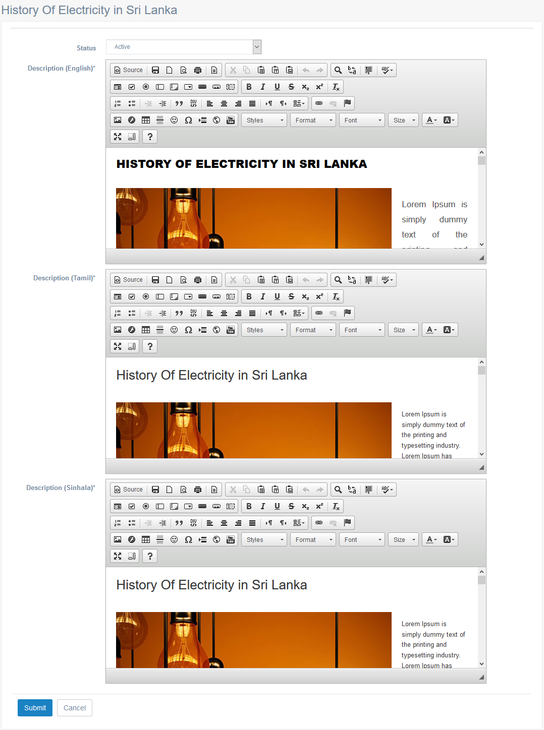

Criteria | Satisfied | Unsatisfied
Accuracy and Order of text fields

Readability and Understandability of
the content

Overall appearance of the form

Accepted by
Name : ……………………… Signature: ………………….. Date: ……………

User Acceptance Testing – Acceptance Sign-Off Form
  - User : Admin
  - From Name : Knowledge Hub – Power Plant Operation – List
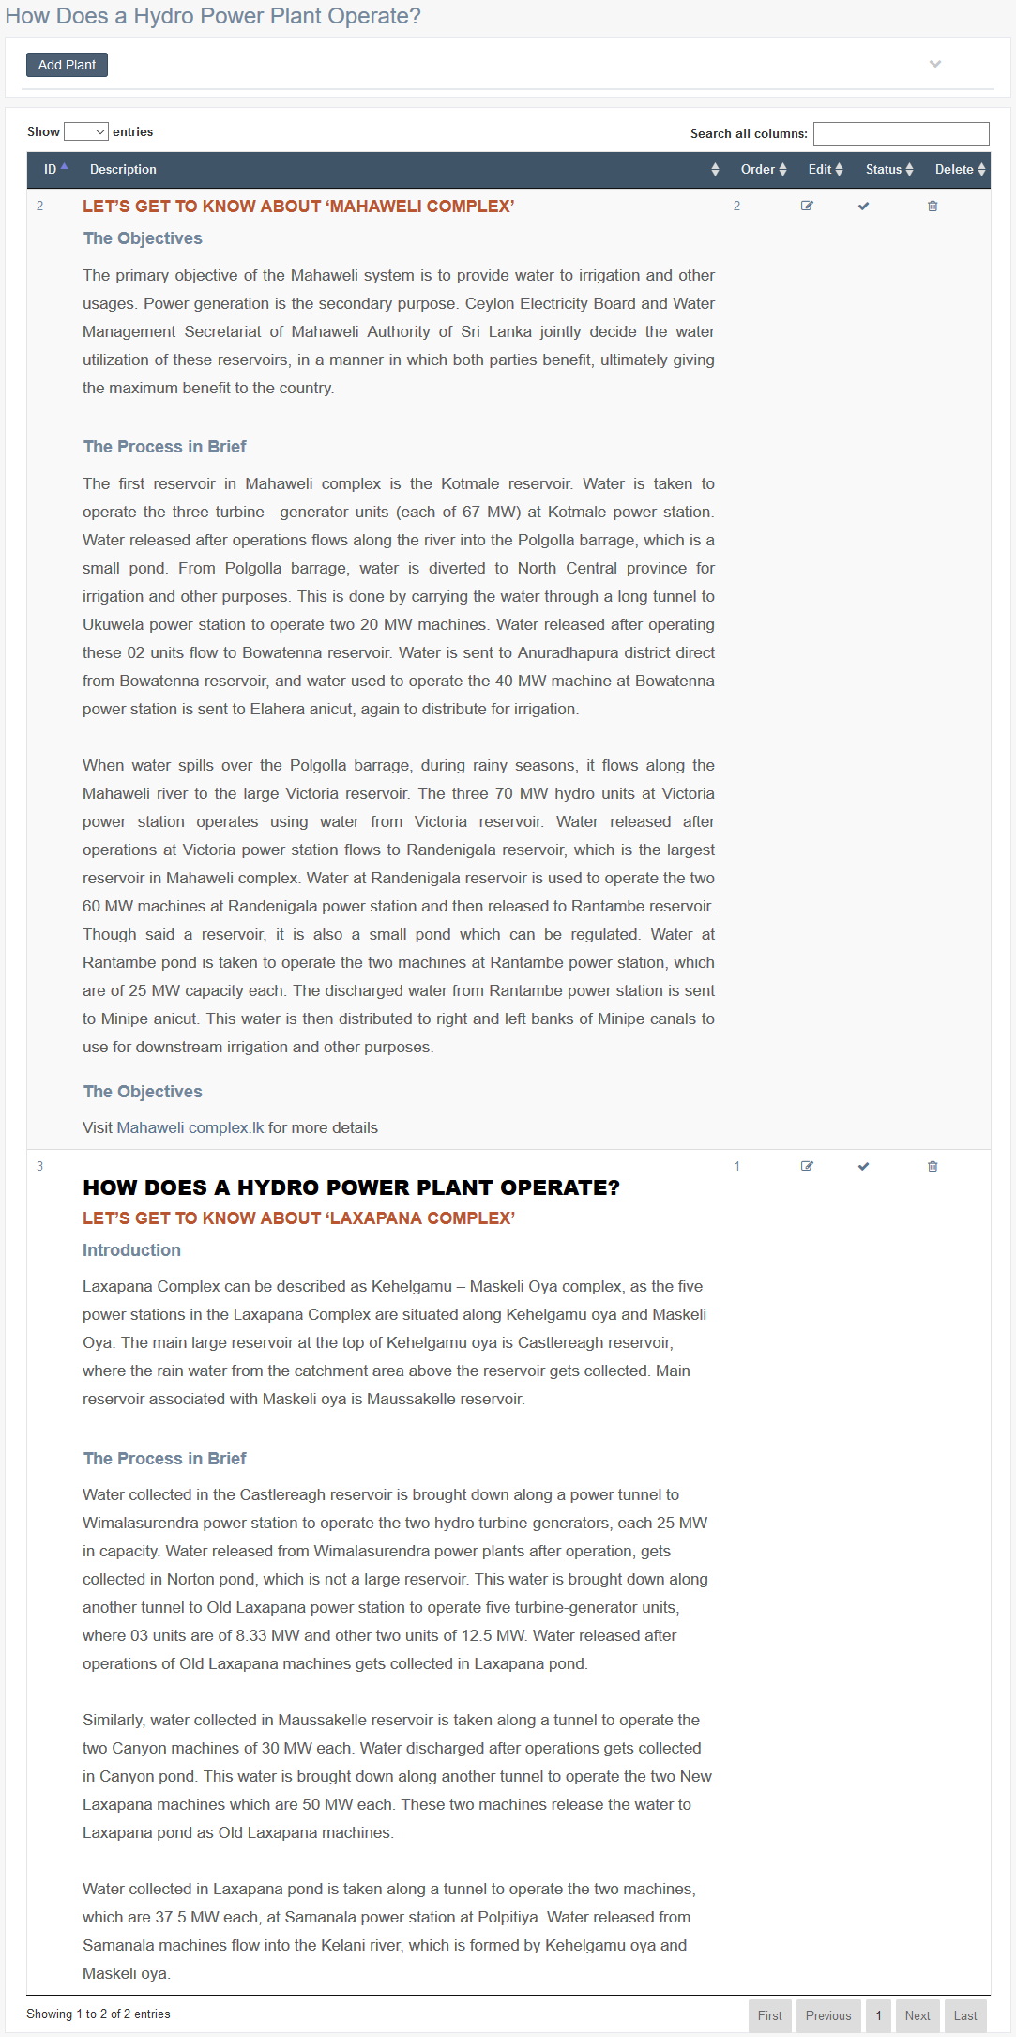

Criteria | Satisfied | Unsatisfied
Accuracy and Order of text fields

Readability and Understandability of
the content

Overall appearance of the form

Accepted by
Name : ……………………… Signature: ………………….. Date: ……………

User Acceptance Testing – Acceptance Sign-Off Form
  - User : Admin
  - From Name : Knowledge Hub – Power Plant Operation – Add Plant
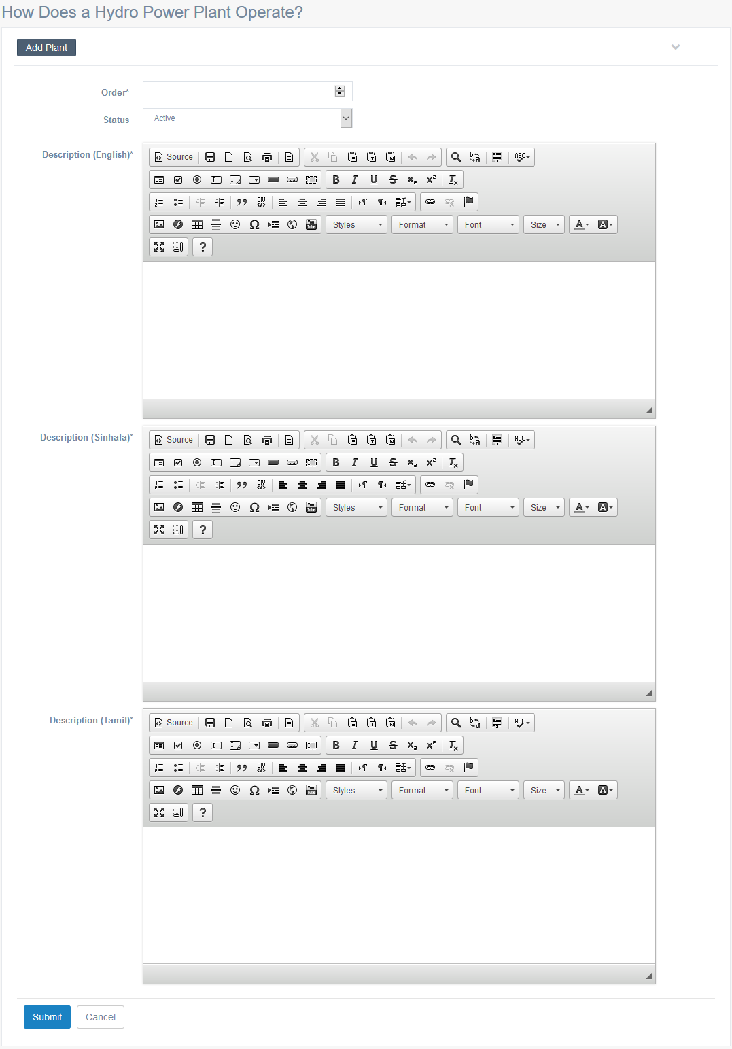

Criteria | Satisfied | Unsatisfied
Accuracy and Order of text fields

Readability and Understandability of
the content

Overall appearance of the form

Accepted by
Name : ……………………… Signature: ………………….. Date: ……………

User Acceptance Testing – Acceptance Sign-Off Form
  - User : Admin
  - From Name : Knowledge Hub – Power Plant Operation – Edit Plant
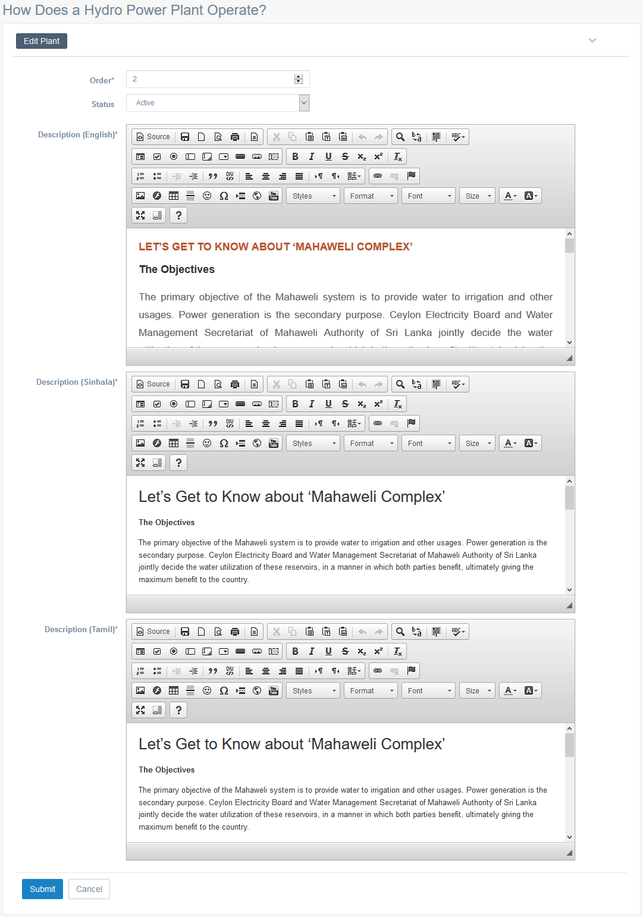

Criteria | Satisfied | Unsatisfied
Accuracy and Order of text fields

Readability and Understandability of
the content

Overall appearance of the form

Accepted by
Name : ……………………… Signature: ………………….. Date: ……………

User Acceptance Testing – Acceptance Sign-Off Form
  - User : Admin
  - From Name : Knowledge Hub – Demand Side Management – What is DSM
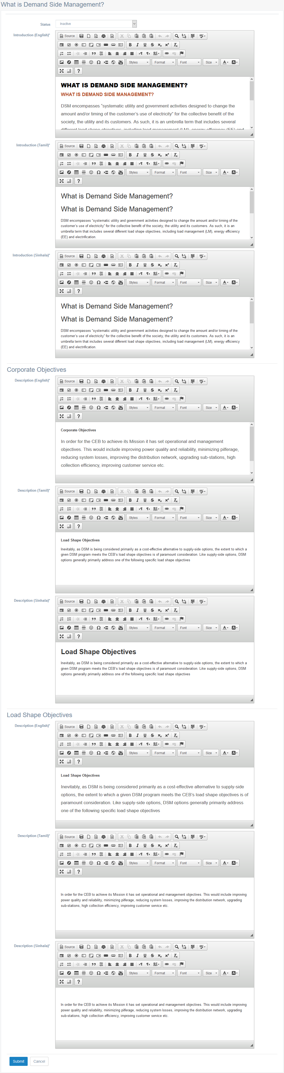

Criteria | Satisfied | Unsatisfied
Accuracy and Order of text fields

Readability and Understandability of
the content

Overall appearance of the form

Accepted by
Name : ……………………… Signature: ………………….. Date: ……………

User Acceptance Testing – Acceptance Sign-Off Form
  - User : Admin
  - From Name : Knowledge Hub – Demand Side Management – Load Shapes – List
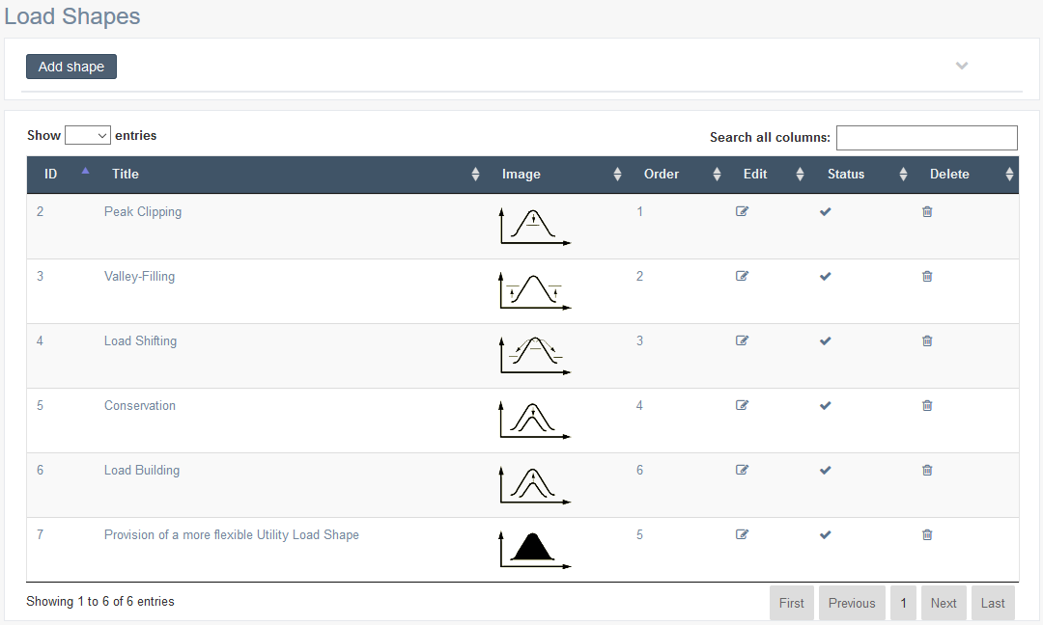

Criteria | Satisfied | Unsatisfied
Accuracy and Order of text fields

Readability and Understandability of
the content

Overall appearance of the form

Accepted by
Name : ……………………… Signature: ………………….. Date: ……………

User Acceptance Testing – Acceptance Sign-Off Form
  - User : Admin
  - From Name : Load Shapes – Add Shape
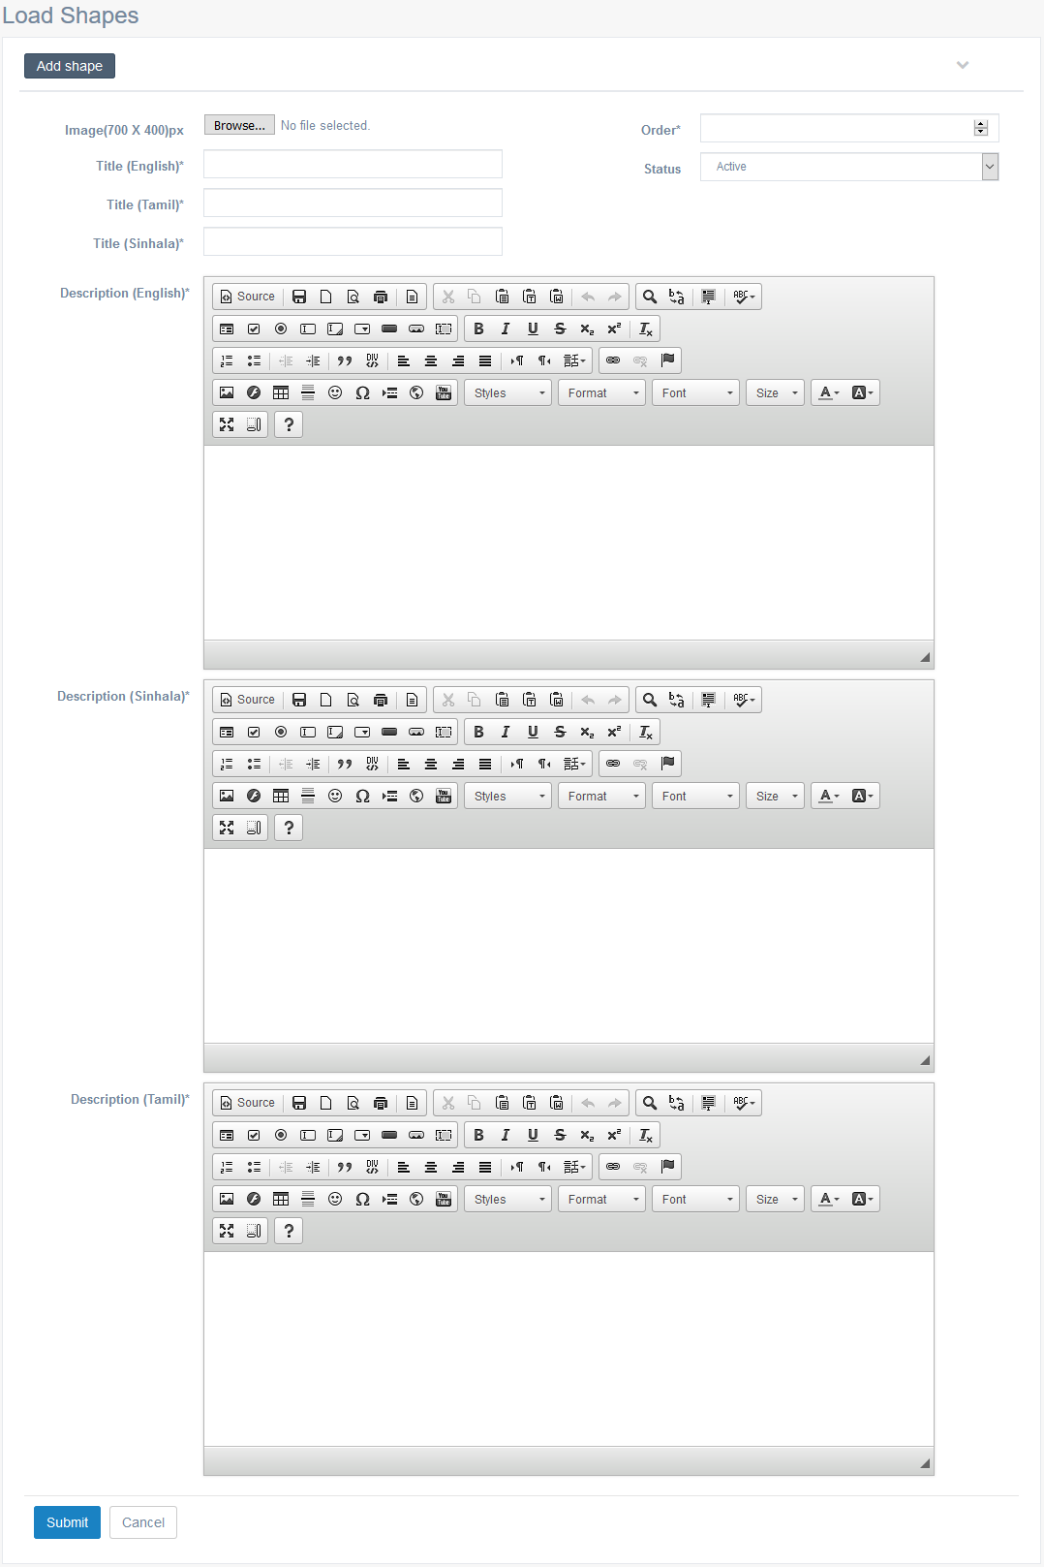

Criteria | Satisfied | Unsatisfied
Accuracy and Order of text fields

Readability and Understandability of
the content

Overall appearance of the form

Accepted by
Name : ……………………… Signature: ………………….. Date: ……………

User Acceptance Testing – Acceptance Sign-Off Form
  - User : Admin
  - From Name : Load Shapes – Edit Shape
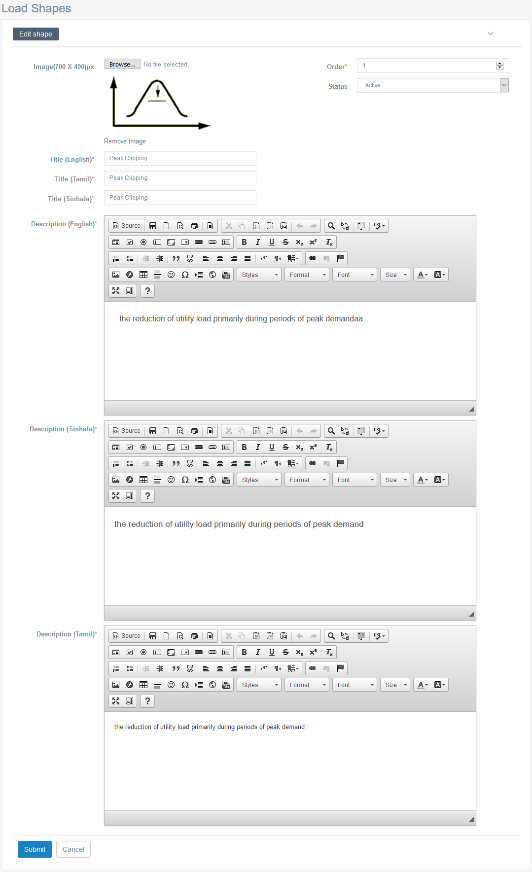

Criteria | Satisfied | Unsatisfied
Accuracy and Order of text fields

Readability and Understandability of
the content

Overall appearance of the form

Accepted by
Name : ……………………… Signature: ………………….. Date: ……………

User Acceptance Testing – Acceptance Sign-Off Form
  - User : Admin
  - From Name : Knowledge Hub – Renewable Energy – Introduction
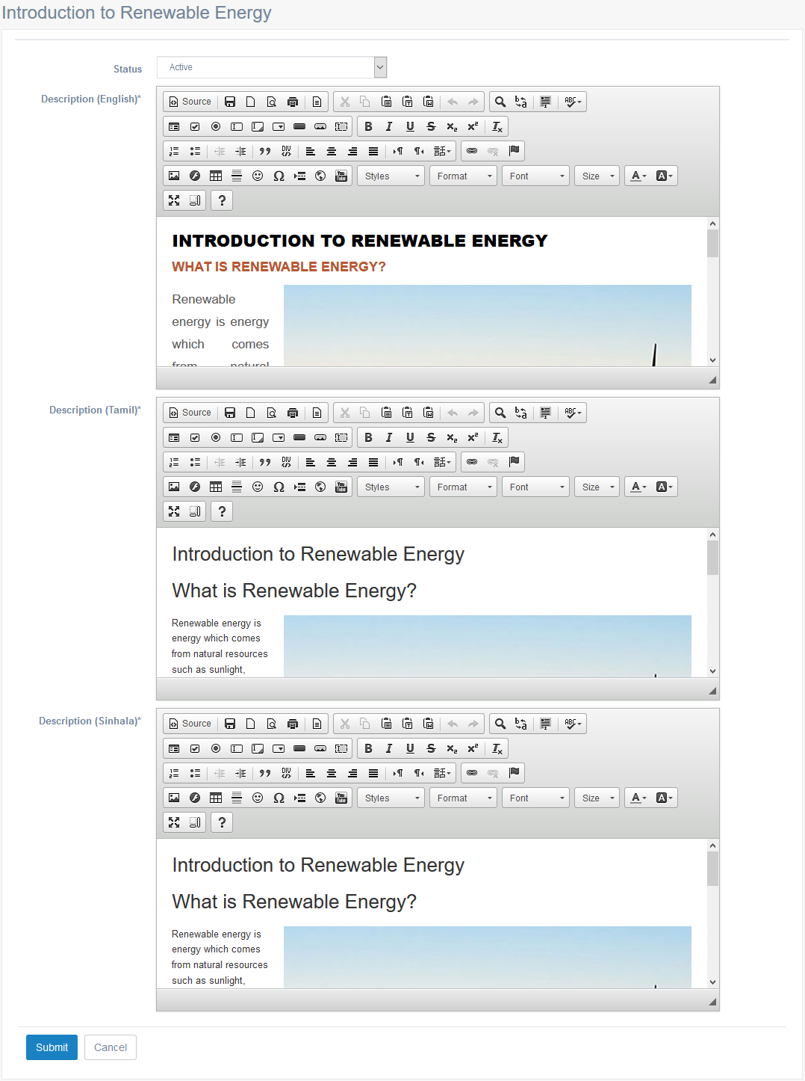

Criteria | Satisfied | Unsatisfied
Accuracy and Order of text fields

Readability and Understandability of
the content

Overall appearance of the form

Accepted by
Name : ……………………… Signature: ………………….. Date: ……………

User Acceptance Testing – Acceptance Sign-Off Form
  - User : Admin
  - From Name : Knowledge Hub – Renewable Energy – Hydro Power
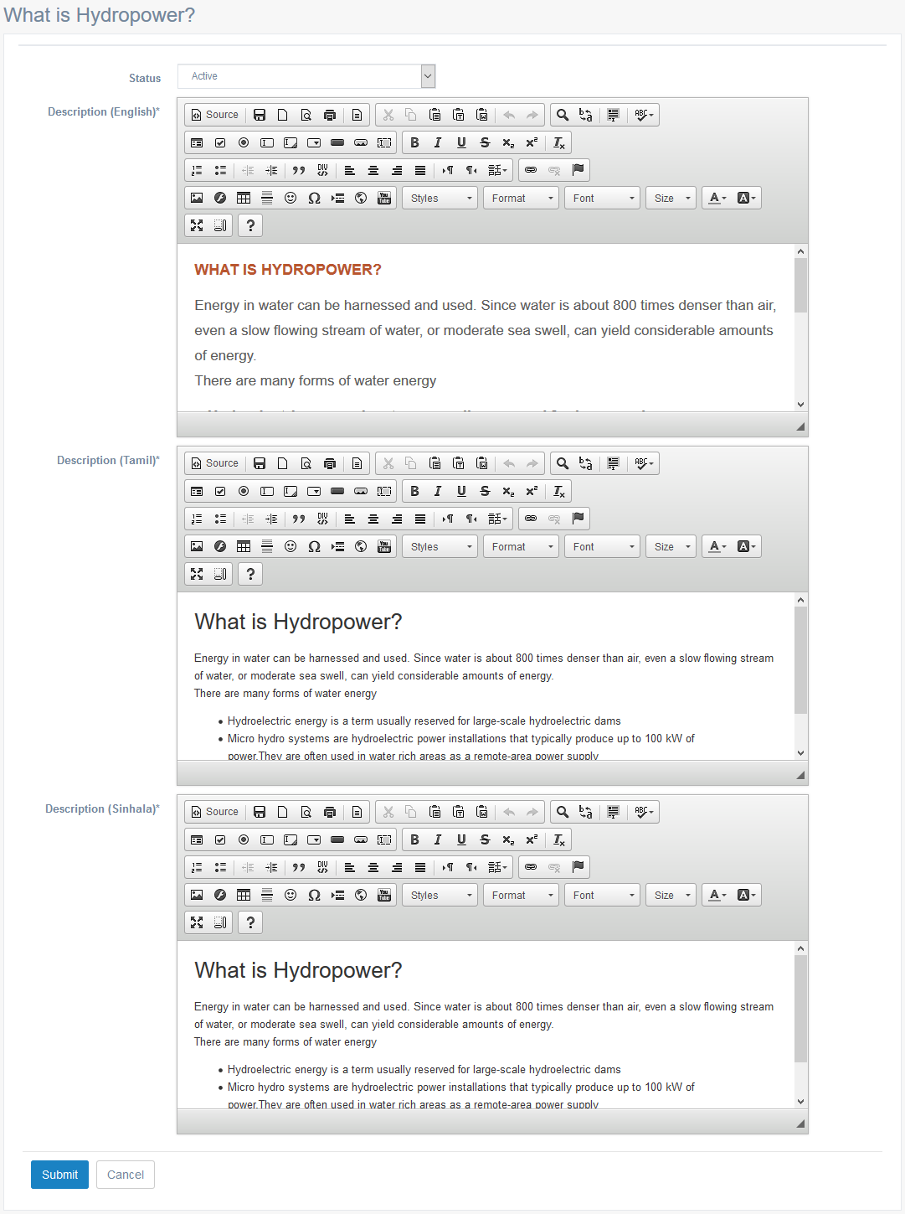

Criteria | Satisfied | Unsatisfied
Accuracy and Order of text fields

Readability and Understandability of
the content

Overall appearance of the form

Accepted by
Name : ……………………… Signature: ………………….. Date: ……………

User Acceptance Testing – Acceptance Sign-Off Form
  - User : Admin
  - From Name : Knowledge Hub – Renewable Energy – Wind Power
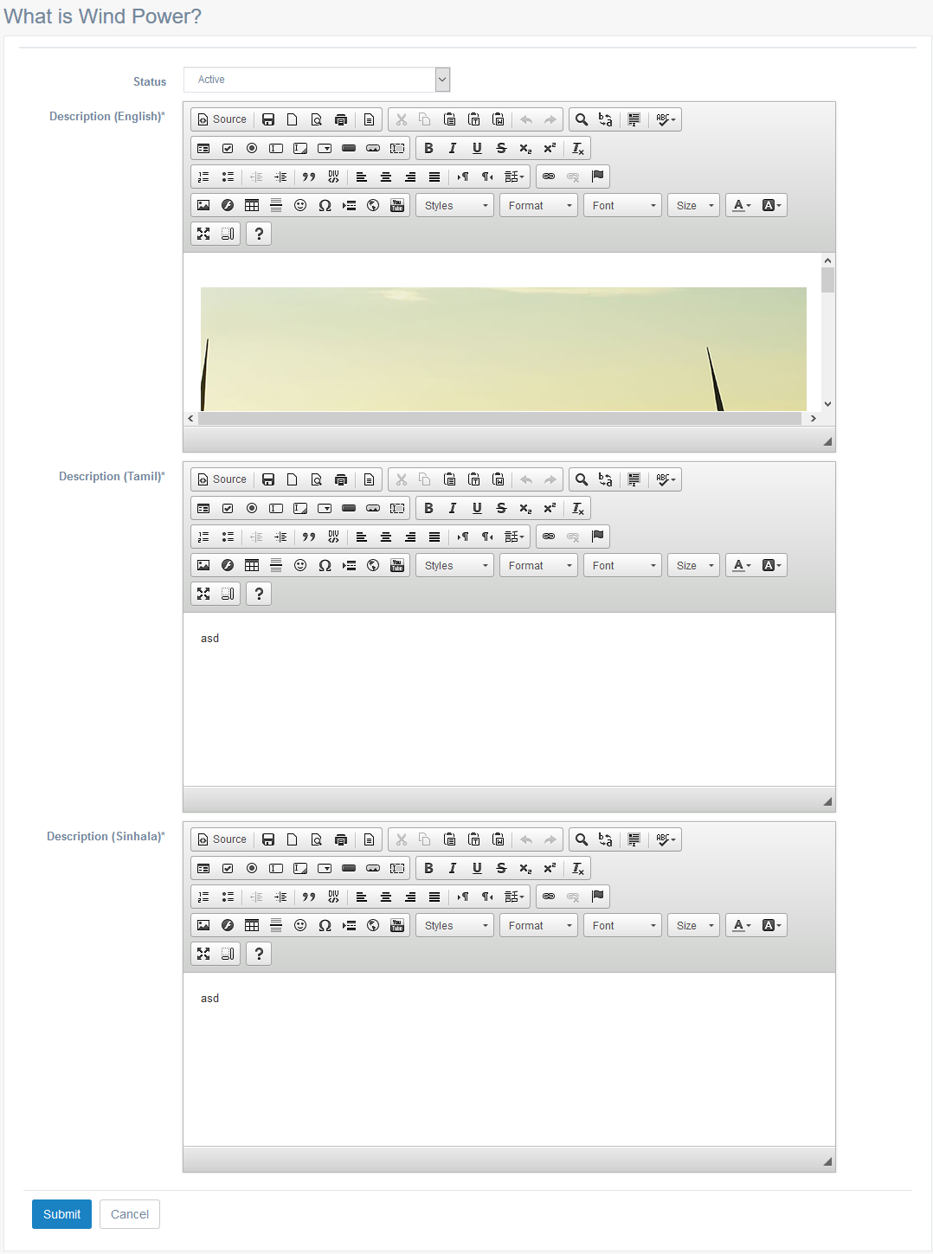

Criteria | Satisfied | Unsatisfied
Accuracy and Order of text fields

Readability and Understandability of
the content

Overall appearance of the form

Accepted by
Name : ……………………… Signature: ………………….. Date: ……………

User Acceptance Testing – Acceptance Sign-Off Form
  - User : Admin
  - From Name : Knowledge Hub – Renewable Energy – Solar / Biomass
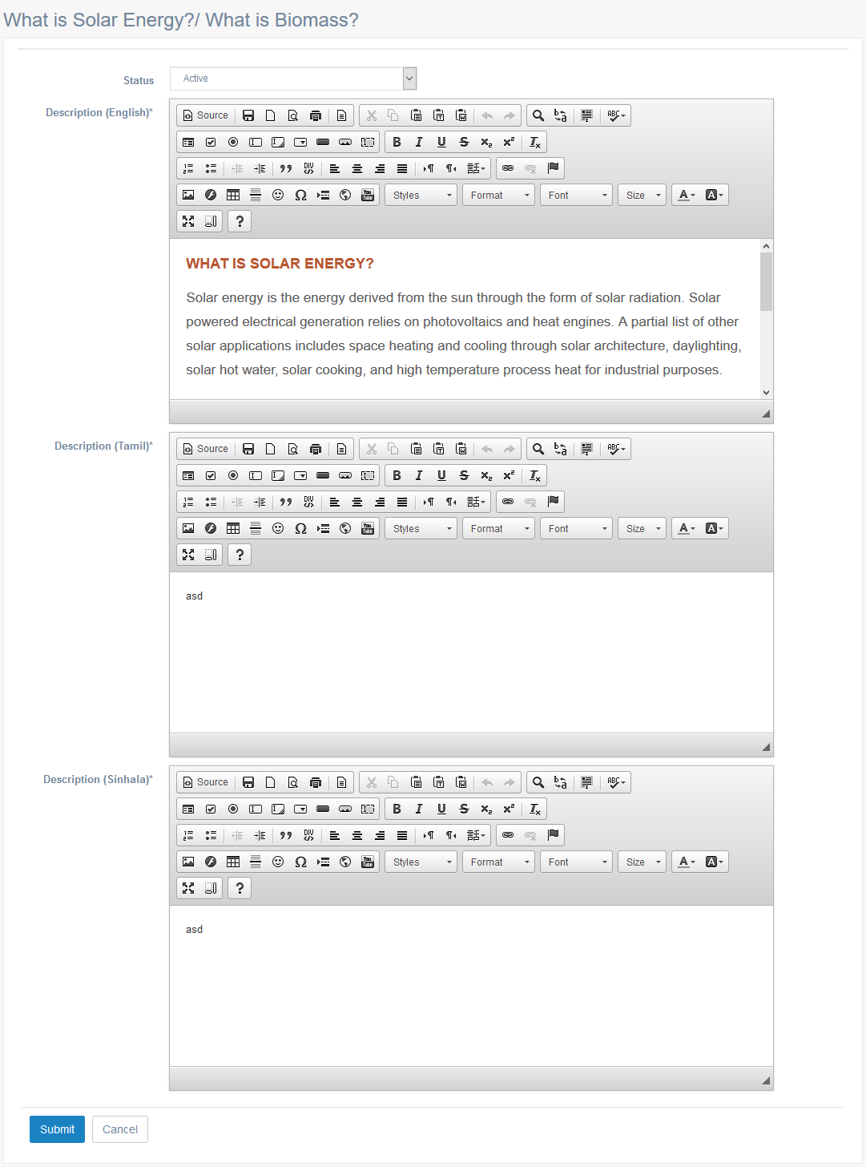

Criteria | Satisfied | Unsatisfied
Accuracy and Order of text fields

Readability and Understandability of
the content

Overall appearance of the form

Accepted by
Name : ……………………… Signature: ………………….. Date: ……………

User Acceptance Testing – Acceptance Sign-Off Form
  - User : Admin
  - From Name : Knowledge Hub – Renewable Energy – Sri Lankan Scenario
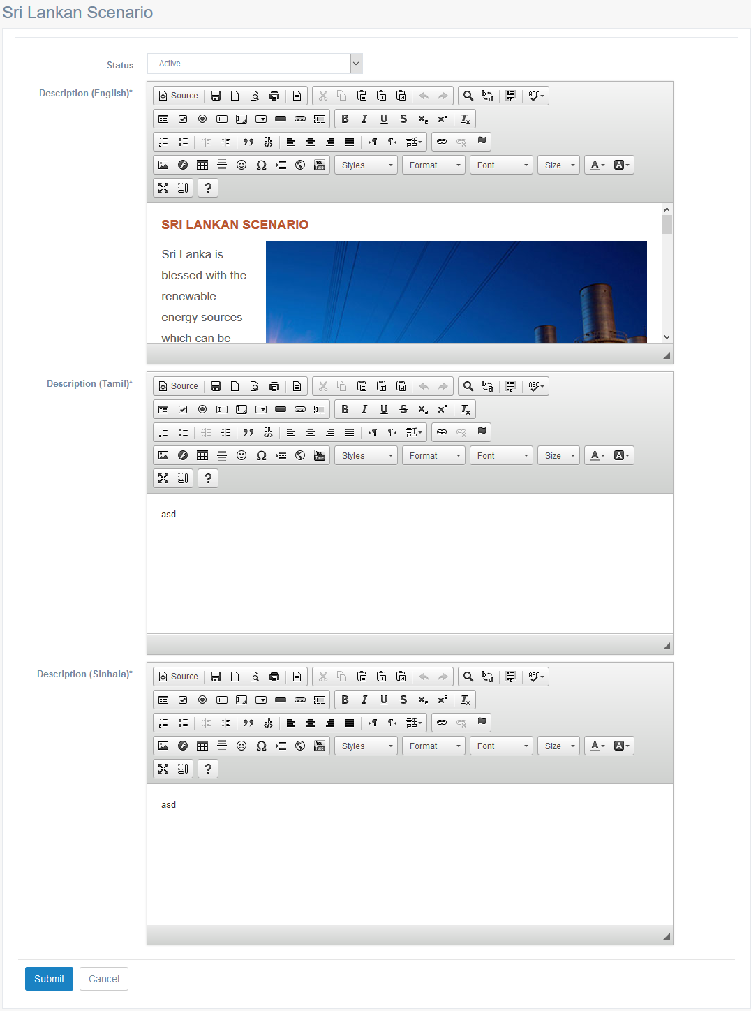

Criteria | Satisfied | Unsatisfied
Accuracy and Order of text fields

Readability and Understandability of
the content

Overall appearance of the form

Accepted by
Name : ……………………… Signature: ………………….. Date: ……………

User Acceptance Testing – Acceptance Sign-Off Form
  - User : Admin
  - From Name : Knowledge Hub – Transmission Network
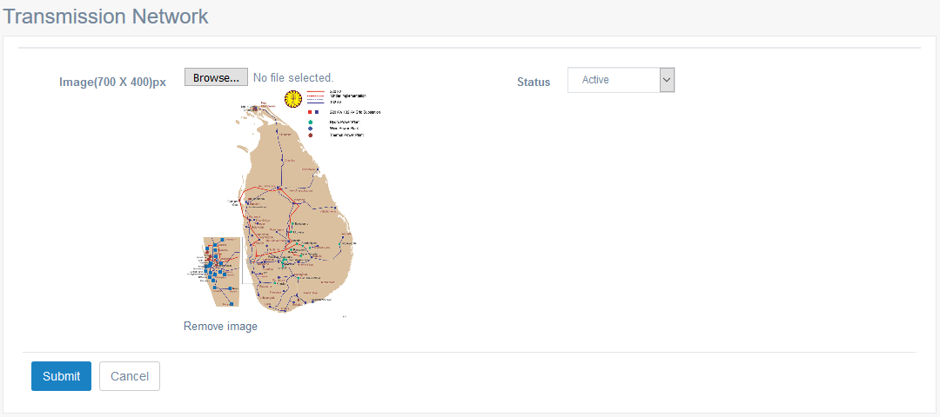

Criteria | Satisfied | Unsatisfied
Accuracy and Order of text fields

Readability and Understandability of
the content

Overall appearance of the form

Accepted by
Name : ……………………… Signature: ………………….. Date: ……………

User Acceptance Testing – Acceptance Sign-Off Form
  - User : Admin
  - From Name : Knowledge Hub – Public Awareness – List
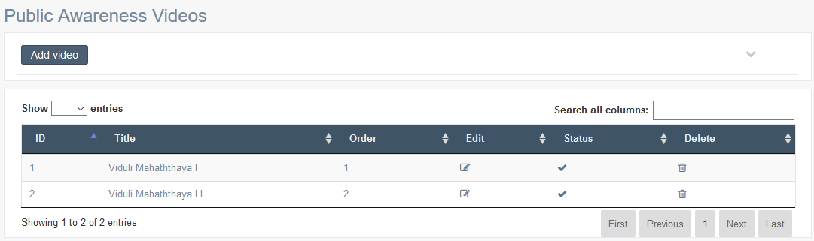

Criteria | Satisfied | Unsatisfied
Accuracy and Order of text fields

Readability and Understandability of
the content

Overall appearance of the form

Accepted by
Name : ……………………… Signature: ………………….. Date: ……………

User Acceptance Testing – Acceptance Sign-Off Form
  - User : Admin
  - From Name : Knowledge Hub – Public Awareness – Add Video
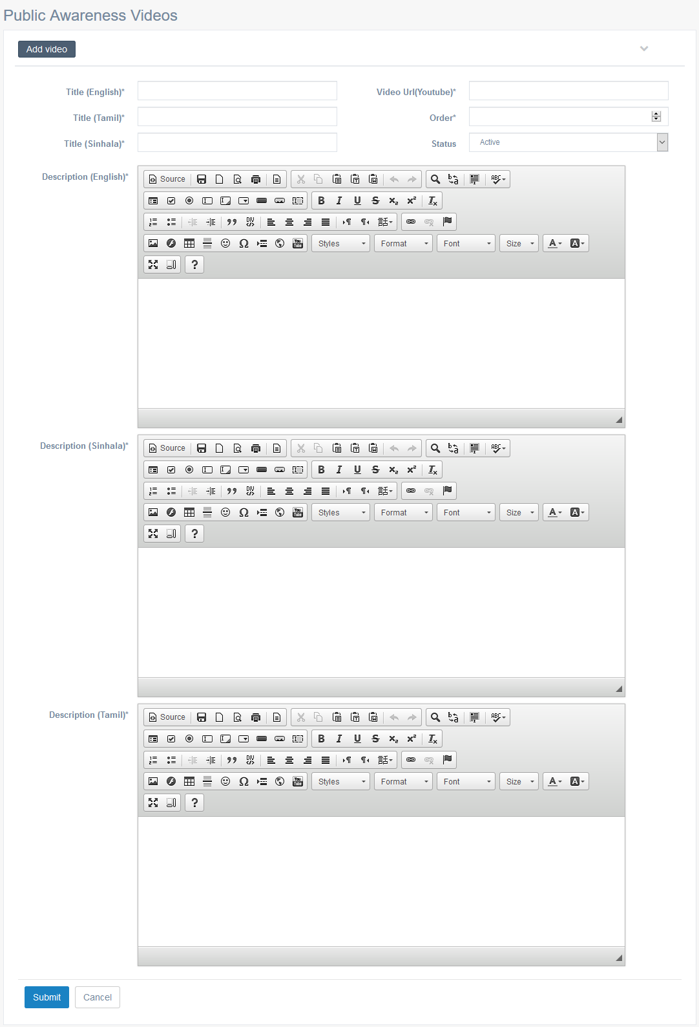

Criteria | Satisfied | Unsatisfied
Accuracy and Order of text fields

Readability and Understandability of
the content

Overall appearance of the form

Accepted by
Name : ……………………… Signature: ………………….. Date: ……………

User Acceptance Testing – Acceptance Sign-Off Form
  - User : Admin
  - From Name : Knowledge Hub – Public Awareness – Edit Video
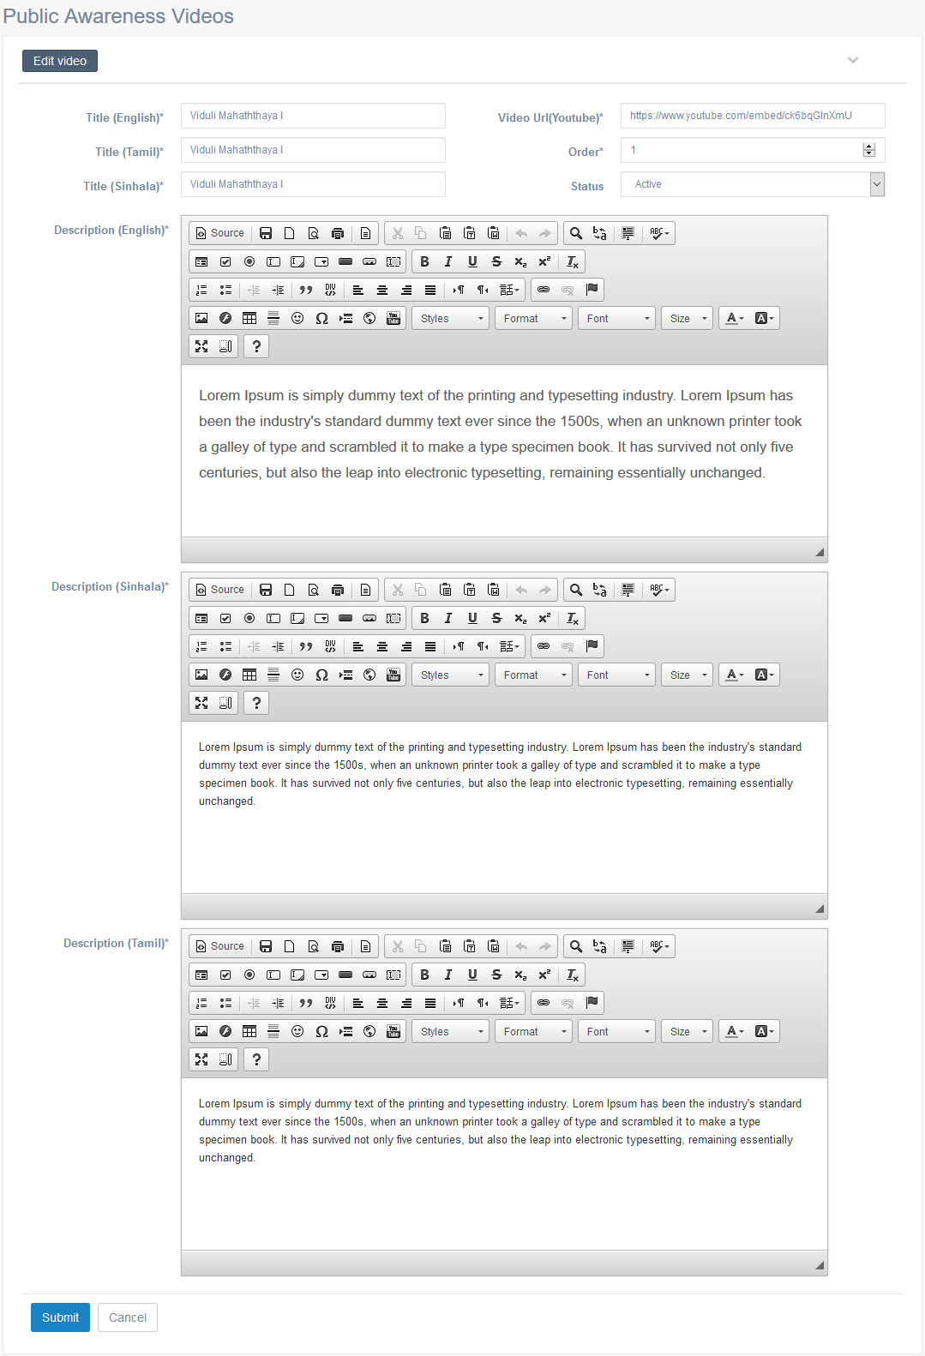

Criteria | Satisfied | Unsatisfied
Accuracy and Order of text fields

Readability and Understandability of
the content

Overall appearance of the form

Accepted by
Name : ……………………… Signature: ………………….. Date: ……………

User Acceptance Testing – Acceptance Sign-Off Form
  - User : Admin
  - From Name : Knowledge Hub – Generation Network – Generating Plant – List
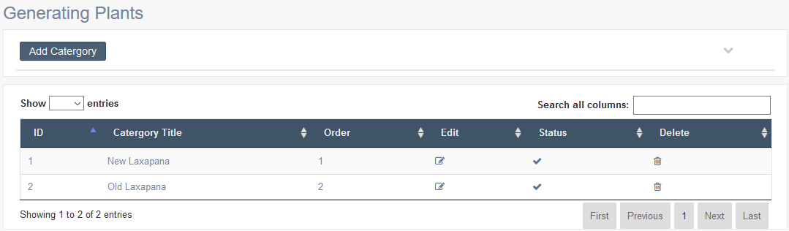

Criteria | Satisfied | Unsatisfied
Accuracy and Order of text fields

Readability and Understandability of
the content

Overall appearance of the form

Accepted by
Name : ……………………… Signature: ………………….. Date: ……………

User Acceptance Testing – Acceptance Sign-Off Form
  - User : Admin
  - From Name : Generation Network – Generating Plant – Add Plant
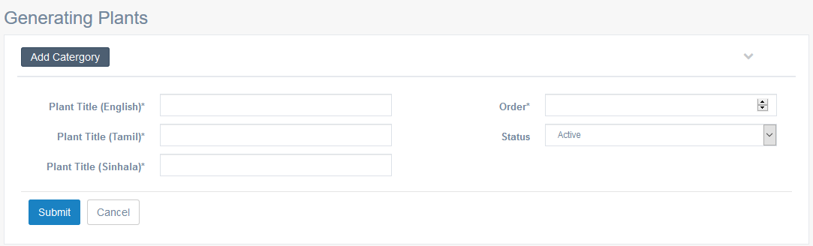

Criteria | Satisfied | Unsatisfied
Accuracy and Order of text fields

Readability and Understandability of
the content

Overall appearance of the form

Accepted by
Name : ……………………… Signature: ………………….. Date: ……………

User Acceptance Testing – Acceptance Sign-Off Form
  - User : Admin
  - From Name : Generation Network – Generating Plant – Edit Plant
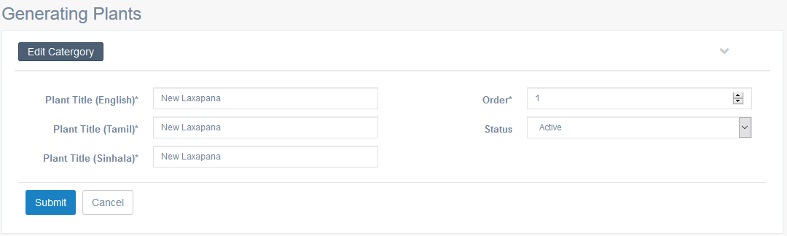

Criteria | Satisfied | Unsatisfied
Accuracy and Order of text fields

Readability and Understandability of
the content

Overall appearance of the form

Accepted by
Name : ……………………… Signature: ………………….. Date: ……………

User Acceptance Testing – Acceptance Sign-Off Form
  - User : Admin
  - From Name : Generation Network – Our Grid Network – List
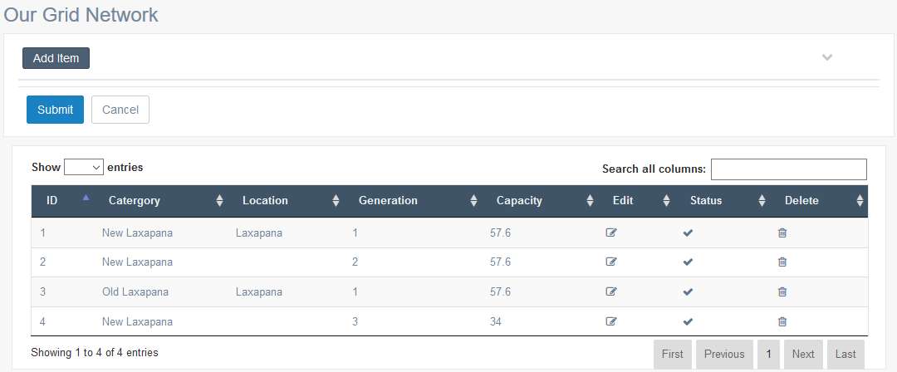

Criteria | Satisfied | Unsatisfied
Accuracy and Order of text fields

Readability and Understandability of
the content

Overall appearance of the form

Accepted by
Name : ……………………… Signature: ………………….. Date: ……………

User Acceptance Testing – Acceptance Sign-Off Form
  - User : Admin
  - From Name : Generation Network – Our Grid Network – Add Details
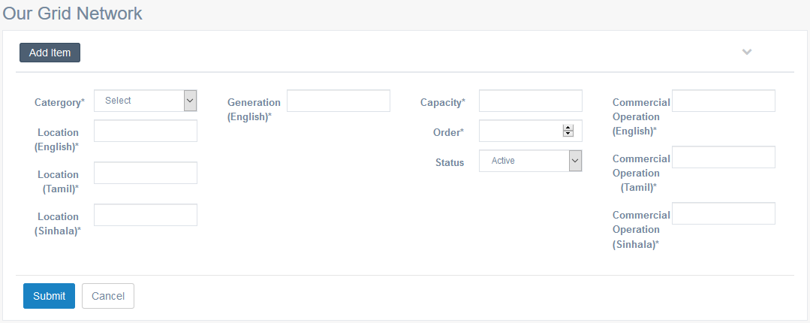

Criteria | Satisfied | Unsatisfied
Accuracy and Order of text fields

Readability and Understandability of
the content

Overall appearance of the form

Accepted by
Name : ……………………… Signature: ………………….. Date: ……………

User Acceptance Testing – Acceptance Sign-Off Form
  - User : Admin
  - From Name : Generation Network – Our Grid Network – Edit Details
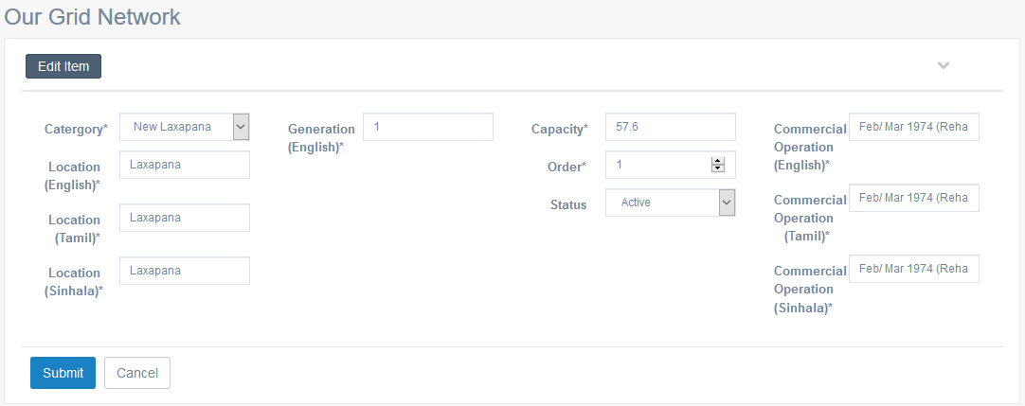

Criteria | Satisfied | Unsatisfied
Accuracy and Order of text fields

Readability and Understandability of
the content

Overall appearance of the form

Accepted by
Name : ……………………… Signature: ………………….. Date: ……………

User Acceptance Testing – Acceptance Sign-Off Form
  - User : Admin
  - From Name : International Standards
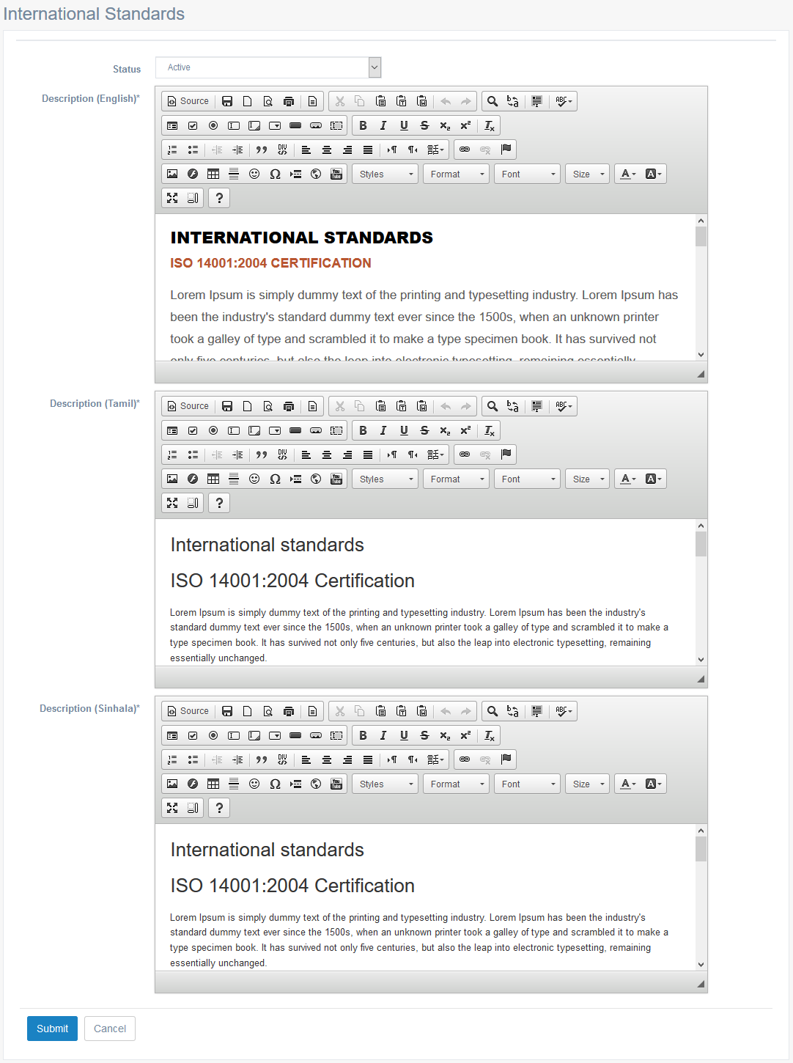

Criteria | Satisfied | Unsatisfied
Accuracy and Order of text fields

Readability and Understandability of
the content

Overall appearance of the form

Accepted by
Name : ……………………… Signature: ………………….. Date: ……………

User Acceptance Testing – Acceptance Sign-Off Form
  - User : Admin
  - From Name : Projects – List
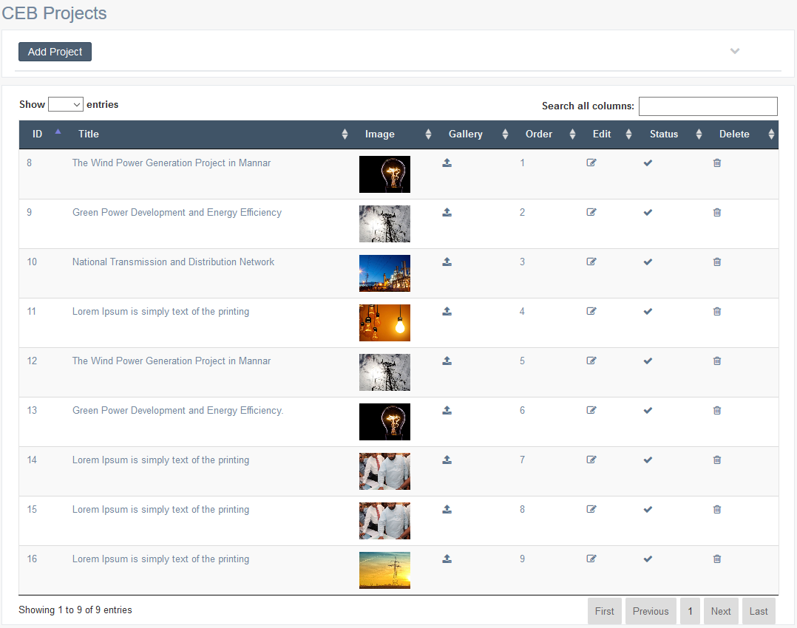

Criteria | Satisfied | Unsatisfied
Accuracy and Order of text fields

Readability and Understandability of
the content

Overall appearance of the form

Accepted by
Name : ……………………… Signature: ………………….. Date: ……………

User Acceptance Testing – Acceptance Sign-Off Form
  - User : Admin
  - From Name : Projects – Add Project
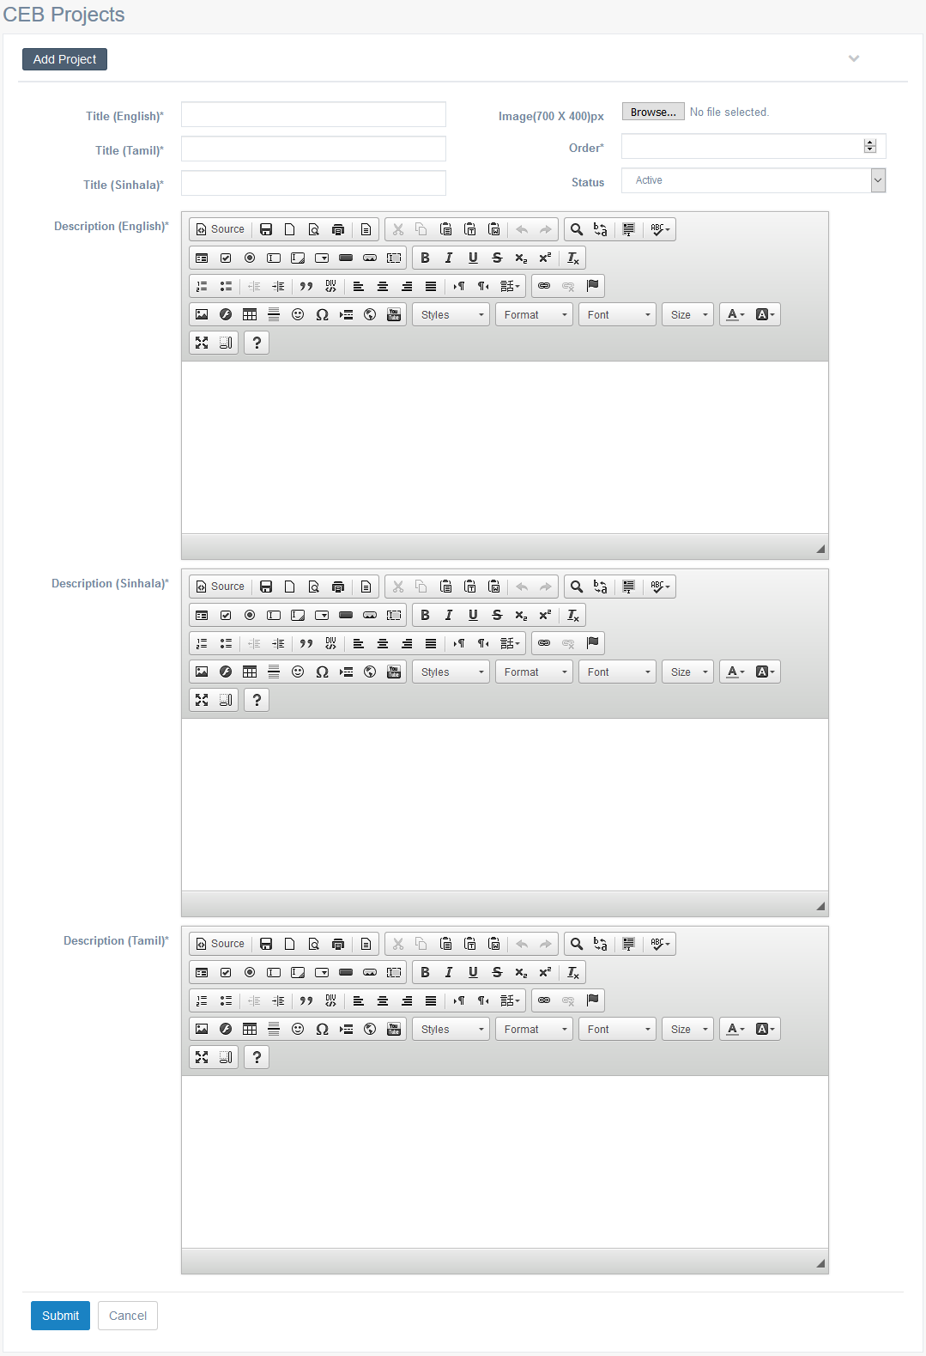

Criteria | Satisfied | Unsatisfied
Accuracy and Order of text fields

Readability and Understandability of
the content

Overall appearance of the form

Accepted by
Name : ……………………… Signature: ………………….. Date: ……………

User Acceptance Testing – Acceptance Sign-Off Form
  - User : Admin
  - From Name : Projects – Edit Project
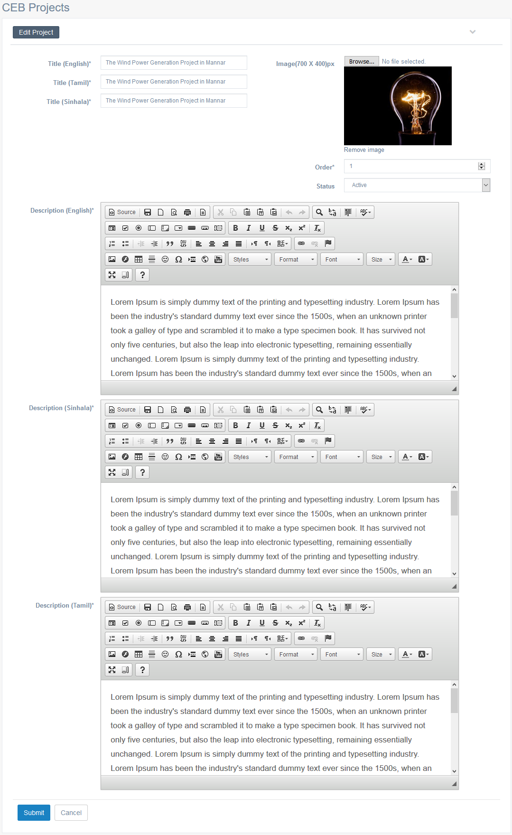

Criteria | Satisfied | Unsatisfied
Accuracy and Order of text fields

Readability and Understandability of
the content

Overall appearance of the form

Accepted by
Name : ……………………… Signature: ………………….. Date: ……………

User Acceptance Testing – Acceptance Sign-Off Form
  - User : Admin
  - From Name : Projects – Gallery


Criteria | Satisfied | Unsatisfied
Accuracy and Order of text fields

Readability and Understandability of
the content

Overall appearance of the form

Accepted by
Name : ……………………… Signature: ………………….. Date: ……………

User Acceptance Testing – Acceptance Sign-Off Form
  - User : Admin
  - From Name : New Customer – How Can I get an Electricity
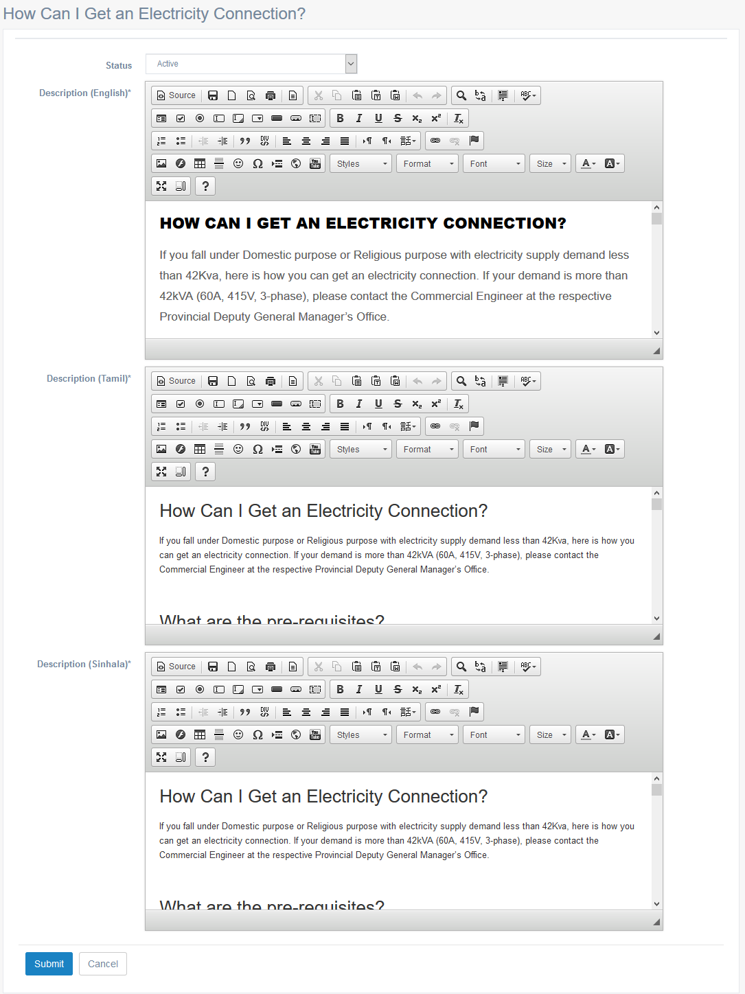

Criteria | Satisfied | Unsatisfied
Accuracy and Order of text fields

Readability and Understandability of
the content

Overall appearance of the form

Accepted by
Name : ……………………… Signature: ………………….. Date: ……………

User Acceptance Testing – Acceptance Sign-Off Form
  - User : Admin
  - From Name : New Customer – Download Applications – Main Category – List
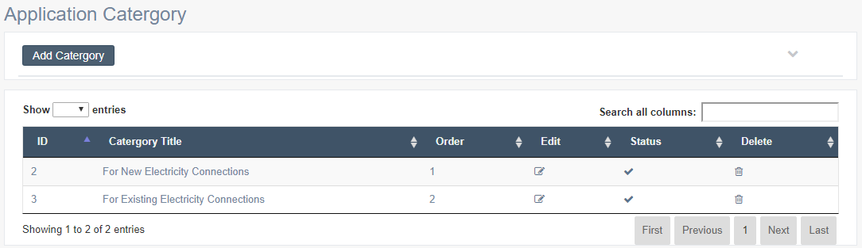

Criteria | Satisfied | Unsatisfied
Accuracy and Order of text fields

Readability and Understandability of
the content

Overall appearance of the form

Accepted by
Name : ……………………… Signature: ………………….. Date: ……………

User Acceptance Testing – Acceptance Sign-Off Form
  - User : Admin
  - From Name : Main Category – Add Category
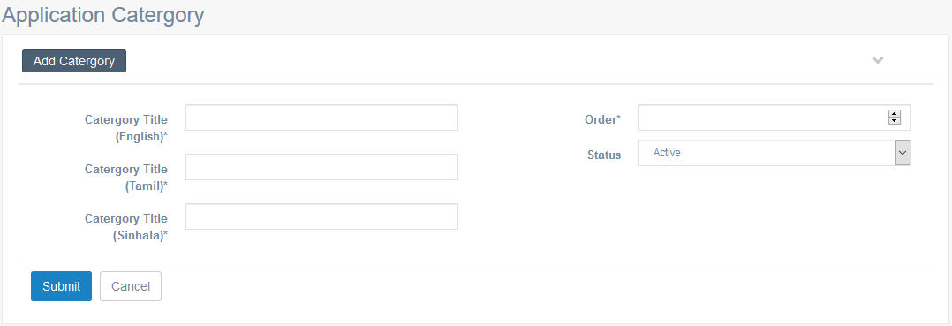

Criteria | Satisfied | Unsatisfied
Accuracy and Order of text fields

Readability and Understandability of
the content

Overall appearance of the form

Accepted by
Name : ……………………… Signature: ………………….. Date: ……………

User Acceptance Testing – Acceptance Sign-Off Form
  - User : Admin
  - From Name : Main Category – Edit Category
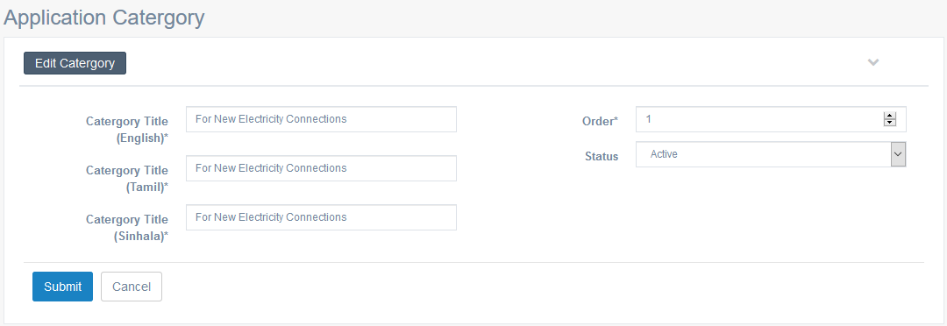

Criteria | Satisfied | Unsatisfied
Accuracy and Order of text fields

Readability and Understandability of
the content

Overall appearance of the form

Accepted by
Name : ……………………… Signature: ………………….. Date: ……………

User Acceptance Testing – Acceptance Sign-Off Form
  - User : Admin
  - From Name : Sub Category – List
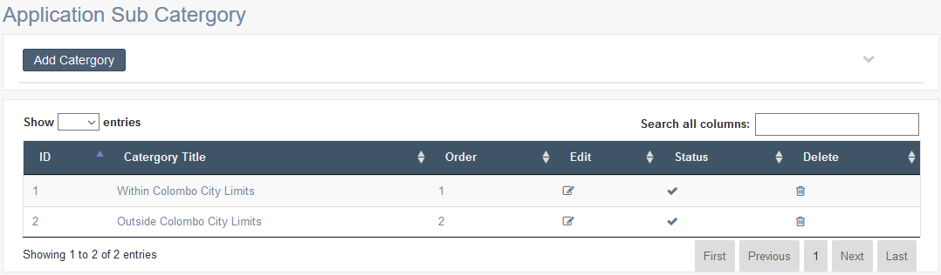

Criteria | Satisfied | Unsatisfied
Accuracy and Order of text fields

Readability and Understandability of
the content

Overall appearance of the form

Accepted by
Name : ……………………… Signature: ………………….. Date: ……………

User Acceptance Testing – Acceptance Sign-Off Form
  - User : Admin
  - From Name : Sub Category – Add Details
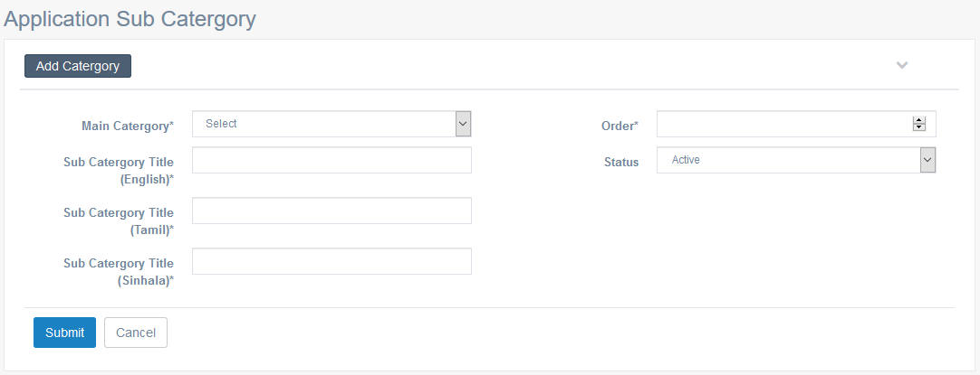

Criteria | Satisfied | Unsatisfied
Accuracy and Order of text fields

Readability and Understandability of
the content

Overall appearance of the form

Accepted by
Name : ……………………… Signature: ………………….. Date: ……………

User Acceptance Testing – Acceptance Sign-Off Form
  - User : Admin
  - From Name : Sub Category – Edit Details
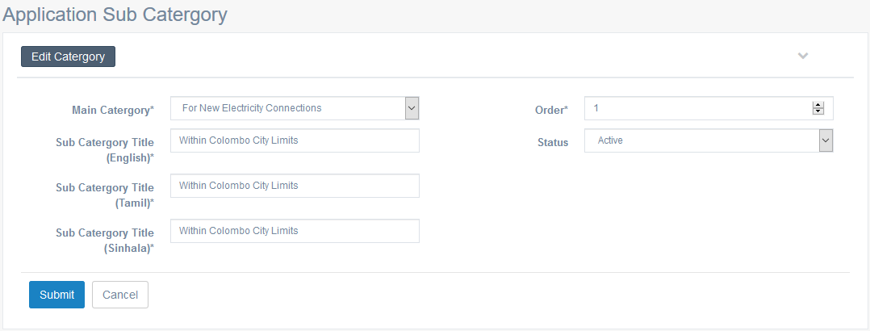

Criteria | Satisfied | Unsatisfied
Accuracy and Order of text fields

Readability and Understandability of
the content

Overall appearance of the form

Accepted by
Name : ……………………… Signature: ………………….. Date: ……………

User Acceptance Testing – Acceptance Sign-Off Form
  - User : Admin
  - From Name : Download Applications – List
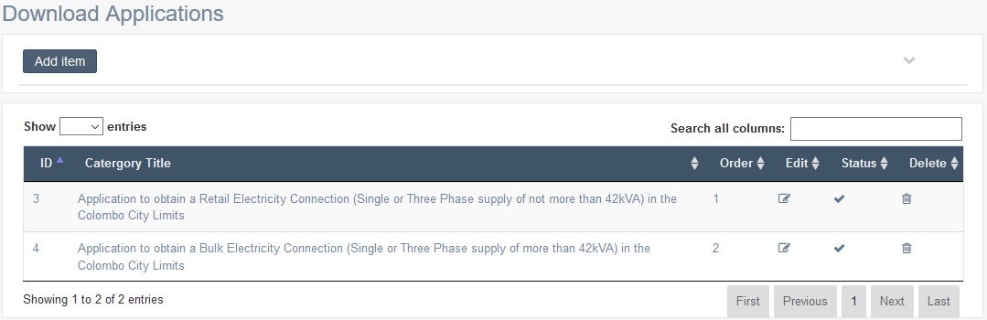

Criteria | Satisfied | Unsatisfied
Accuracy and Order of text fields

Readability and Understandability of
the content

Overall appearance of the form

Accepted by
Name : ……………………… Signature: ………………….. Date: ……………

User Acceptance Testing – Acceptance Sign-Off Form
  - User : Admin
  - From Name : Download Applications – Add Details
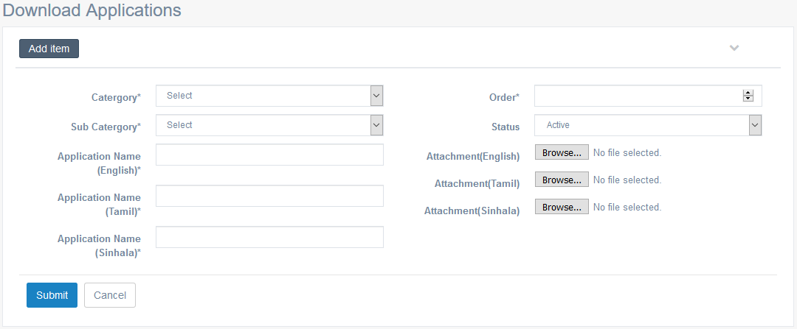

Criteria | Satisfied | Unsatisfied
Accuracy and Order of text fields

Readability and Understandability of
the content

Overall appearance of the form

Accepted by
Name : ……………………… Signature: ………………….. Date: ……………

User Acceptance Testing – Acceptance Sign-Off Form
  - User : Admin
  - From Name : Download Applications – Edit Details
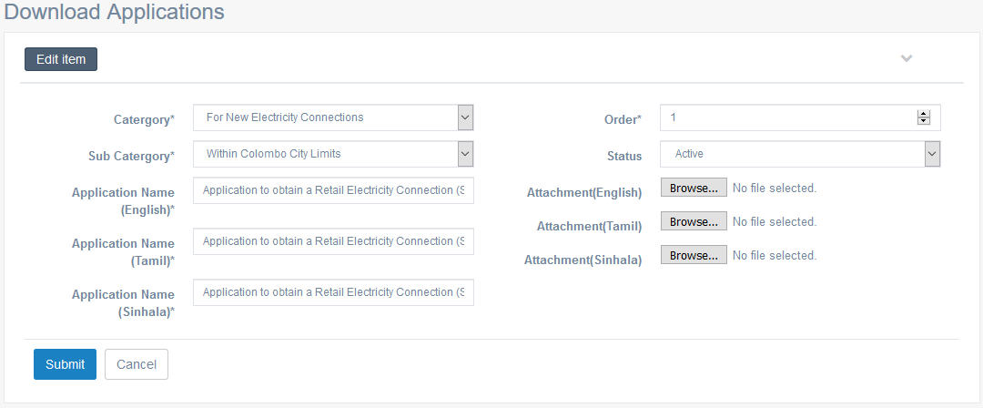

Criteria | Satisfied | Unsatisfied
Accuracy and Order of text fields

Readability and Understandability of
the content

Overall appearance of the form

Accepted by
Name : ……………………… Signature: ………………….. Date: ……………

User Acceptance Testing – Acceptance Sign-Off Form
  - User : Admin
  - From Name : Existing Customer – Tariff Category – Purpose Description – List
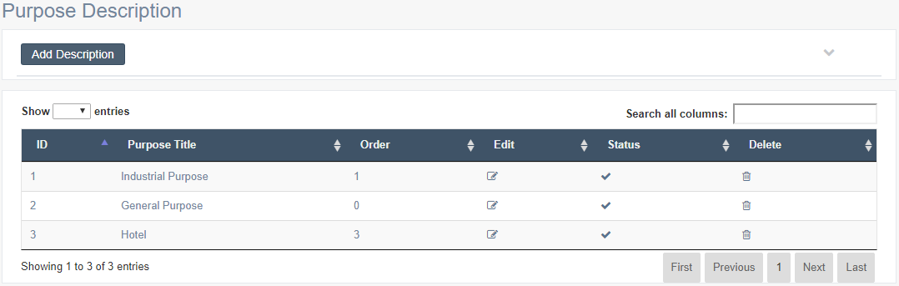

Criteria | Satisfied | Unsatisfied
Accuracy and Order of text fields

Readability and Understandability of
the content

Overall appearance of the form

Accepted by
Name : ……………………… Signature: ………………….. Date: ……………

User Acceptance Testing – Acceptance Sign-Off Form
  - User : Admin
  - From Name : Purpose Description – Add Description
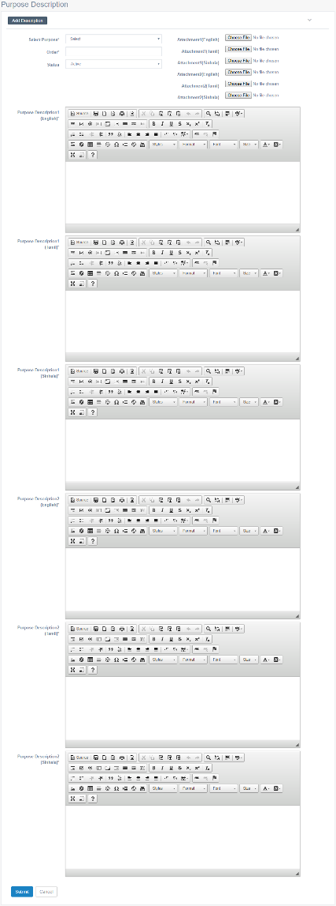

Criteria | Satisfied | Unsatisfied
Accuracy and Order of text fields

Readability and Understandability of
the content

Overall appearance of the form

Accepted by
Name : ……………………… Signature: ………………….. Date: ……………

User Acceptance Testing – Acceptance Sign-Off Form
  - User : Admin
  - From Name : Purpose Description – Edit Description
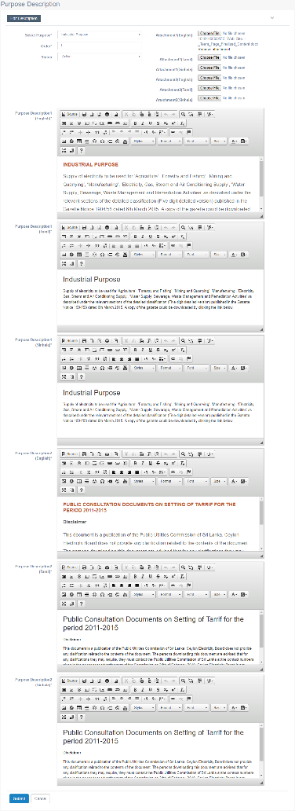

Criteria | Satisfied | Unsatisfied
Accuracy and Order of text fields

Readability and Understandability of
the content

Overall appearance of the form

Accepted by
Name : ……………………… Signature: ………………….. Date: ……………

User Acceptance Testing – Acceptance Sign-Off Form
  - User : Admin
  - From Name : Customer Category – List
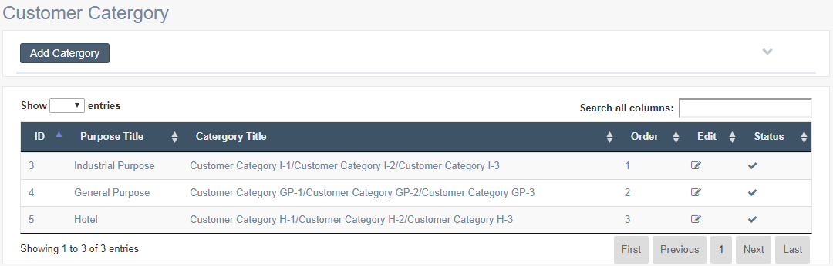

Criteria | Satisfied | Unsatisfied
Accuracy and Order of text fields

Readability and Understandability of
the content

Overall appearance of the form

Accepted by
Name : ……………………… Signature: ………………….. Date: ……………

User Acceptance Testing – Acceptance Sign-Off Form
  - User : Admin
  - From Name : Customer Category – Add Category
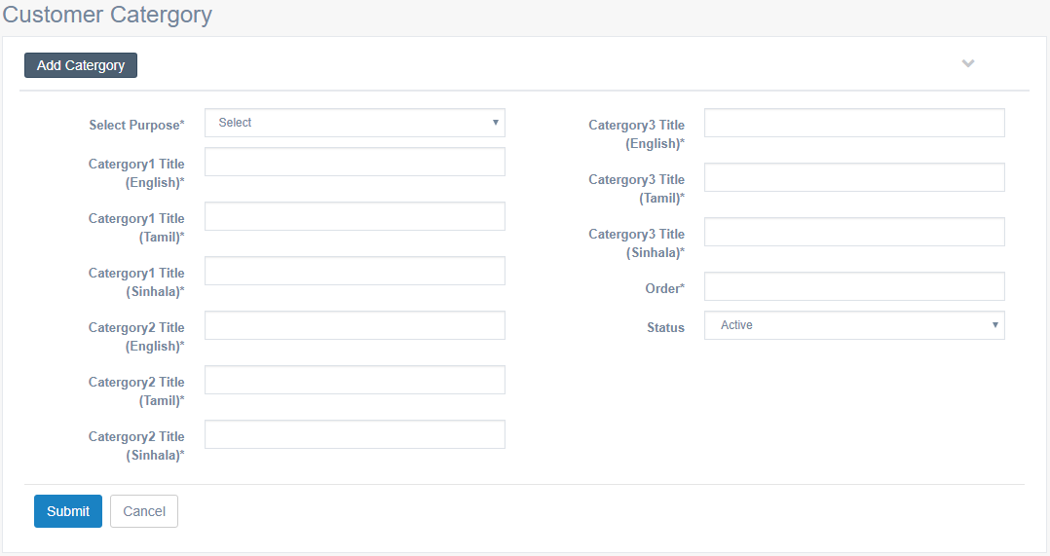

Criteria | Satisfied | Unsatisfied
Accuracy and Order of text fields

Readability and Understandability of
the content

Overall appearance of the form

Accepted by
Name : ……………………… Signature: ………………….. Date: ……………

User Acceptance Testing – Acceptance Sign-Off Form
  - User : Admin
  - From Name : Customer Category – Edit Category
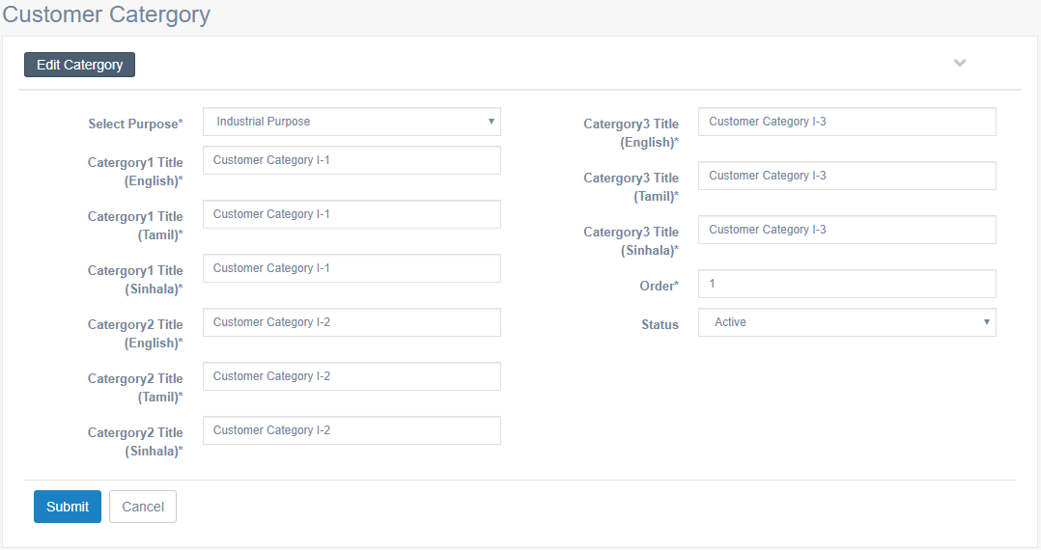

Criteria | Satisfied | Unsatisfied
Accuracy and Order of text fields

Readability and Understandability of
the content

Overall appearance of the form

Accepted by
Name : ……………………… Signature: ………………….. Date: ……………

User Acceptance Testing – Acceptance Sign-Off Form
  - User : Admin
  - From Name : Category Description – List
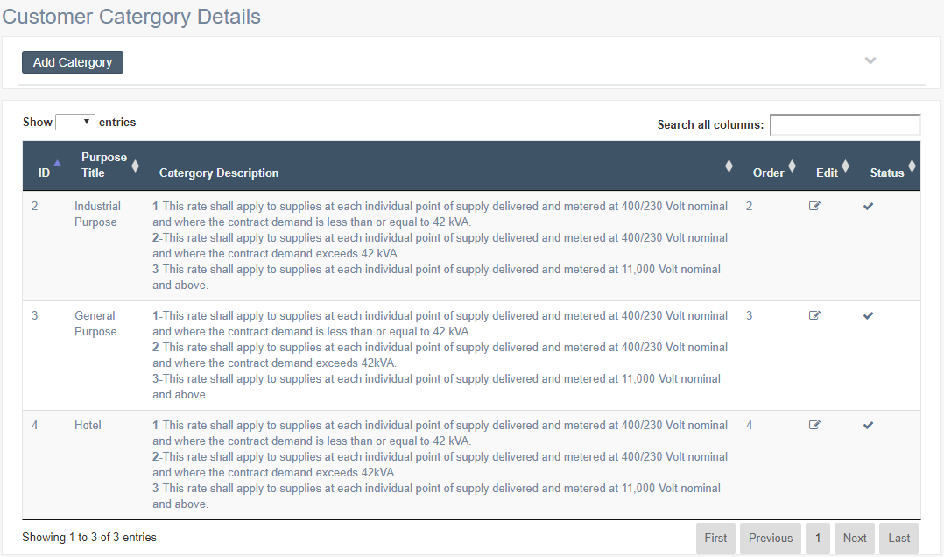

Criteria | Satisfied | Unsatisfied
Accuracy and Order of text fields

Readability and Understandability of
the content

Overall appearance of the form

Accepted by
Name : ……………………… Signature: ………………….. Date: ……………

User Acceptance Testing – Acceptance Sign-Off Form
  - User : Admin
  - From Name : Category Description – Add Details
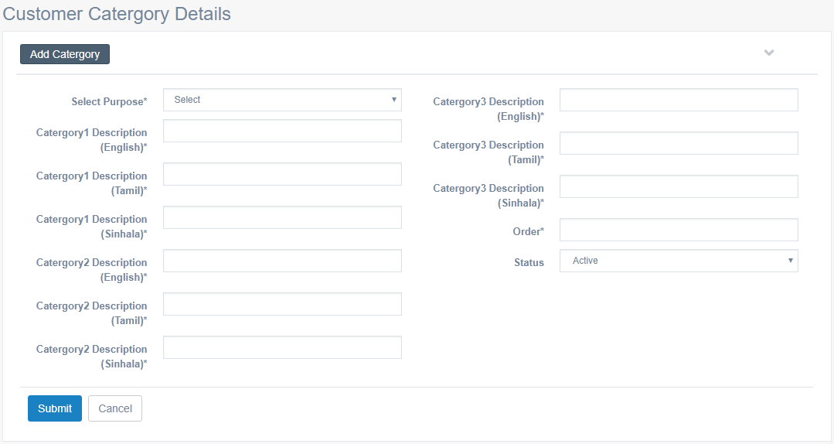

Criteria | Satisfied | Unsatisfied
Accuracy and Order of text fields

Readability and Understandability of
the content

Overall appearance of the form

Accepted by
Name : ……………………… Signature: ………………….. Date: ……………

User Acceptance Testing – Acceptance Sign-Off Form
  - User : Admin
  - From Name : Category Description – Edit Details
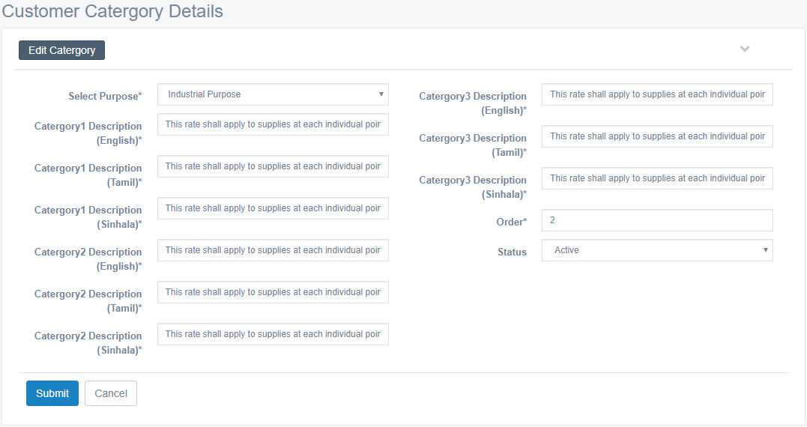

Criteria | Satisfied | Unsatisfied
Accuracy and Order of text fields

Readability and Understandability of
the content

Overall appearance of the form

Accepted by
Name : ……………………… Signature: ………………….. Date: ……………

User Acceptance Testing – Acceptance Sign-Off Form
  - User : Admin
  - From Name : Category 1 – List
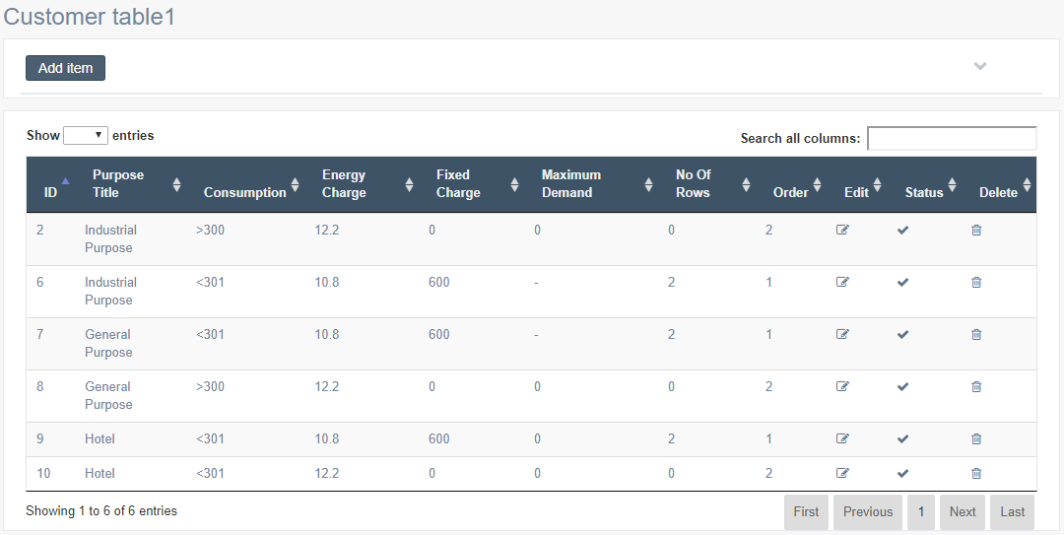

Criteria | Satisfied | Unsatisfied
Accuracy and Order of text fields

Readability and Understandability of
the content

Overall appearance of the form

Accepted by
Name : ……………………… Signature: ………………….. Date: ……………

User Acceptance Testing – Acceptance Sign-Off Form
  - User : Admin
  - From Name : Category 1 – Add Details
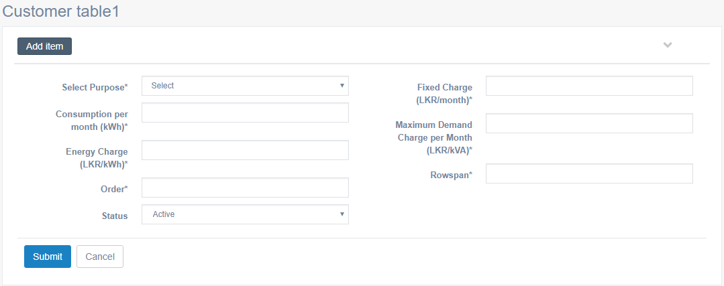

Criteria | Satisfied | Unsatisfied
Accuracy and Order of text fields

Readability and Understandability of
the content

Overall appearance of the form

Accepted by
Name : ……………………… Signature: ………………….. Date: ……………

User Acceptance Testing – Acceptance Sign-Off Form
  - User : Admin
  - From Name : Category 1 – Edit Details
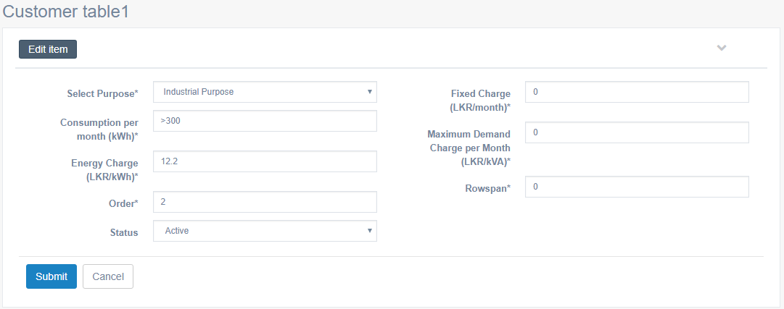

Criteria | Satisfied | Unsatisfied
Accuracy and Order of text fields

Readability and Understandability of
the content

Overall appearance of the form

Accepted by
Name : ……………………… Signature: ………………….. Date: ……………

User Acceptance Testing – Acceptance Sign-Off Form
  - User : Admin
  - From Name : Category 2 – List
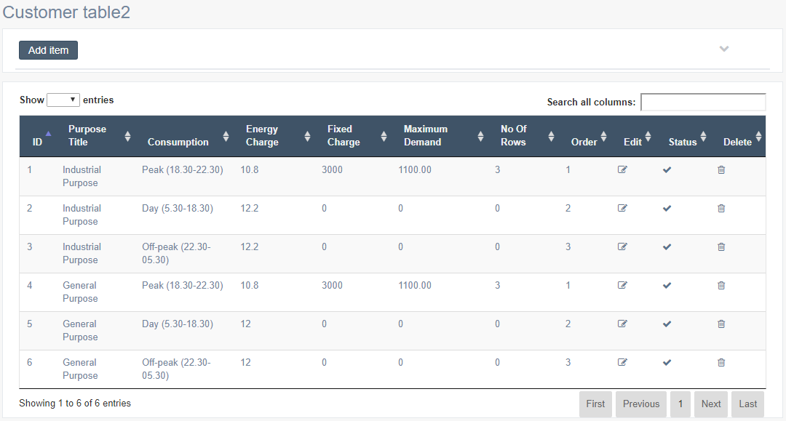

Criteria | Satisfied | Unsatisfied
Accuracy and Order of text fields

Readability and Understandability of
the content

Overall appearance of the form

Accepted by
Name : ……………………… Signature: ………………….. Date: ……………

User Acceptance Testing – Acceptance Sign-Off Form
  - User : Admin
  - From Name : Category 2 – Add Details
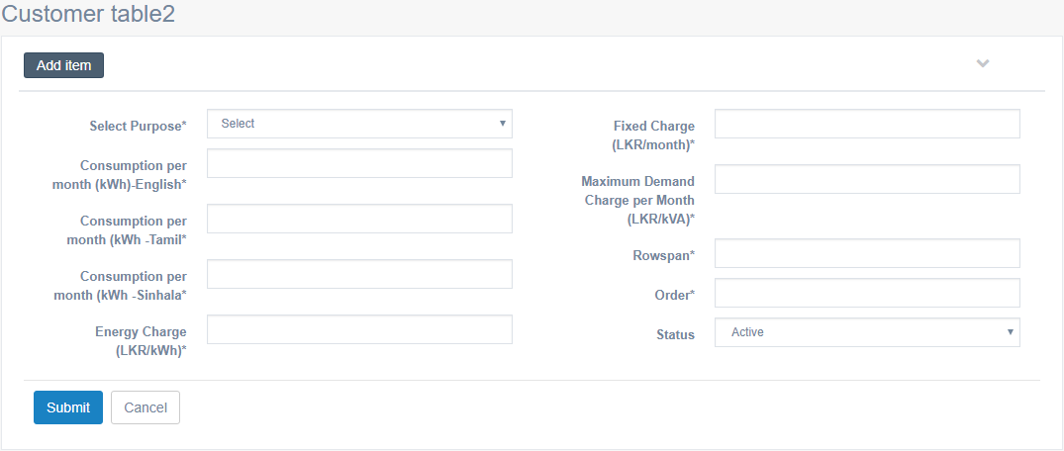

Criteria | Satisfied | Unsatisfied
Accuracy and Order of text fields

Readability and Understandability of
the content

Overall appearance of the form

Accepted by
Name : ……………………… Signature: ………………….. Date: ……………

User Acceptance Testing – Acceptance Sign-Off Form
  - User : Admin
  - From Name : Category 2 – Edit Details
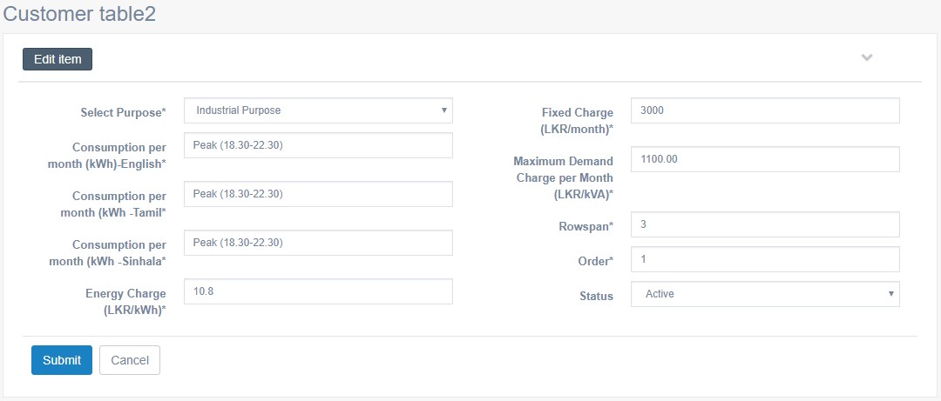

Criteria | Satisfied | Unsatisfied
Accuracy and Order of text fields

Readability and Understandability of
the content

Overall appearance of the form

Accepted by
Name : ……………………… Signature: ………………….. Date: ……………

User Acceptance Testing – Acceptance Sign-Off Form
  - User : Admin
  - From Name : Category 3 – List
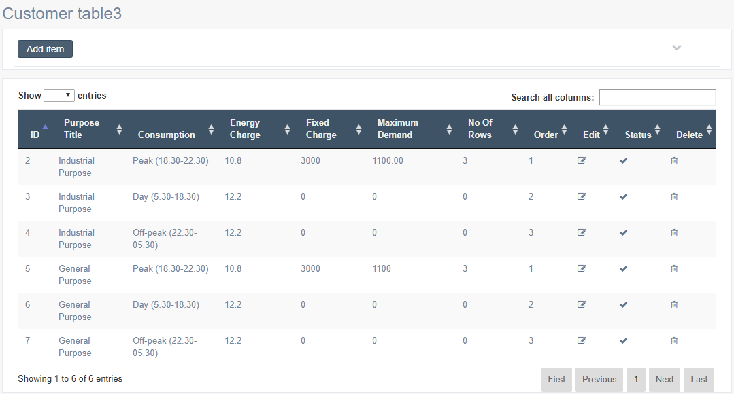

Criteria | Satisfied | Unsatisfied
Accuracy and Order of text fields

Readability and Understandability of
the content

Overall appearance of the form

Accepted by
Name : ……………………… Signature: ………………….. Date: ……………

User Acceptance Testing – Acceptance Sign-Off Form
  - User : Admin
  - From Name : Category 3 – Add Details
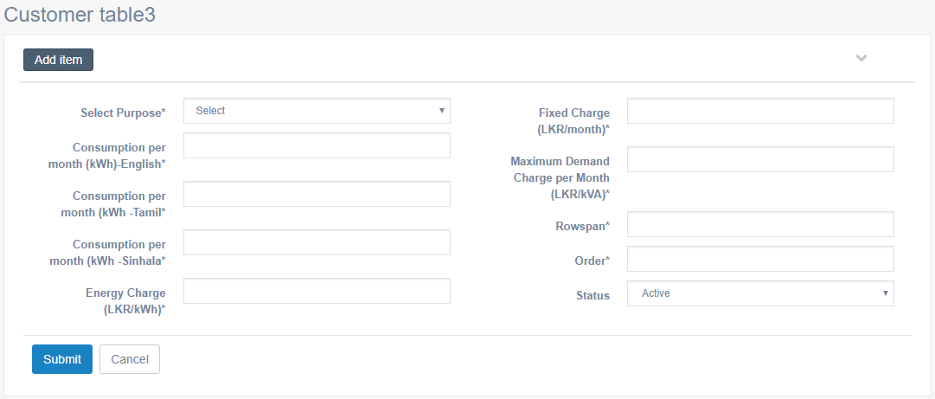

Criteria | Satisfied | Unsatisfied
Accuracy and Order of text fields

Readability and Understandability of
the content

Overall appearance of the form

Accepted by
Name : ……………………… Signature: ………………….. Date: ……………

User Acceptance Testing – Acceptance Sign-Off Form
  - User : Admin
  - From Name : Category 3 – Edit Details
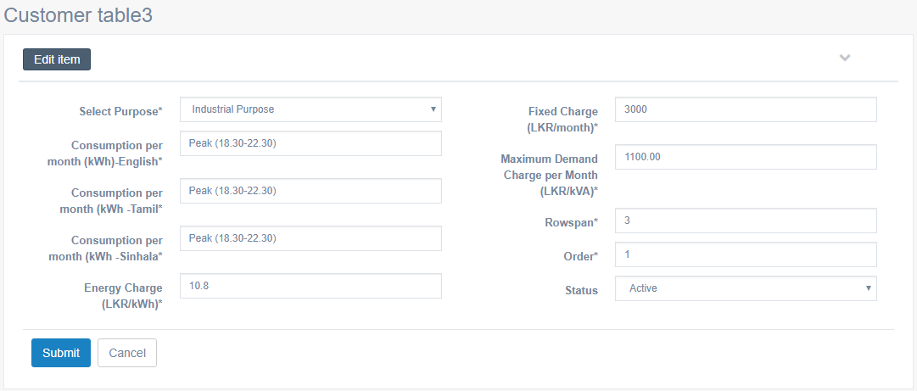

Criteria | Satisfied | Unsatisfied
Accuracy and Order of text fields

Readability and Understandability of
the content

Overall appearance of the form

Accepted by
Name : ……………………… Signature: ………………….. Date: ……………

User Acceptance Testing – Acceptance Sign-Off Form
  - User : Admin
  - From Name : Safety
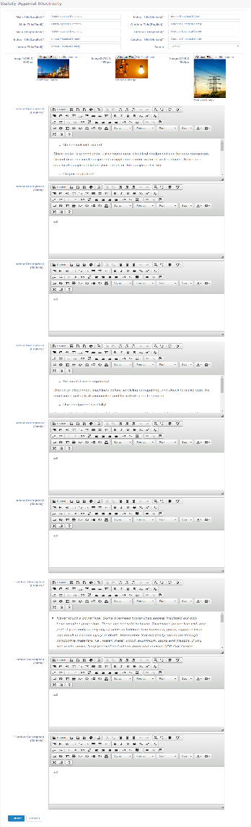

Criteria | Satisfied | Unsatisfied
Accuracy and Order of text fields

Readability and Understandability of
the content

Overall appearance of the form

Accepted by
Name : ……………………… Signature: ………………….. Date: ……………

User Acceptance Testing – Acceptance Sign-Off Form
  - User : Admin
  - From Name : Save Electricity
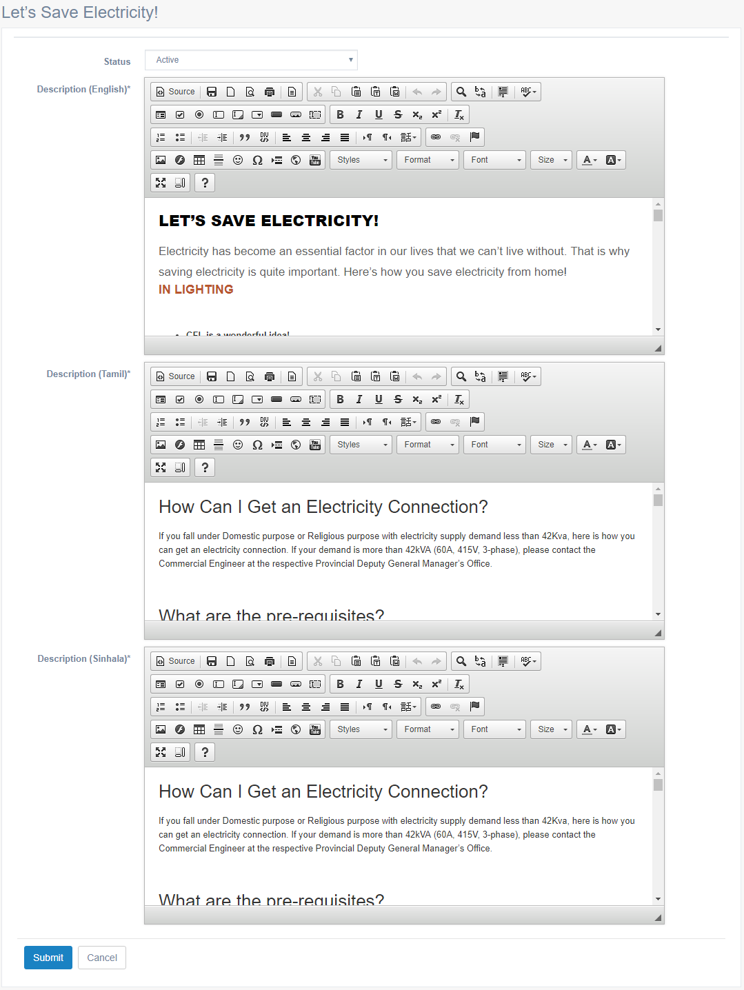

Criteria | Satisfied | Unsatisfied
Accuracy and Order of text fields

Readability and Understandability of
the content

Overall appearance of the form

Accepted by
Name : ……………………… Signature: ………………….. Date: ……………

User Acceptance Testing – Acceptance Sign-Off Form
  - User : Admin
  - From Name : Bill Calculation
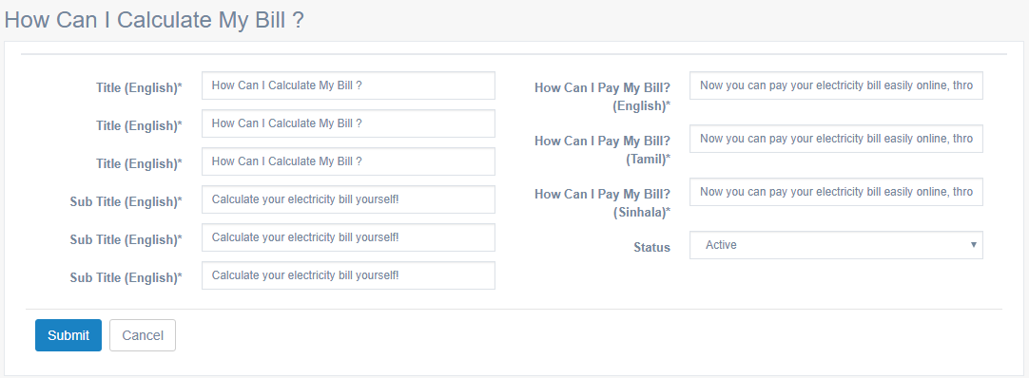

Criteria | Satisfied | Unsatisfied
Accuracy and Order of text fields

Readability and Understandability of
the content

Overall appearance of the form

Accepted by
Name : ……………………… Signature: ………………….. Date: ……………

User Acceptance Testing – Acceptance Sign-Off Form
  - User : Admin
  - From Name : Main Category – List
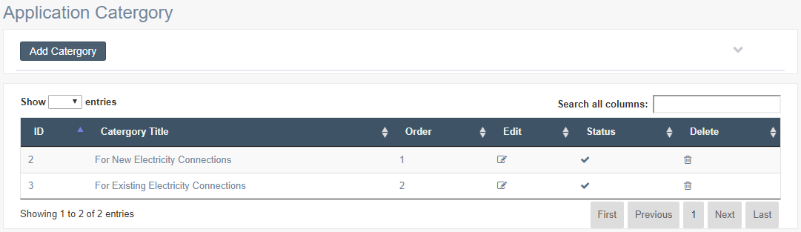

Criteria | Satisfied | Unsatisfied
Accuracy and Order of text fields

Readability and Understandability of
the content

Overall appearance of the form

Accepted by
Name : ……………………… Signature: ………………….. Date: ……………

User Acceptance Testing – Acceptance Sign-Off Form
  - User : Admin
  - From Name : Main Category – Add Details
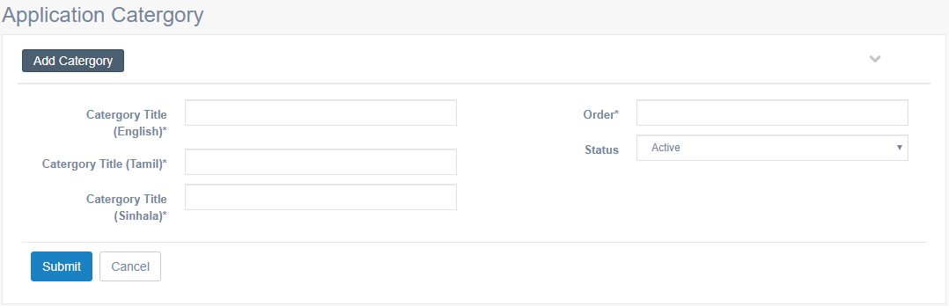

Criteria | Satisfied | Unsatisfied
Accuracy and Order of text fields

Readability and Understandability of
the content

Overall appearance of the form

Accepted by
Name : ……………………… Signature: ………………….. Date: ……………

User Acceptance Testing – Acceptance Sign-Off Form
  - User : Admin
  - From Name : Main Category – Edit Details
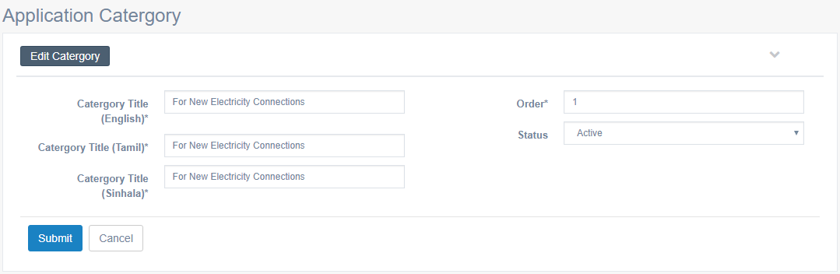

Criteria | Satisfied | Unsatisfied
Accuracy and Order of text fields

Readability and Understandability of
the content

Overall appearance of the form

Accepted by
Name : ……………………… Signature: ………………….. Date: ……………

User Acceptance Testing – Acceptance Sign-Off Form
  - User : Admin
  - From Name : Sub Category – List
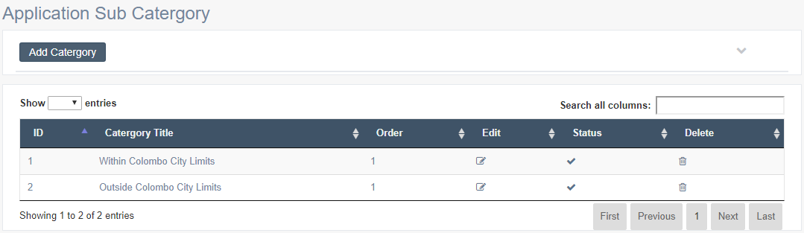

Criteria | Satisfied | Unsatisfied
Accuracy and Order of text fields

Readability and Understandability of
the content

Overall appearance of the form

Accepted by
Name : ……………………… Signature: ………………….. Date: ……………

User Acceptance Testing – Acceptance Sign-Off Form
  - User : Admin
  - From Name : Sub Category – Add Details
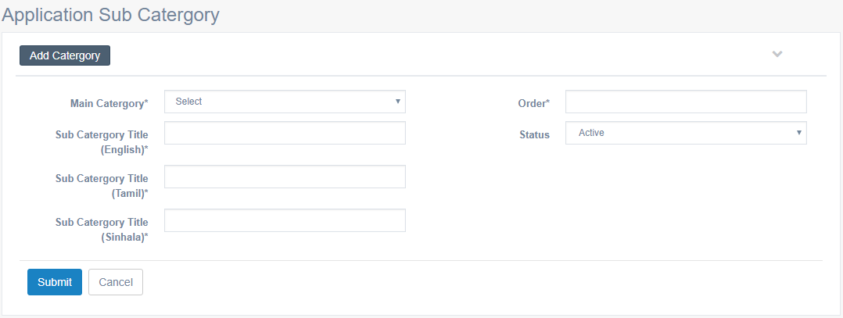

Criteria | Satisfied | Unsatisfied
Accuracy and Order of text fields

Readability and Understandability of
the content

Overall appearance of the form

Accepted by
Name : ……………………… Signature: ………………….. Date: ……………

User Acceptance Testing – Acceptance Sign-Off Form
  - User : Admin
  - From Name : Sub Category – Edit Details
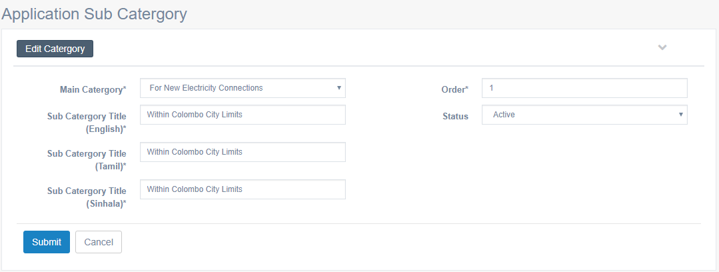

Criteria | Satisfied | Unsatisfied
Accuracy and Order of text fields

Readability and Understandability of
the content

Overall appearance of the form

Accepted by
Name : ……………………… Signature: ………………….. Date: ……………

User Acceptance Testing – Acceptance Sign-Off Form
  - User : Admin
  - From Name : Download Applications – List
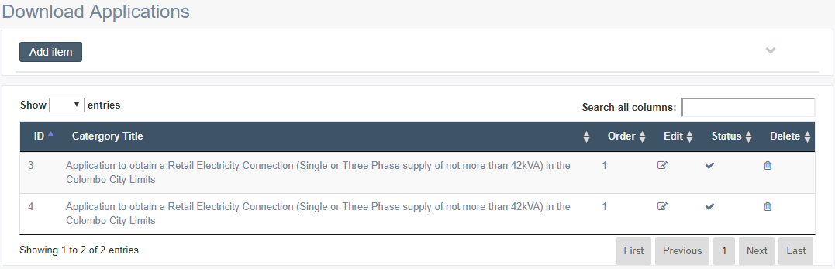

Criteria | Satisfied | Unsatisfied
Accuracy and Order of text fields

Readability and Understandability of
the content

Overall appearance of the form

Accepted by
Name : ……………………… Signature: ………………….. Date: ……………

User Acceptance Testing – Acceptance Sign-Off Form
  - User : Admin
  - From Name : Download Applications – Add Details
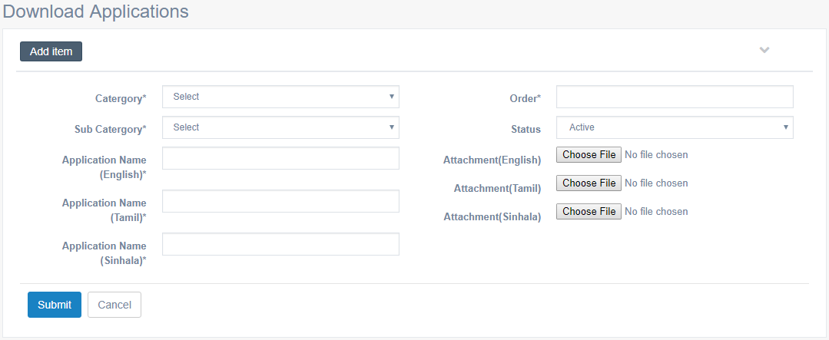

Criteria | Satisfied | Unsatisfied
Accuracy and Order of text fields

Readability and Understandability of
the content

Overall appearance of the form

Accepted by
Name : ……………………… Signature: ………………….. Date: ……………

User Acceptance Testing – Acceptance Sign-Off Form
  - User : Admin
  - From Name : Download Applications – Edit Details
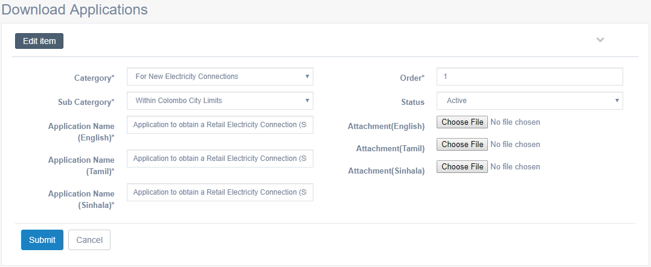

Criteria | Satisfied | Unsatisfied
Accuracy and Order of text fields

Readability and Understandability of
the content

Overall appearance of the form

Accepted by
Name : ……………………… Signature: ………………….. Date: ……………

User Acceptance Testing – Acceptance Sign-Off Form
  - User : Admin
  - From Name : News & Media - List
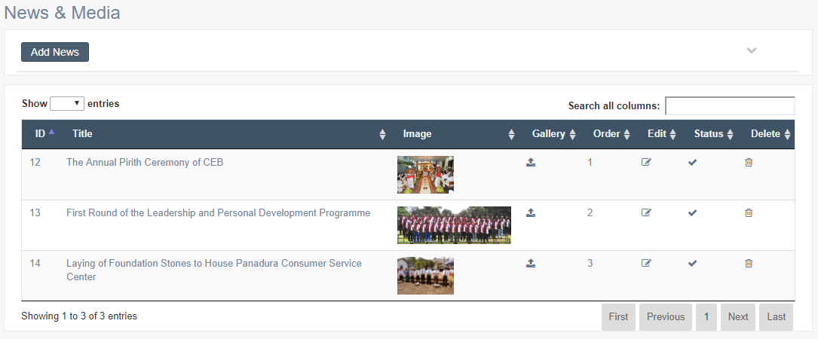

Criteria | Satisfied | Unsatisfied
Accuracy and Order of text fields

Readability and Understandability of
the content

Overall appearance of the form

Accepted by
Name : ……………………… Signature: ………………….. Date: ……………

User Acceptance Testing – Acceptance Sign-Off Form
  - User : Admin
  - From Name : News & Media - Add Details
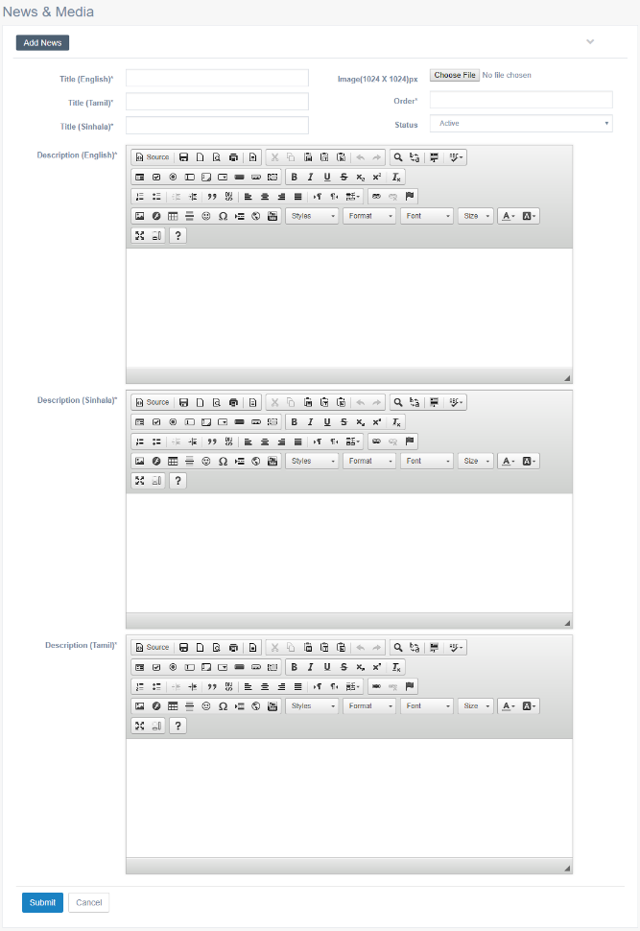

Criteria | Satisfied | Unsatisfied
Accuracy and Order of text fields

Readability and Understandability of
the content

Overall appearance of the form

Accepted by
Name : ……………………… Signature: ………………….. Date: ……………

User Acceptance Testing – Acceptance Sign-Off Form
  - User : Admin
  - From Name : News & Media - Edit Details
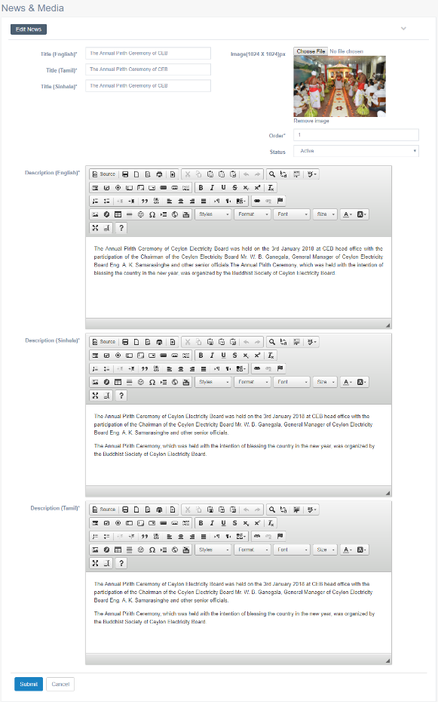

Criteria | Satisfied | Unsatisfied
Accuracy and Order of text fields

Readability and Understandability of
the content

Overall appearance of the form

Accepted by
Name : ……………………… Signature: ………………….. Date: ……………

User Acceptance Testing – Acceptance Sign-Off Form
  - User : Admin
  - From Name : News & Media - Gallery



Criteria | Satisfied | Unsatisfied
Accuracy and Order of text fields

Readability and Understandability of
the content

Overall appearance of the form

Accepted by
Name : ……………………… Signature: ………………….. Date: ……………

User Acceptance Testing – Acceptance Sign-Off Form
  - User : Admin
  - From Name : Reservoir Storage - List

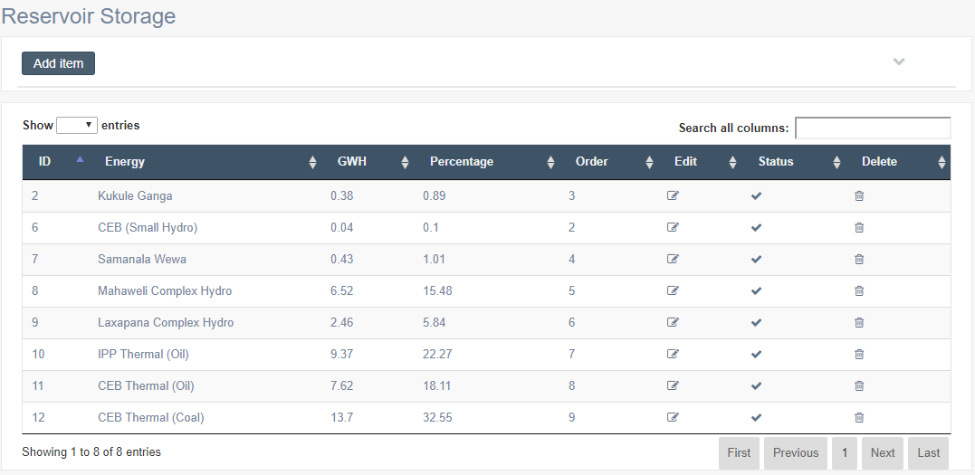

Criteria | Satisfied | Unsatisfied
Accuracy and Order of text fields

Readability and Understandability of
the content

Overall appearance of the form

Accepted by
Name : ……………………… Signature: ………………….. Date: ……………

User Acceptance Testing – Acceptance Sign-Off Form
  - User : Admin
  - From Name : Reservoir Storage - Add Details

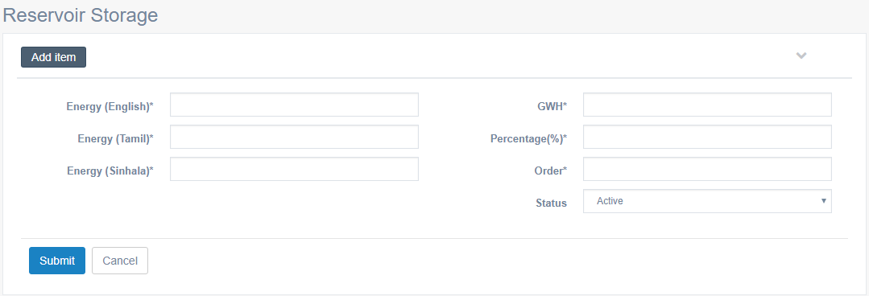

Criteria | Satisfied | Unsatisfied
Accuracy and Order of text fields

Readability and Understandability of
the content

Overall appearance of the form

Accepted by
Name : ……………………… Signature: ………………….. Date: ……………

User Acceptance Testing – Acceptance Sign-Off Form
  - User : Admin
  - From Name : Reservoir Storage - Edit Details

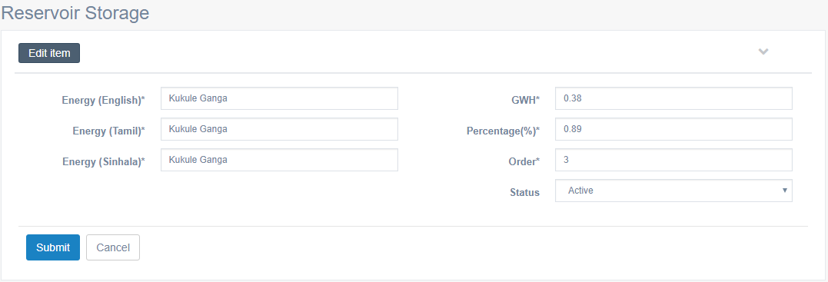

Criteria | Satisfied | Unsatisfied
Accuracy and Order of text fields

Readability and Understandability of
the content

Overall appearance of the form

Accepted by
Name : ……………………… Signature: ………………….. Date: ……………

User Acceptance Testing – Acceptance Sign-Off Form
  - User : Admin
  - From Name : Peak Demand - List
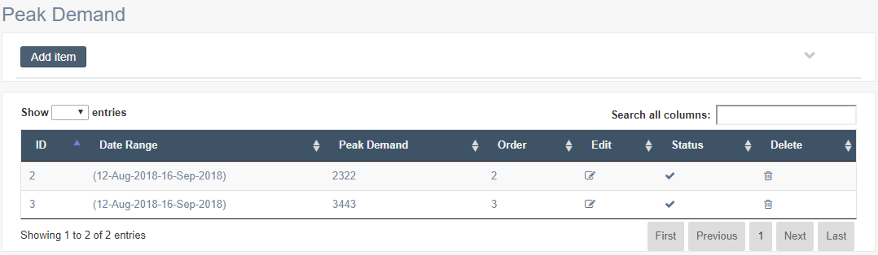

Criteria | Satisfied | Unsatisfied
Accuracy and Order of text fields

Readability and Understandability of
the content

Overall appearance of the form

Accepted by
Name : ……………………… Signature: ………………….. Date: ……………

User Acceptance Testing – Acceptance Sign-Off Form
  - User : Admin
  - From Name : Peak Demand – Add Details

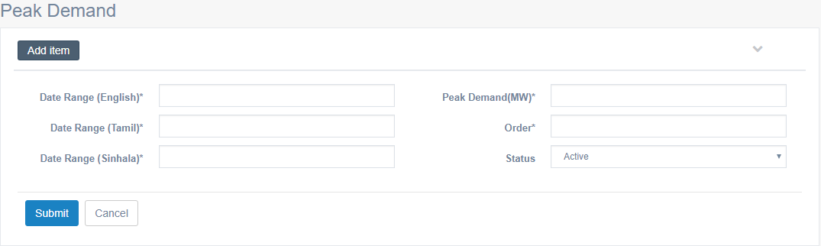

Criteria | Satisfied | Unsatisfied
Accuracy and Order of text fields

Readability and Understandability of
the content

Overall appearance of the form

Accepted by
Name : ……………………… Signature: ………………….. Date: ……………

User Acceptance Testing – Acceptance Sign-Off Form
  - User : Admin
  - From Name : Peak Demand – Edit Details

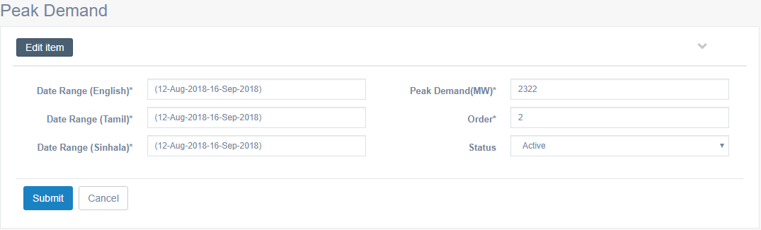

Criteria | Satisfied | Unsatisfied
Accuracy and Order of text fields

Readability and Understandability of
the content

Overall appearance of the form

Accepted by
Name : ……………………… Signature: ………………….. Date: ……………

User Acceptance Testing – Acceptance Sign-Off Form
  - User : Admin
  - From Name : Total Energy - List

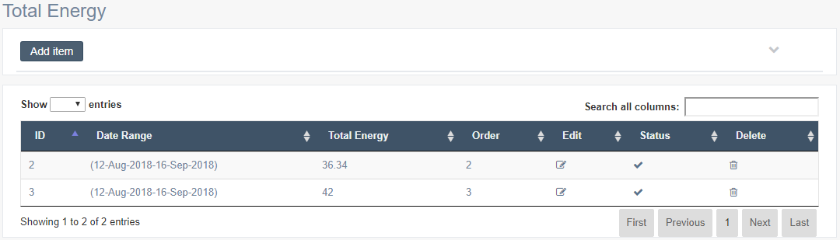

Criteria | Satisfied | Unsatisfied
Accuracy and Order of text fields

Readability and Understandability of
the content

Overall appearance of the form

Accepted by
Name : ……………………… Signature: ………………….. Date: ……………

User Acceptance Testing – Acceptance Sign-Off Form
  - User : Admin
  - From Name : Total Energy – Add Details

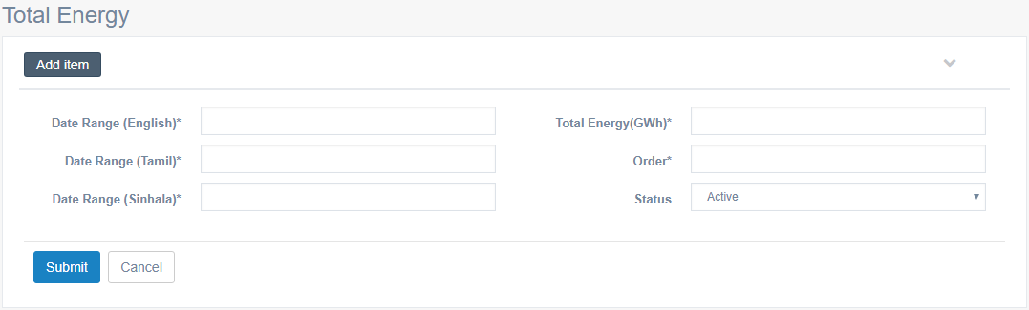

Criteria | Satisfied | Unsatisfied
Accuracy and Order of text fields

Readability and Understandability of
the content

Overall appearance of the form

Accepted by
Name : ……………………… Signature: ………………….. Date: ……………

User Acceptance Testing – Acceptance Sign-Off Form
  - User : Admin
  - From Name : Total Energy – Edit Details

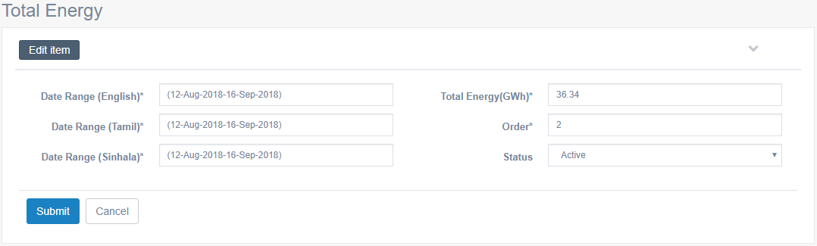

Criteria | Satisfied | Unsatisfied
Accuracy and Order of text fields

Readability and Understandability of
the content

Overall appearance of the form

Accepted by
Name : ……………………… Signature: ………………….. Date: ……………

User Acceptance Testing – Acceptance Sign-Off Form
  - User : Admin
  - From Name : Province - List

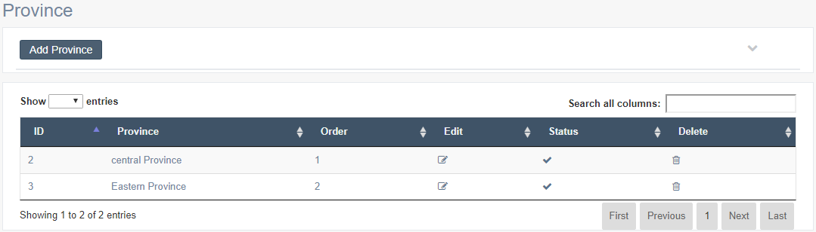

Criteria | Satisfied | Unsatisfied
Accuracy and Order of text fields

Readability and Understandability of
the content

Overall appearance of the form

Accepted by
Name : ……………………… Signature: ………………….. Date: ……………

User Acceptance Testing – Acceptance Sign-Off Form
  - User : Admin
  - From Name : Province – Add Province

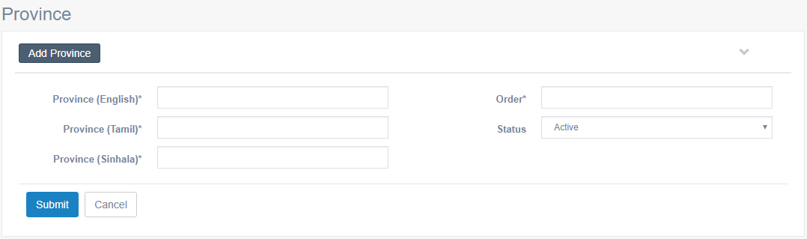

Criteria | Satisfied | Unsatisfied
Accuracy and Order of text fields

Readability and Understandability of
the content

Overall appearance of the form

Accepted by
Name : ……………………… Signature: ………………….. Date: ……………

User Acceptance Testing – Acceptance Sign-Off Form
  - User : Admin
  - From Name : Province – Edit Province

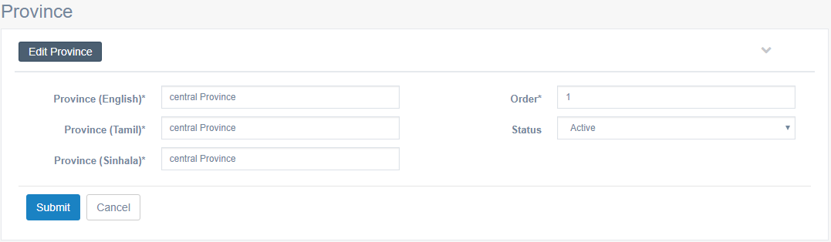

Criteria | Satisfied | Unsatisfied
Accuracy and Order of text fields

Readability and Understandability of
the content

Overall appearance of the form

Accepted by
Name : ……………………… Signature: ………………….. Date: ……………

User Acceptance Testing – Acceptance Sign-Off Form
  - User : Admin
  - From Name : Power Interruption Area - List

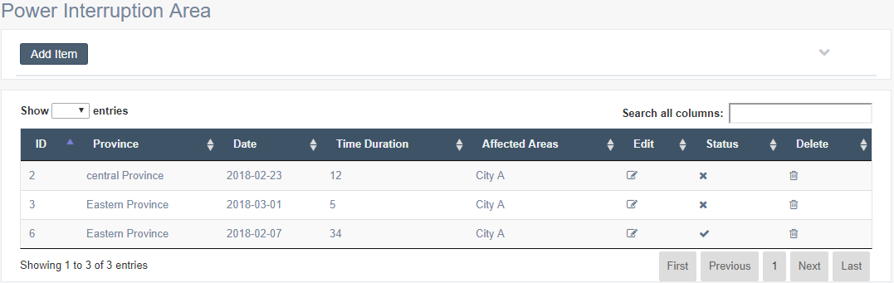

Criteria | Satisfied | Unsatisfied
Accuracy and Order of text fields

Readability and Understandability of
the content

Overall appearance of the form

Accepted by
Name : ……………………… Signature: ………………….. Date: ……………

User Acceptance Testing – Acceptance Sign-Off Form
  - User : Admin
  - From Name : Power Interruption Area – Add Details

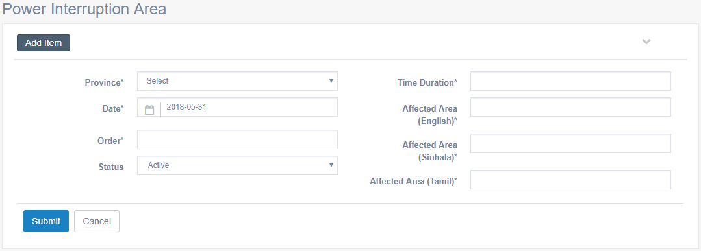

Criteria | Satisfied | Unsatisfied
Accuracy and Order of text fields

Readability and Understandability of
the content

Overall appearance of the form

Accepted by
Name : ……………………… Signature: ………………….. Date: ……………

User Acceptance Testing – Acceptance Sign-Off Form
  - User : Admin
  - From Name : Power Interruption Area – Edit Details

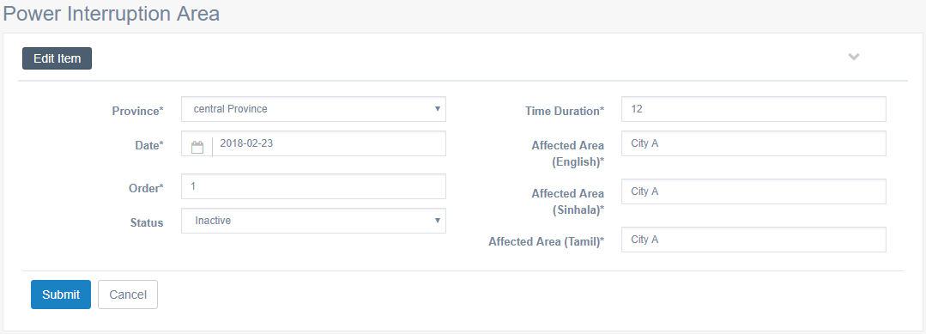

Criteria | Satisfied | Unsatisfied
Accuracy and Order of text fields

Readability and Understandability of
the content

Overall appearance of the form

Accepted by
Name : ……………………… Signature: ………………….. Date: ……………

User Acceptance Testing – Acceptance Sign-Off Form
  - User : Admin
  - From Name : Footer Links

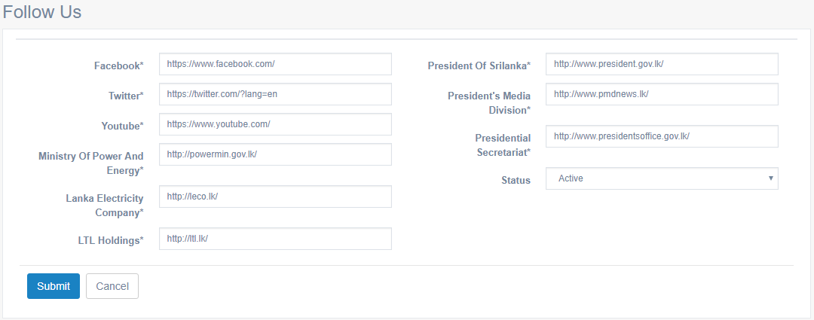

Criteria | Satisfied | Unsatisfied
Accuracy and Order of text fields

Readability and Understandability of
the content

Overall appearance of the form

Accepted by
Name : ……………………… Signature: ………………….. Date: ……………

User Acceptance Testing – Acceptance Sign-Off Form
  - User : Admin
  - From Name : User Type – List

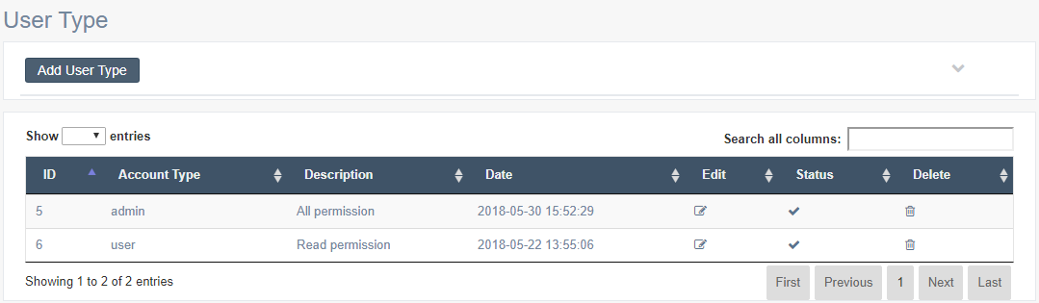

Criteria | Satisfied | Unsatisfied
Accuracy and Order of text fields

Readability and Understandability of
the content

Overall appearance of the form

Accepted by
Name : ……………………… Signature: ………………….. Date: ……………

User Acceptance Testing – Acceptance Sign-Off Form
  - User : Admin
  - From Name : User Type – Add User Type

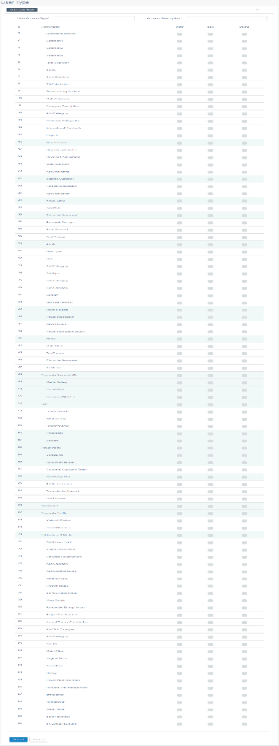

Criteria | Satisfied | Unsatisfied
Accuracy and Order of text fields

Readability and Understandability of
the content

Overall appearance of the form

Accepted by
Name : ……………………… Signature: ………………….. Date: ……………

User Acceptance Testing – Acceptance Sign-Off Form
  - User : Admin
  - From Name : User Type – Edit User Type

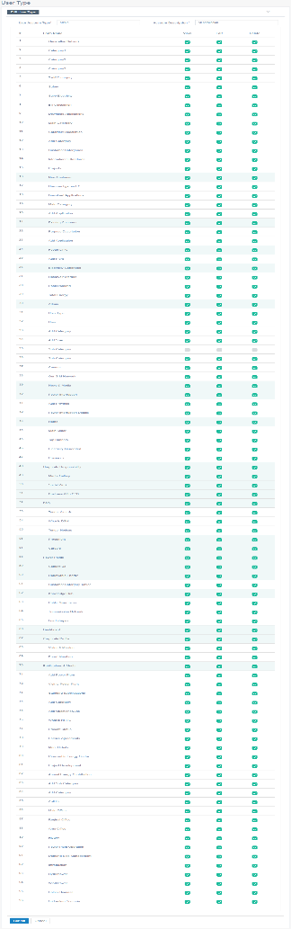

Criteria | Satisfied | Unsatisfied
Accuracy and Order of text fields

Readability and Understandability of
the content

Overall appearance of the form

Accepted by
Name : ……………………… Signature: ………………….. Date: ……………

User Acceptance Testing – Acceptance Sign-Off Form
  - User : Admin
  - From Name : User – List

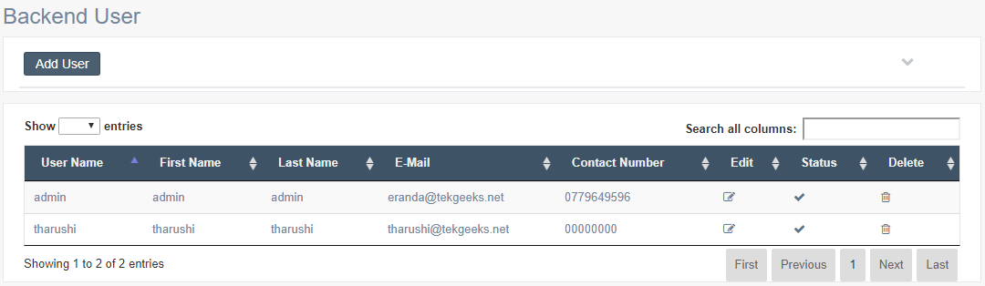

Criteria | Satisfied | Unsatisfied
Accuracy and Order of text fields

Readability and Understandability of
the content

Overall appearance of the form

Accepted by
Name : ……………………… Signature: ………………….. Date: ……………

User Acceptance Testing – Acceptance Sign-Off Form
  - User : Admin
  - From Name : User – Add User

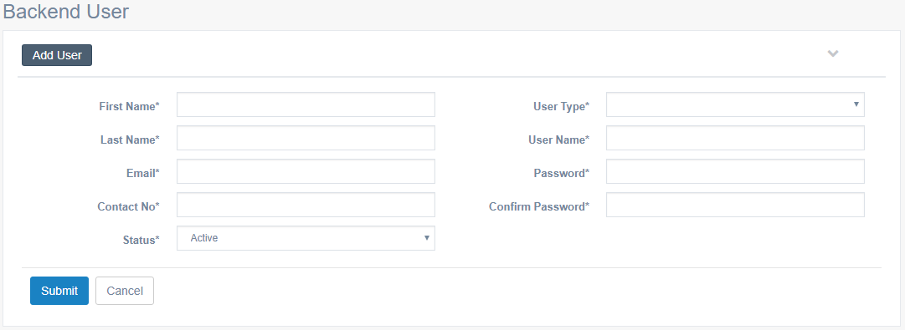

Criteria | Satisfied | Unsatisfied
Accuracy and Order of text fields

Readability and Understandability of
the content

Overall appearance of the form

Accepted by
Name : ……………………… Signature: ………………….. Date: ……………

User Acceptance Testing – Acceptance Sign-Off Form
  - User : Admin
  - From Name : User – Edit User

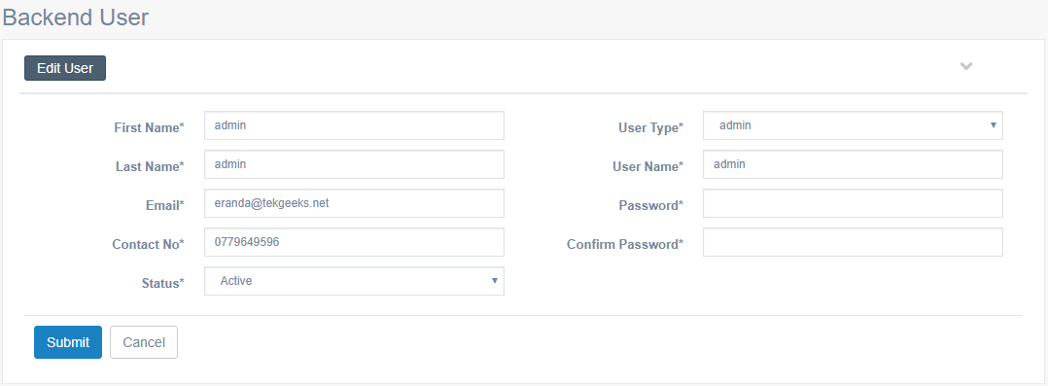

Criteria | Satisfied | Unsatisfied
Accuracy and Order of text fields

Readability and Understandability of
the content

Overall appearance of the form

Accepted by
Name : ……………………… Signature: ………………….. Date: ……………

